**Horizontal Projectile Motion Intro Worksheet**

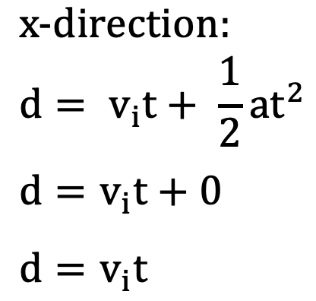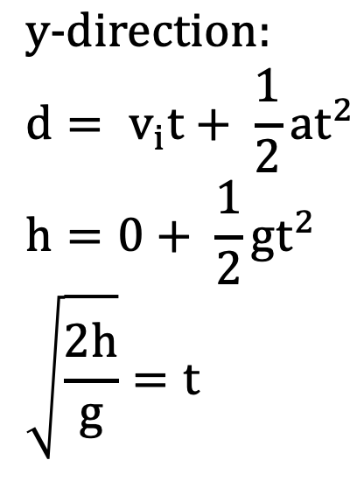

1. A ball is dropped from 4 meters high. How long does it take for the ball to reach the ground?
2. A ball is launched horizontally at 2 m/s from 2 meters high. How long does it take for the ball to reach the ground?
3. A ball is launched horizontally at 2 m/s from 2 meters high. How far away does the ball hit the ground?