**Horizontal Projectile Motion Intro Worksheet Answer Key**

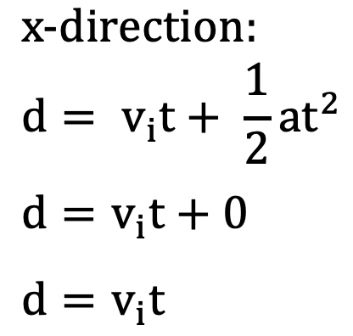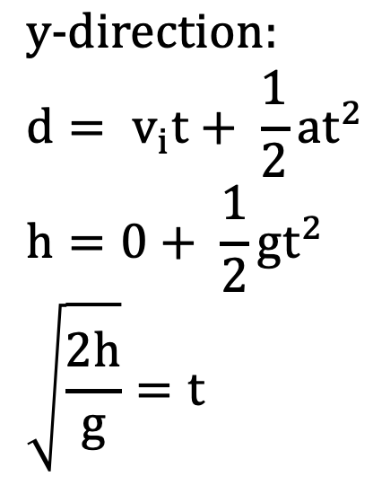

1. A black background with red text

   Description automatically generatedA ball is dropped from 4 meters high. How long does it take for the ball to reach the ground?

1. A ball is launched horizontally at 2 m/s from 2 meters high. How long does it take for the ball to reach the ground?A black background with red text

   Description automatically generatedA black background with red text

   Description automatically generated

Ignore horizontal velocity.

Initial velocity in the y-direction is zero.

1. A ball is launched horizontally at 2 m/s from 2 meters high. How far away does the ball hit the ground?A black background with red text

   Description automatically generated

Y-direction is the same as the previous problem.

The time it takes to hit the ground is 0.64 s.