Horizontal Projectile Motion With Arduino Handout

Learning objectives:
By the end of this project, you will be able to:
- Set up an Arduino speed sensor using IR proximity sensors.
- Understand the basics of Arduino programming.
- Determine the distance of a horizontally launched projectile given initial velocity and height.

Materials:
- 1 Arduino UNO w/ USB cable
- 1 computer or laptop with Arduino IDE
- 2 IR proximity sensors
- 1 RGB LED
- 6 female-to-male Dupont wires
- 1 Arduino holder and ramp

Prepare:
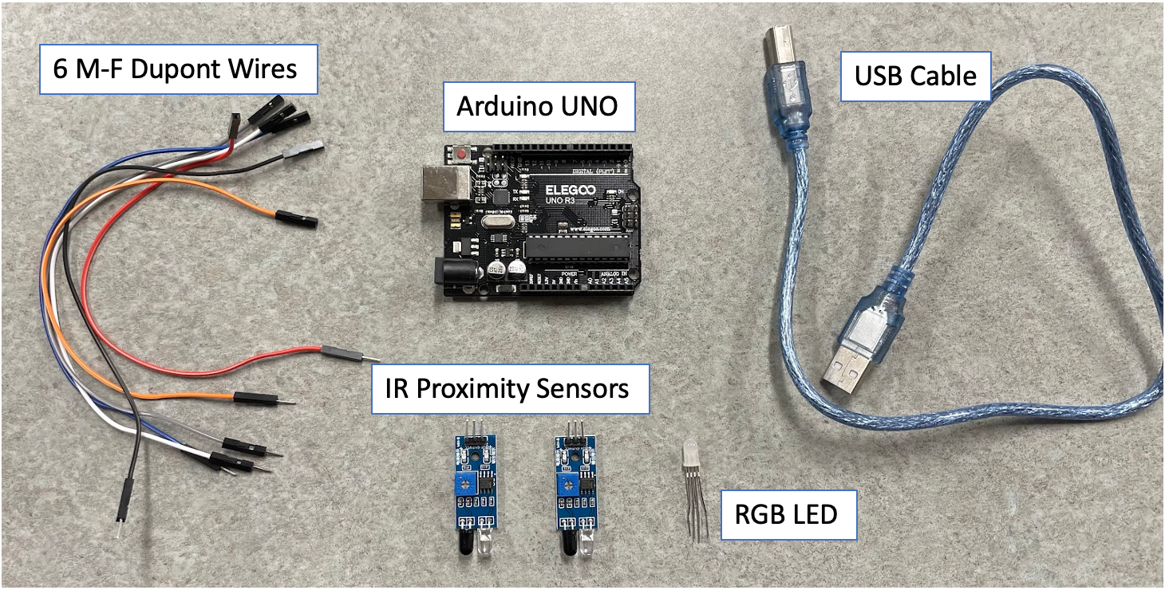
- Gather the following materials:

Assemble
- Follow the next five diagrams to set up your Arduino IR speed sensor.
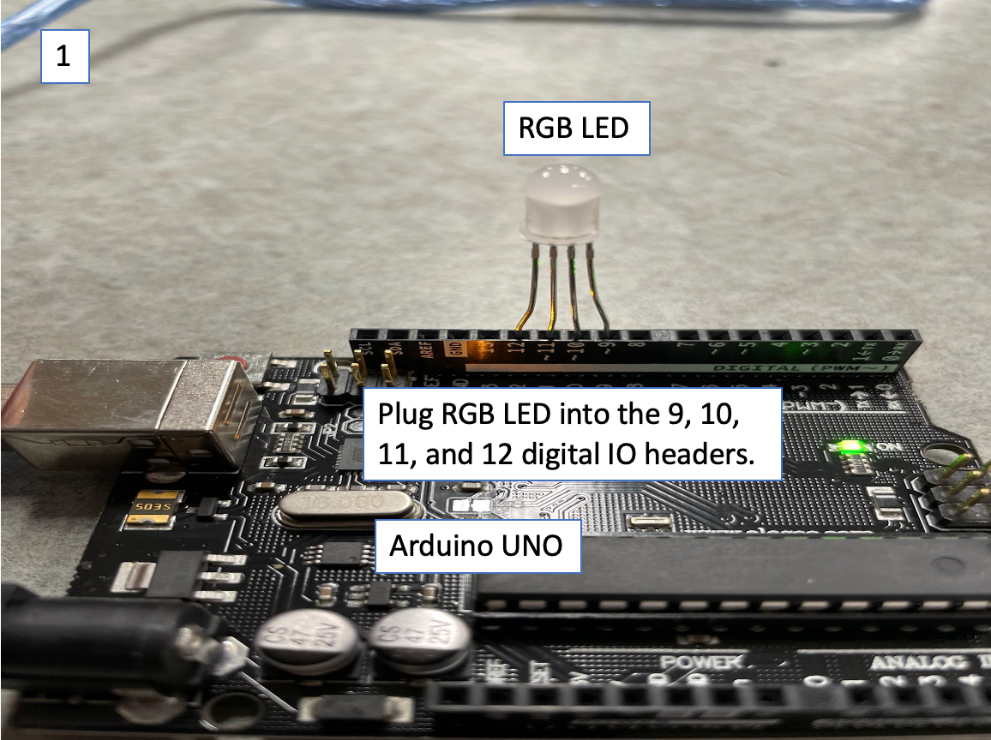

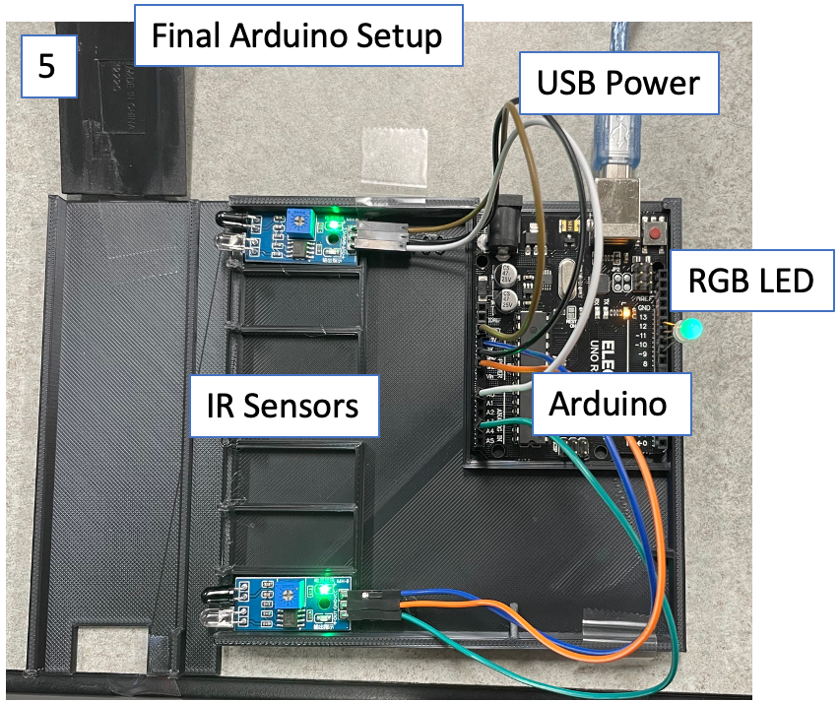
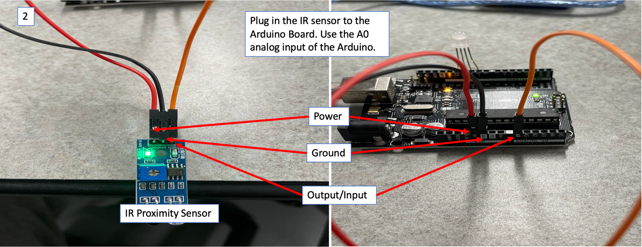
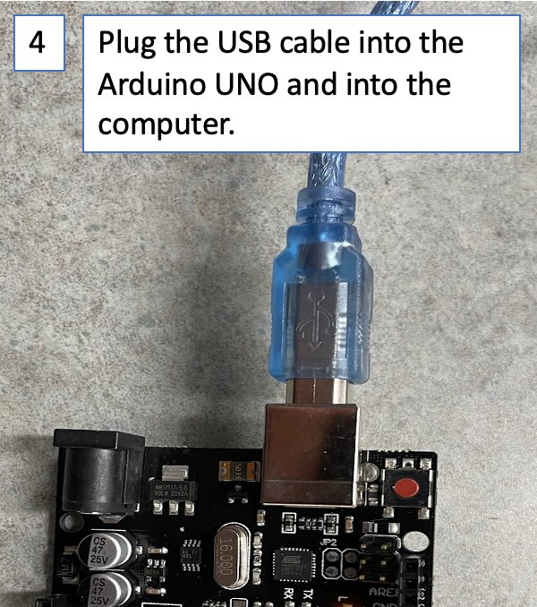
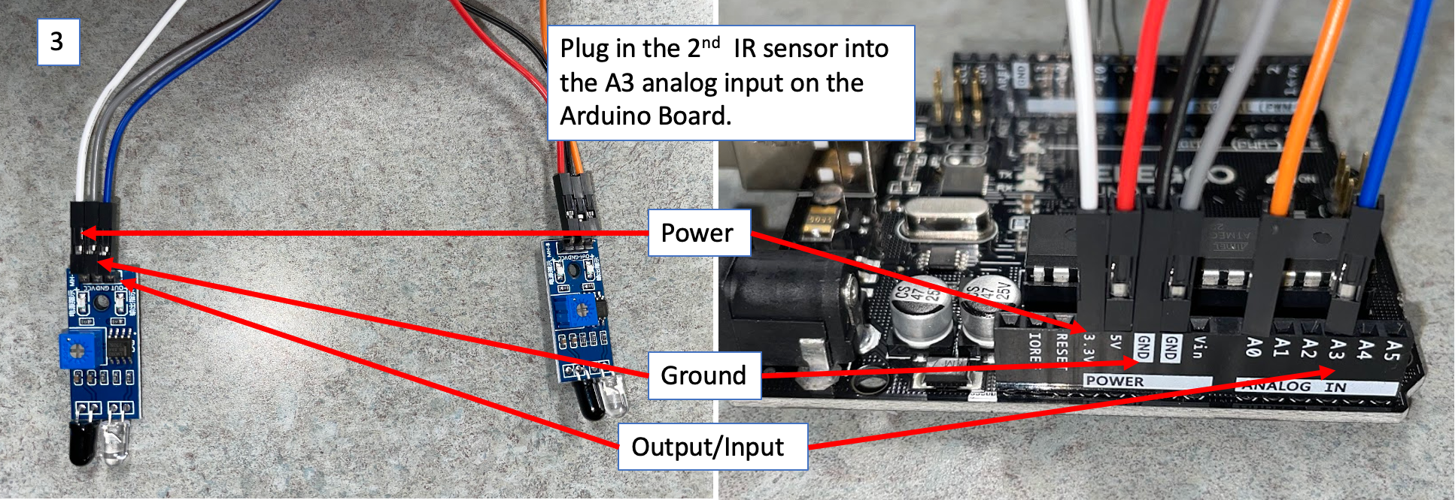

- Set up the Arduino IDE code.
  - Open the Arduino IDE software on computer.
  - Copy and paste the IR Speed Sensor Using Arduino code into the IDE.

- Answer the following questions based on the IR Speed Sensor Using Arduino code:
  - Identify the lines where the IR sensors are inputting their data:

  - Identify the line where the distance between the sensors is being set:

  - Identify the lines where the velocity is being calculated:

  - In what unit is the velocity after being calculated?

  - Where is the velocity being converted into m/s?

- Ramp setup:
  - Place the Arduino speed detector at the edge of the table.
  - Place the ramp just before the speed detector, as shown in the diagrams below:
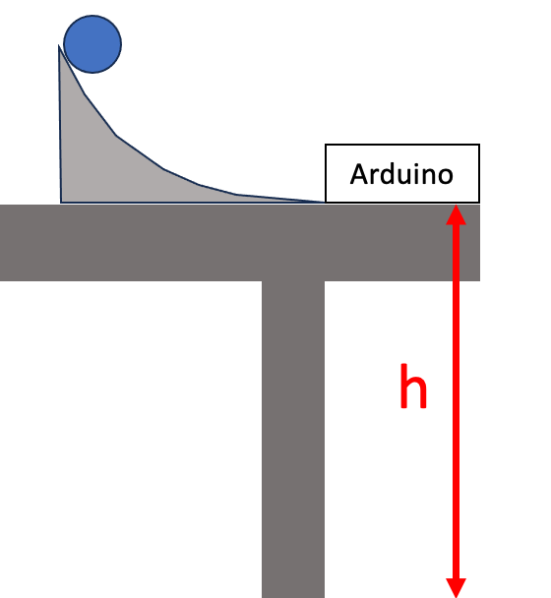
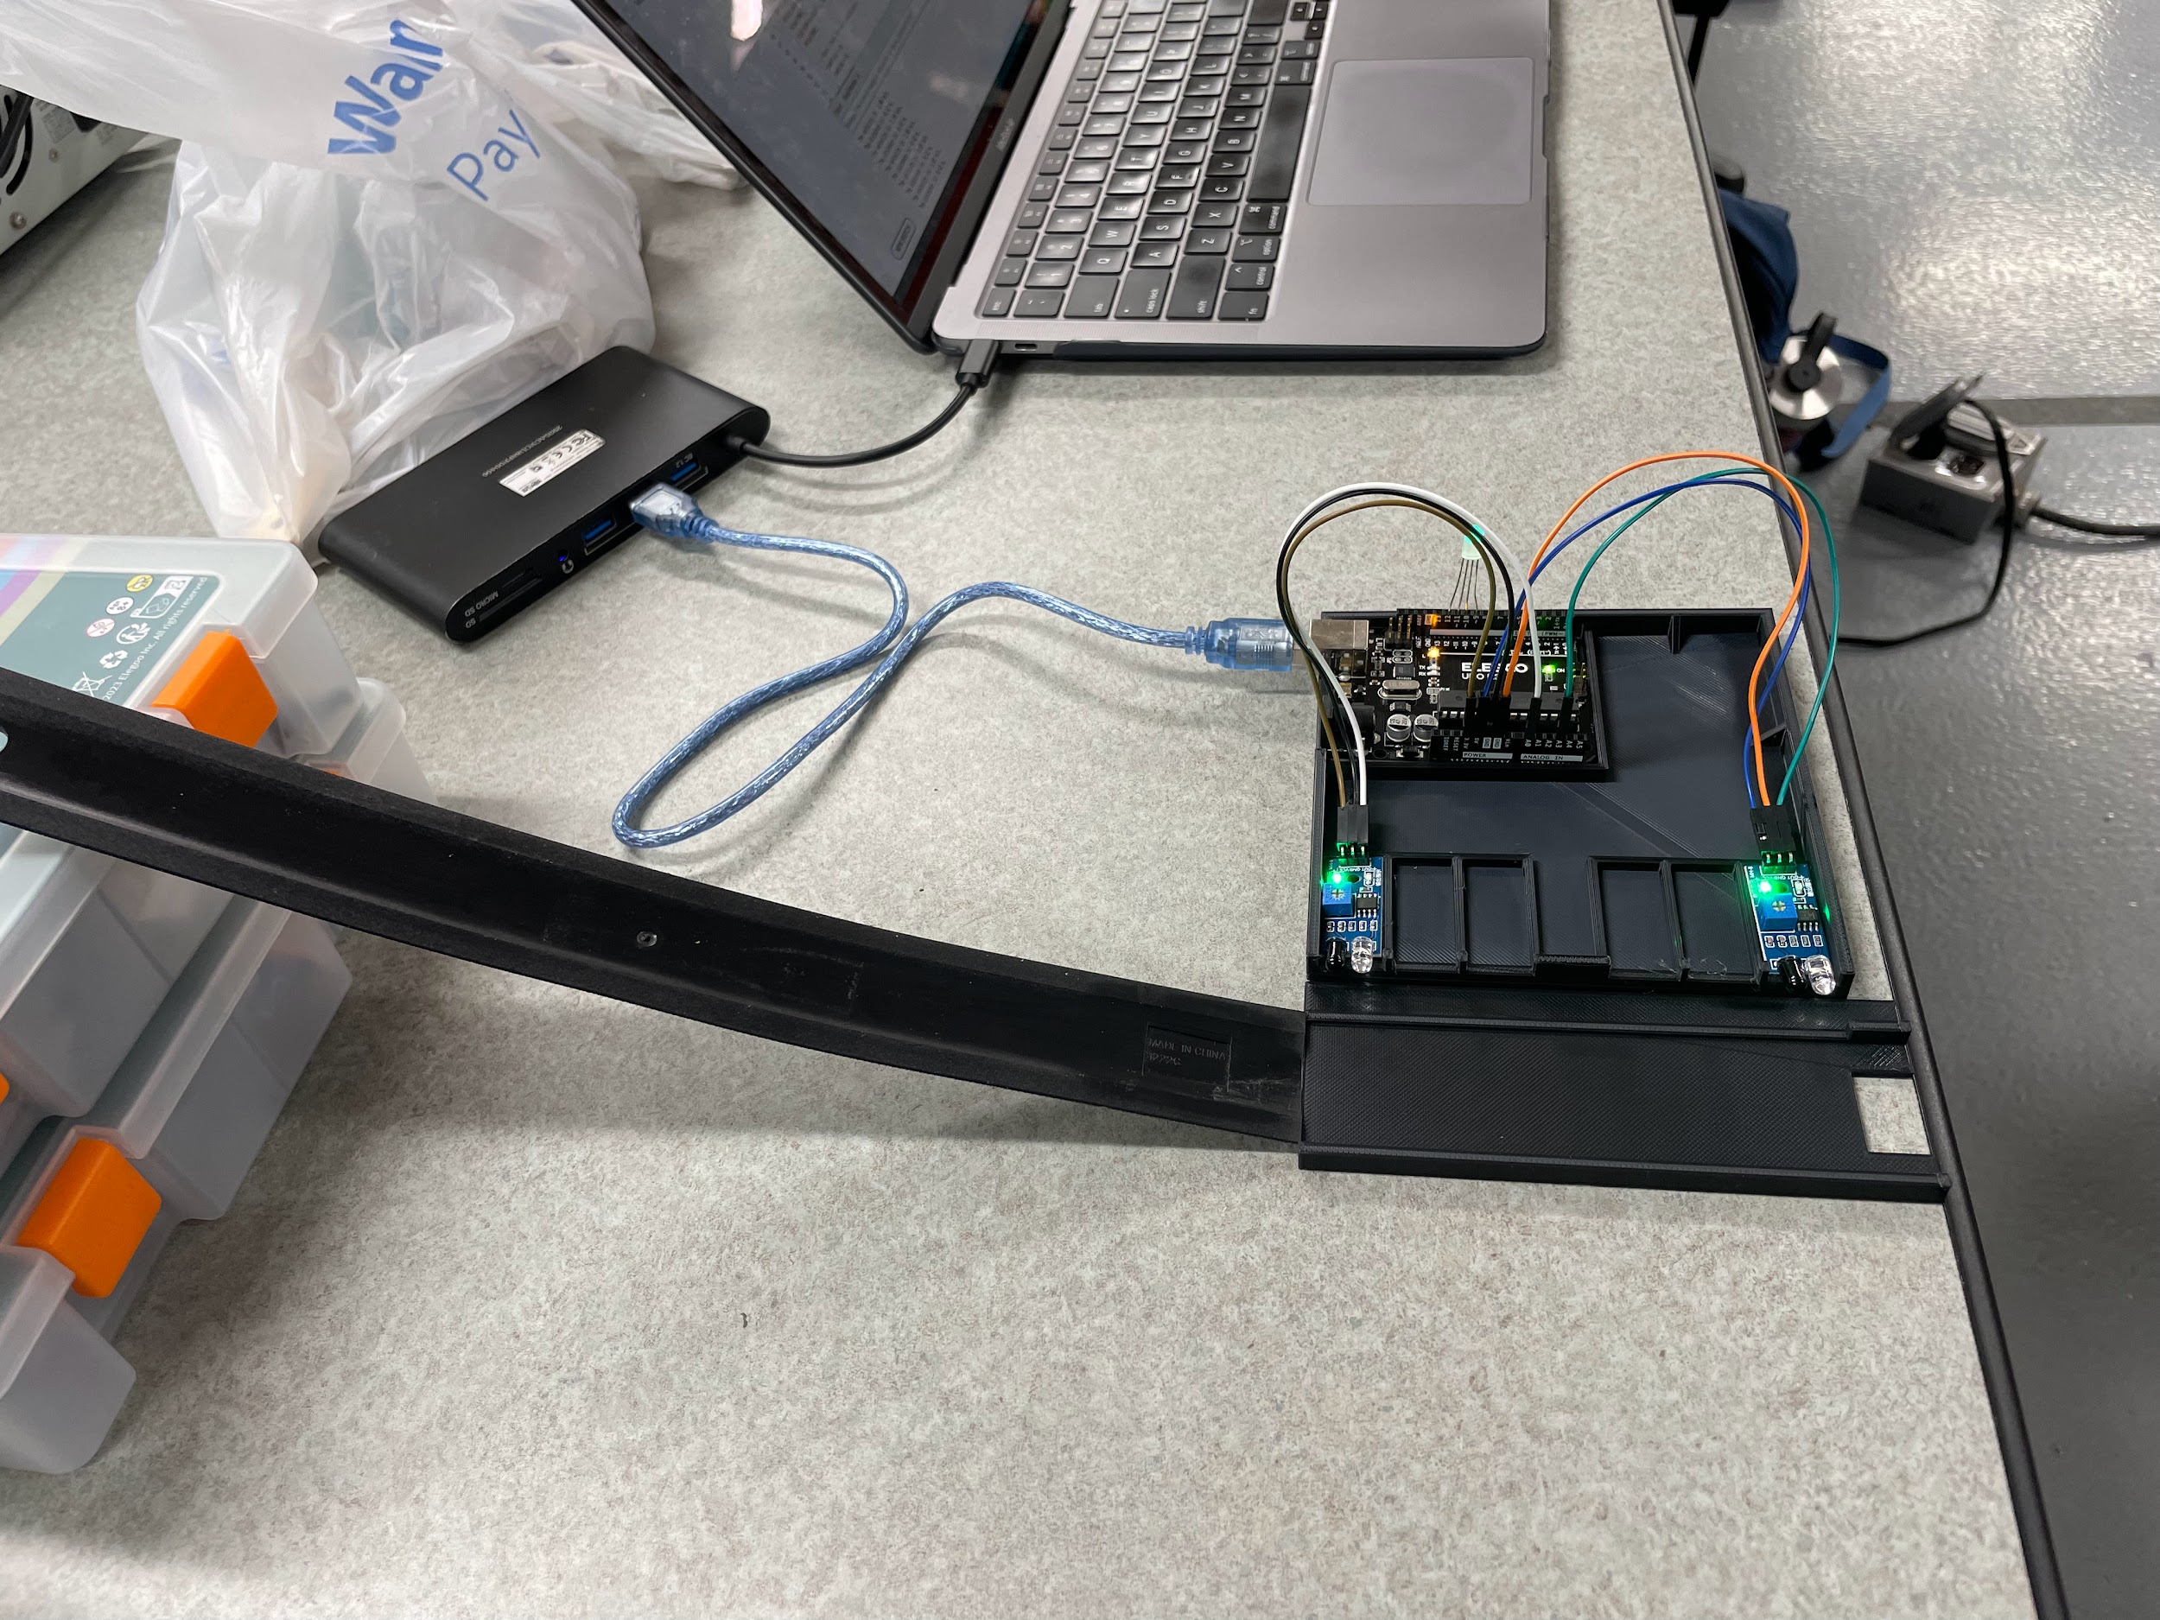

What is the height of your launch point?

h = meters

- Test the ramp and Arduino setup.
  - Initial Velocity
    - Place the projectile on the ramp and release it from the same spot three times. DO NOT let the projectile hit the floor; catch it after it passes the speed sensor.
    - Record these values in the table below:

 | Trial 1 | Trial 2 | Trial 3 | Avg (m/s)
Velocity

  - Calculate Distance
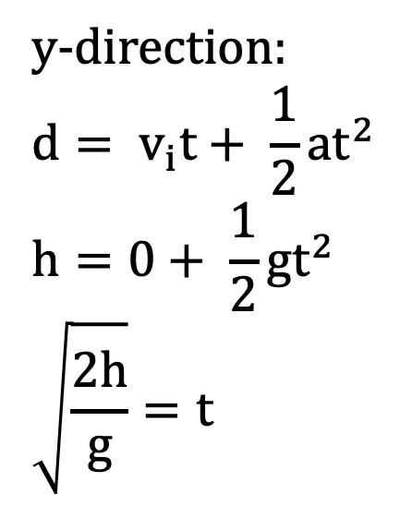
    - Use the following kinematic equation to determine the distance away the projectile will hit the ground. Use your calculated Avg Velocity and the height you measured.

y-direction x-direction

  - Test!

    - Place a cup at the distance you calculated.
    - Place the ball on the ramp and release it.
    - Did your projectile land in the cup?

Post-Experiment Questions:
- How did you use the Arduino speed detector to determine the initial velocity of the ball? Describe the process, and any challenges you encountered.

- Without the use of the Arduino, how could you have found the initial velocity?

- Explain how you used the kinematic equations to predict the horizontal distance where the ball would land.

- Identify and discuss at least three potential sources of error in your experiment. How could these errors have affected your results, and what steps could you take to minimize them in future experiments?

- Outside of learning how to predict the distance of a horizontally launched projectile, describe something you learned from this experiment.

