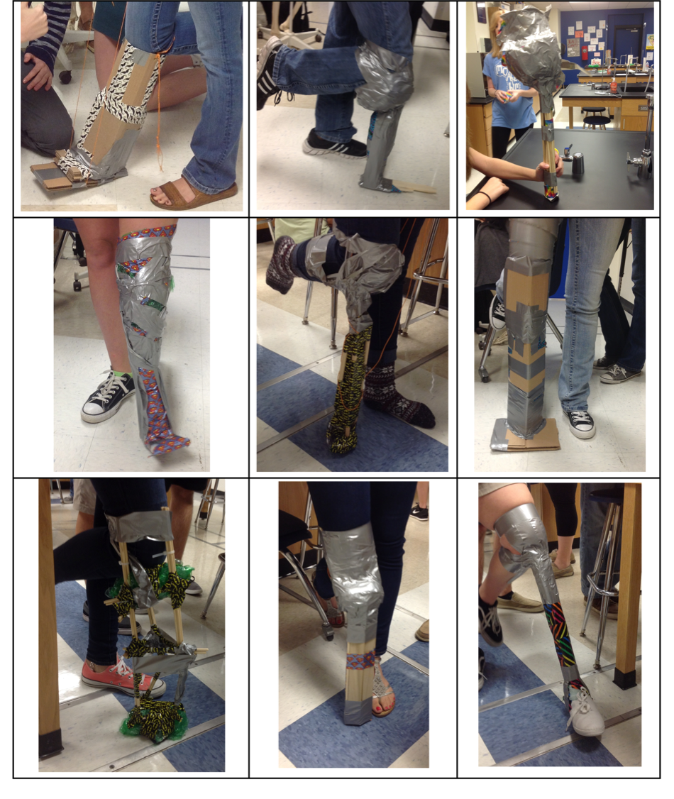
Examples of Student-Created Prosthetic Prototypes

