Engineering Design Process Quiz Answer Key
- What is the engineering design process?
The engineering design process is a series of steps that engineers follow when solving a problem and designing a solution.

- In the diagram below, fill in the steps of engineering design process.
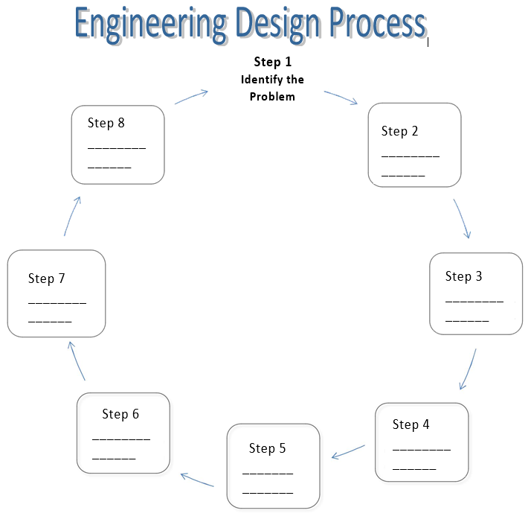

Redesign, improve
Research the problem

Develop possible solutions
Communicate the solution

Test and evaluate the prototype
Select a solution; plan
Build a prototype

Communicate the solution

