Wind Turbines Post-Quiz
A. Circle the best choice:
- energy: quantitative qualitative

- water: renewable nonrenewable
energy source energy source

- fossil fuel: renewable nonrenewable
energy source energy source

- gasoline: renewable nonrenewable
energy source energy source

- wind: renewable nonrenewable
energy source energy source

- natural gas: renewable nonrenewable
energy source energy source

- heat: energy form energy source

- sun: energy form energy source

- light: energy form energy source

- gravity: energy form energy source

B. Use the following words to label the six basic components that composes a wind turbine:

tower
shaft
electric generator
rotor
gearbox
rotor blade

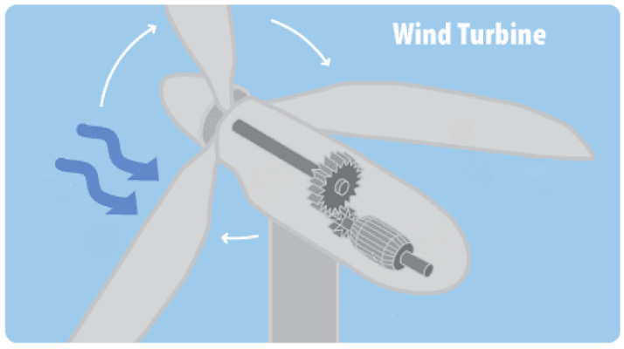

C. Write a short description of each:
- Rotor and rotor blade:

- Shaft:

- Gearbox:

- Electric generator:

