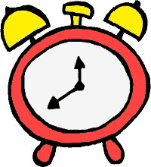
Robo Clock Pre-Assessment

- A quarter past 12 PM is _____________ PM
  - Would the minute hand on the clock move clockwise or counter-clockwise? __________
  - How many degrees would the minute hand move? ____________

- A quarter to 12 PM is _____________ AM
  - How many degrees would the minute hand have to move from 12 PM to show the new time? In which direction? _________

- Half past 3 PM is _____________ PM

- Half an hour to 3 PM is ___________ PM

- How many minutes are in quarter of an hour? _____________

- How many minutes in half of an hour? _____________

- How many degrees make up 12 hours of the clock? (Hint: a full circle) ______________

