Linear Equations Quiz Answer Key
- What is the equation for the slope of a line?
$$m= \frac{y_{2-}y_{1}}{x_{2}{-x}_{1}}$$
- Identify the slope and y-intercept of Line 2, below.
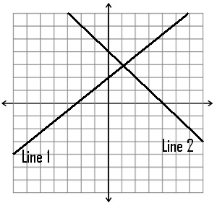
Line 2: $m= \frac{y_{2-}y_{1}}{x_{2}{-x}_{1}}$=$\frac{4-0}{0-4}=\frac{4}{-4}=-1$ y=mx+b -> 4=6/7*0+b b=4
- Without solving, what do you think slope of Line 1 is? Explain your logic.
1, because Line 1 and Line 2 are perpendicular lines, the product of their slopes should equal -1.

- If you were in the middle of an ice rink that has “perfect ice” (no friction),
how would you get off the ice rink? Explain your logic.
- Blow in the opposite direction.
- Throw an object in the opposite direction.
- Wave your hands to produce wind in the opposite direction.
These actions work because the floor has no friction so the only way to move is through reaction forces / propulsion.

