Pre-Activity Preparation Process Sheet
- Check the fan and power supply to make sure the two are compatible. AC power adapter should be 12V and capable of putting out AT LEAST the same current draw specified on the fan (can be more, but should never be less). Below, see this information highlighted on the power supply and fan.
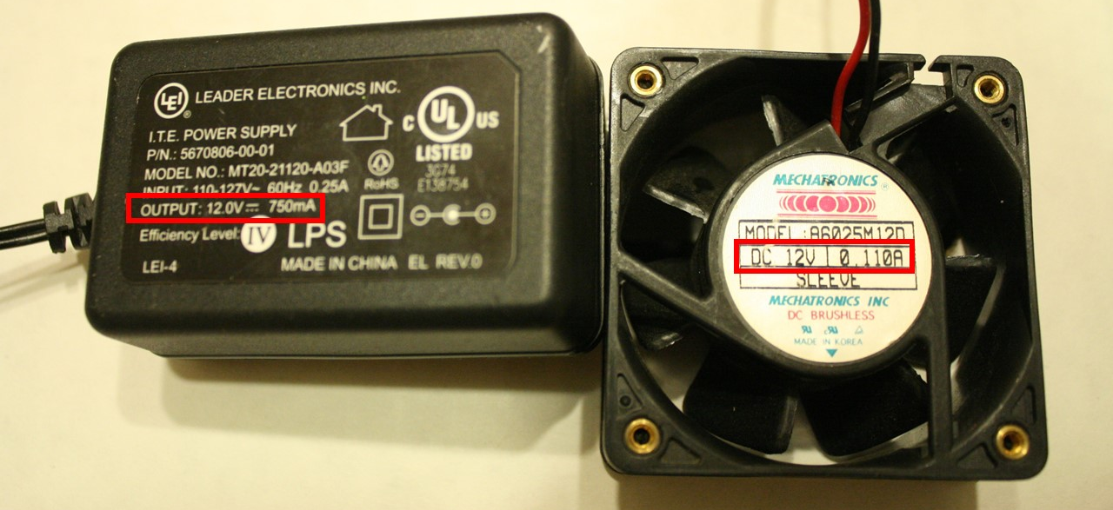

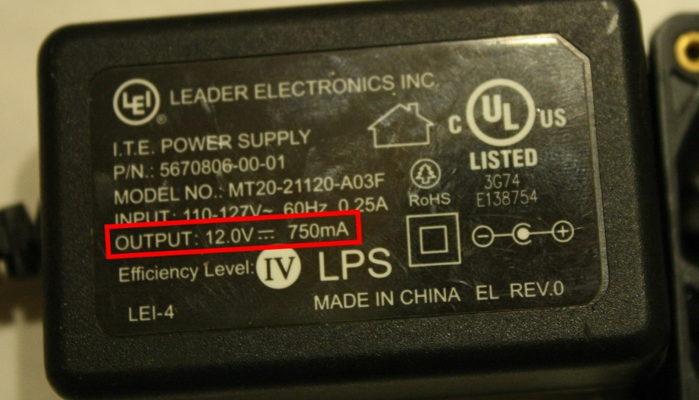

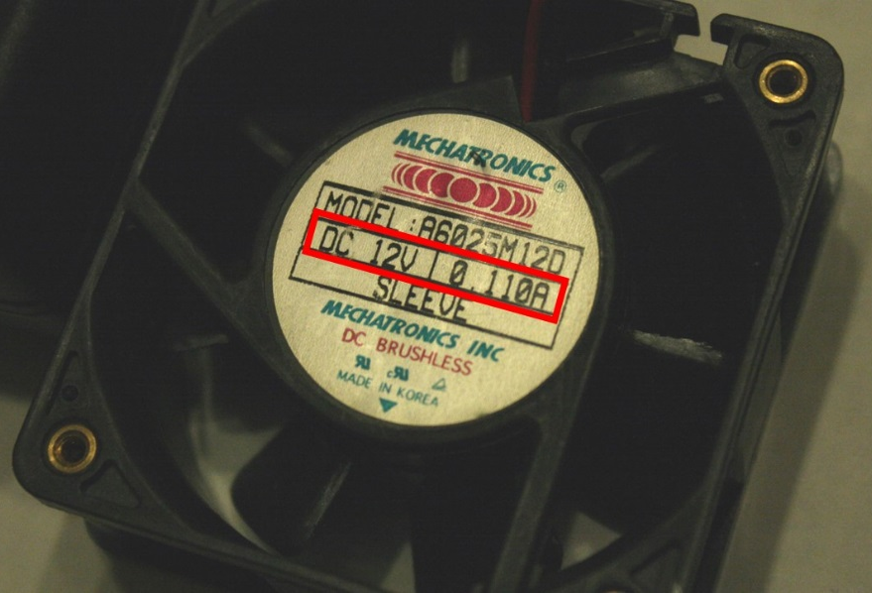

- Clip the wire ends off the fan and power supply cables. You’ll need to have access to both the positive and negative leads.
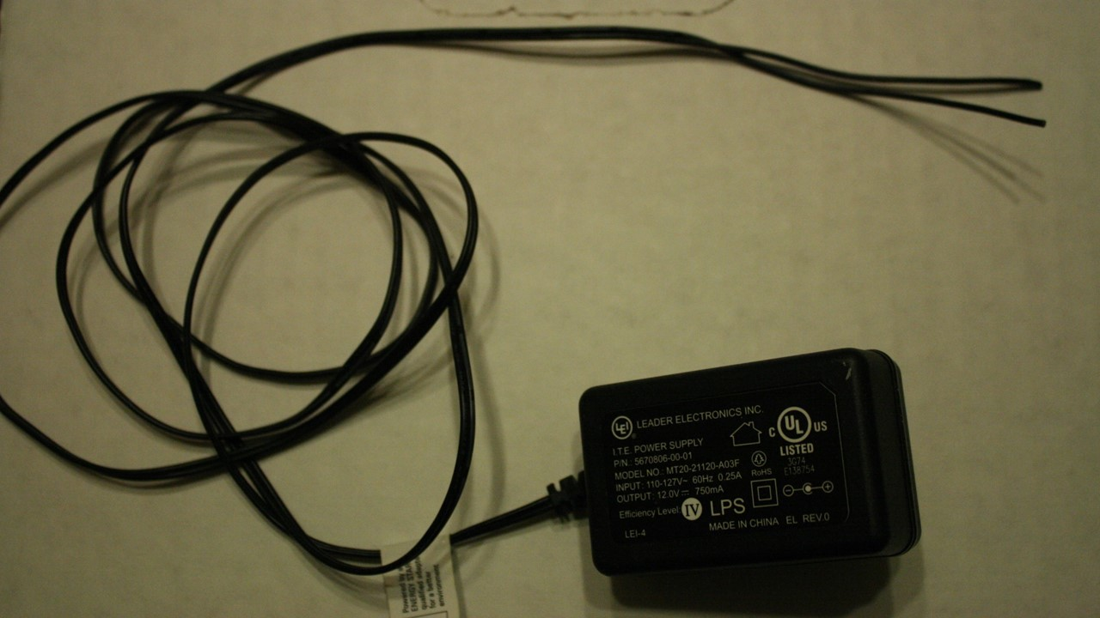

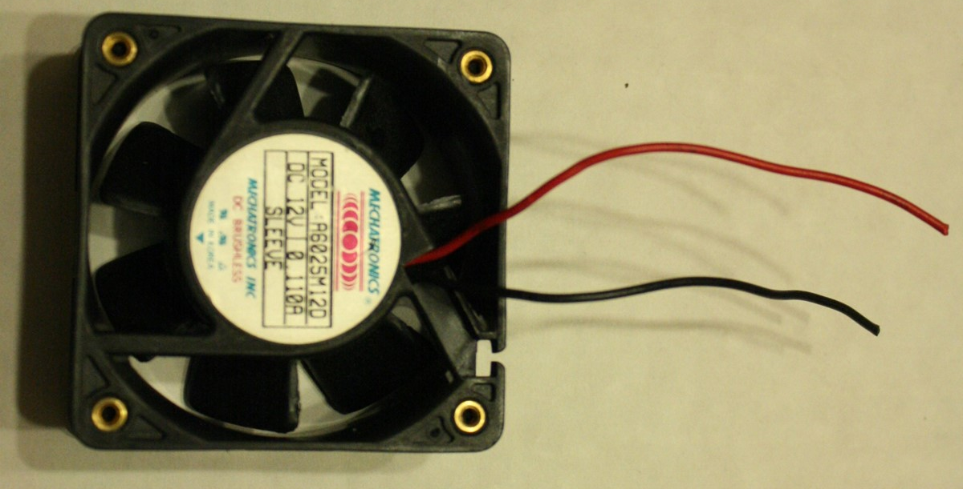

- Strip the insulation from the ends of the fan and power supply cables.
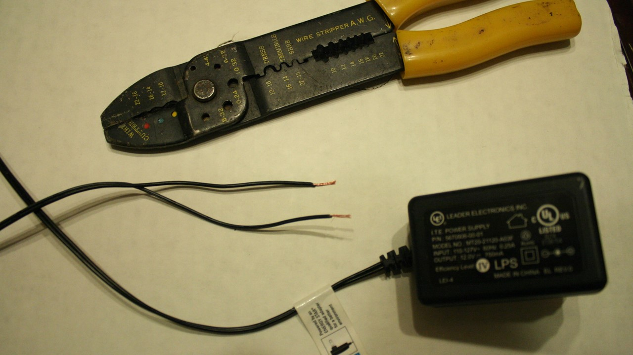

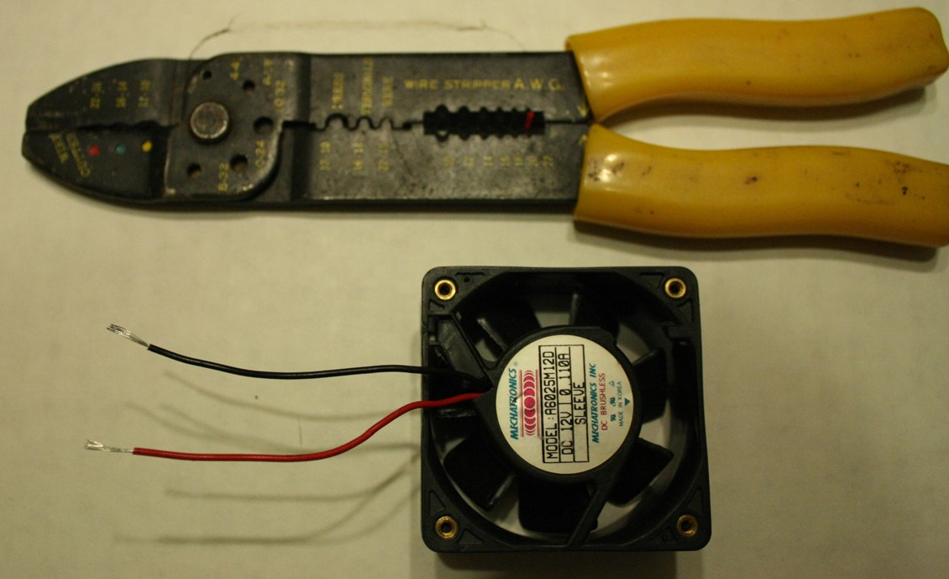

- Determine which of the power supply leads is positive. Typically, this is not obvious, since both leads are usually black. The positive lead often has a white stripe running down it that may (or may not) be dashed. If you are not sure, plug the power supply into a wall outlet and use a multimeter to determine which side is positive (will read a positive voltage when connected to the red multimeter probe). Once the positive lead has been determined, mark it with red tape so you don’t forget.
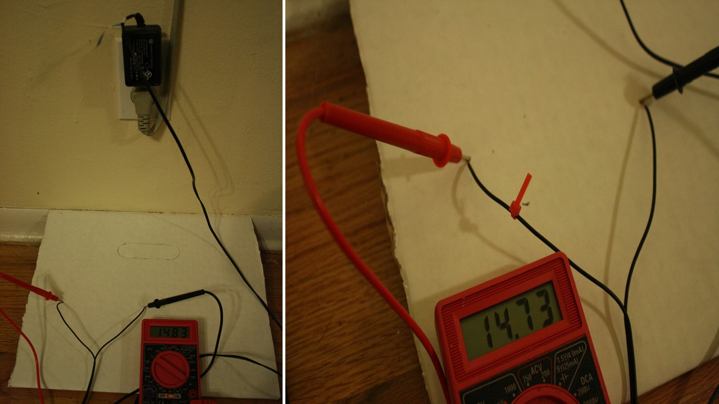

- Positive and negative leads on your computer fan SHOULD be labeled or color coated. If they are not, simply attach these cables to your plugged-in power supply to test them. If you have the leads reversed, the fan will either not run or run in reverse. If this step was necessary, then mark your positive fan lead with red tape as you did in step 4 with the positive power supply lead.

- Install Arduino IDE on all computers used for this activity. Arduino IDE software is available at the Arduino website at https://www.arduino.cc/en/Main/Software.
Images source: 2016 Aaron Lamplugh, ITL Program, College of Engineering and Applied Science, University of Colorado Boulder

