Demo Worksheet Example Answers
- Prediction/Hypothesis: Before the demo, briefly describe what you think will happen when water is added to the model. This is a model that we are going to use to investigate the behavior of water.
Accept all logical answers because this is a hypothesis. Possible example answers:
Water will move up the tubes.
Water will move up the tubes at different speeds.
Water will move up the highest in tube 1 and the lowest in tube 4.

- Observations: Closely observe the demonstration. Then use a blue or red colored pencil to sketch in the diagram below what you observed.
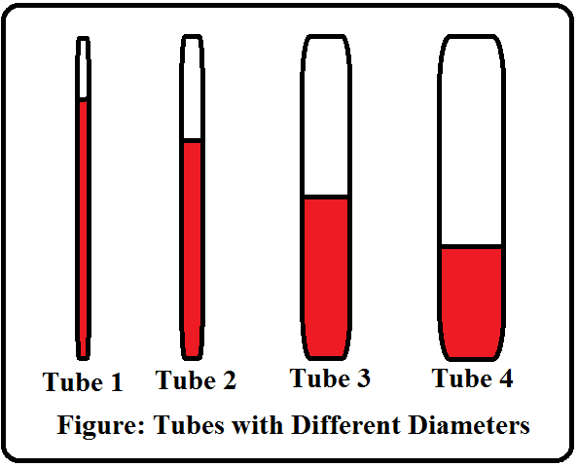

- In your own words, describe what happened to the water in the four tubes when the water was added to the demonstrator. Provide a logical explanation for your observations.
Water moves up in all the tubes. The level of water mobility decreases from left to right. This is because water molecules are attracted to the wall of the tube and therefore move upwards.

- Based on your experiences, where do you see this phenomenon occur in real life? Give as many examples as you can.
Paper towels, sponges, fountain pens, plants

- What is the scientific term used to describe this phenomenon? What do you know about this process?
Capillary action is the scientific term; it is defined as the ability of water to move upwards.

