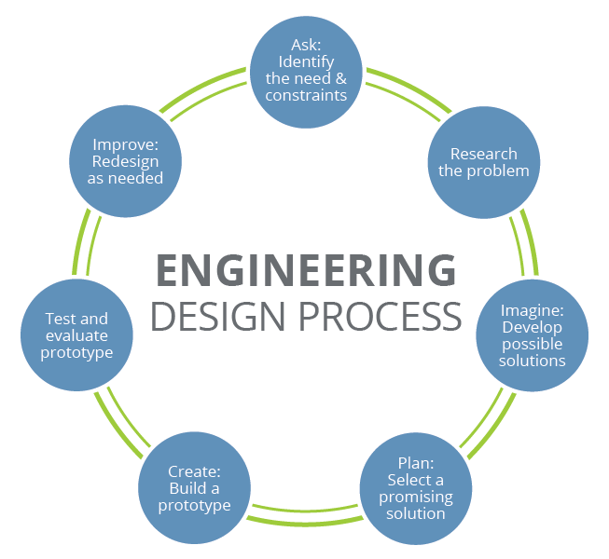
Design Challenge Handout
Design Challenge
You have been tasked with creating a new ping-pong paddle design for the 2020 Olympics. You and your group need to study the materials and determine which ones will create the most effective paddle design. After creating your prototype, your group will perform several tests to compare your paddle to a store-bought paddle for ball control, comfort, and durability. After comparing your design to a store-bought paddle, you will have the opportunity to redesign your paddle. Your paddle must have a core, a coating to make the core sturdy, and a covering over the blade. Good luck!

Research
Use this space to take any notes you find important from today’s presentation.

Brainstorm
Possible paddle designs?

Build
Build your paddle. Include pictures of your design.

