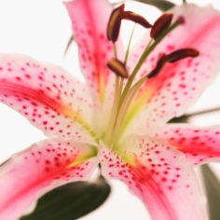
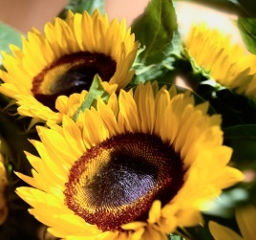

Design Inspired By Nature Activity –
Exploring Biomimicry Worksheet

Biomimicry is the science that studies nature to find solutions to human challenges. Even a flower can be studied for inspiration! Today, we are going to reverse engineer a flower, and you become nature investigators to design new products.

Reverse engineering is the process of discovering the technological principles of an object by taking it apart and carefully studying its different parts.
Design Process Directions

- Carefully take apart your flower and sketch its different components.

- Describe the colors and textures of the flower. Why was the flower created with these materials?

- Describe the overall shape and structure of the flower. What challenge might the flower be solving by having this shape and structure?

- How could you, as an engineer, mimic the material, color, shape, and structure of the flower to design something new? In the space below, sketch a new product or design.
- What scientific concepts that you have learned about before relate to the flower?

- What would you name your new design?

