Thermodynamics worksheet

Name: _________________________________________Period: __________________

Date: __________________

Design Need: The customer needs a thermos designed that is capable of the following:
- holding 200mL of water
- spending less than $3 for all materials
- least amount of heat loss (smallest decrease in temperature of boiling water after 10 minutes)
- lowest total design cost
- using only the materials listed below
- Can be built & tested by end of class tomorrow (2 days total)

Material Specifications: Heat Loss Equation:
Material | Thermal Conductivity  (W/m.K) | Cost  ($)
Water (insulation) | 0.60 | 0.25/ mL
Aluminum Foil | 250 | 0.05/ inch
Cotton Balls | 0.03 | 0.15/ each
Paper Cup | 0.05 | 0.55/ each
Sand | 0.25 | 0.01/ gram
Plastic Cup | 0.23 | 0.15/ each
Styrofoam Cup | 0.03 | 0.85/ each
Paint | radiation heat | 0.25/ layer
Foam Insulation | 0.03 | 0.05/ inch
Masking Tape | 0.08 | 0.05/ inch
Fourier’s Law:
where
q = heat transferred per unit time (W)
A = heat transfer area (m²)
k = thermal conductivity of the material (W/m.K)
T_{H} = hot temperature (K)
T_{C} = cold temperature (K)
L = material thickness (m)

1. Complete the following statements based on the introduction from your teacher

a. According to the Heat Loss Equation the value of q should be ________ (big or small) if we want
less heat loss.

b. According to the Heat Loss Equation the value of q should be ________ (big or small) if we want
more heat loss.

c. According to the Heat Loss Equation the value of k should be ________ (big or small) if we want
less heat loss.

d. According to the Heat Loss Equation the value of k should be ________ (big or small) if we want
more heat loss.

2. Draw a picture of Design #1. Include cost of design and construction details.

Fill in the following table as you choose materials.
Material | Quantity | Cost  ($)

Complete the following table as you test your design
Time (minutes) | Temperature (ºF)
0 - initial temperature reading
1
2
3
4
5
6
7
8
9
10

3. Draw a picture of Design #1. Include cost of design and construction details

Fill in the following table as you choose materials.
Material | Quantity | Cost  ($)

Complete the following table as you test your design
Time (minutes) | Temperature (ºF)
0 - initial temperature reading
1
2
3
4
5
6
7
8
9
10

4. Plot the heat loss of each thermos design
- y-axis = temperature
- x-axis = time in minutes
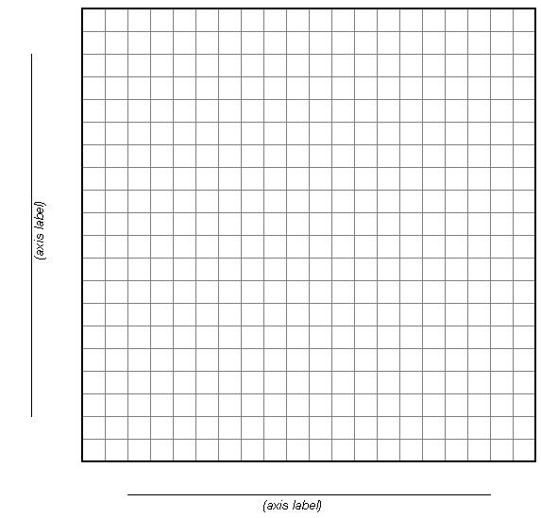
5. What was your best design (#1 or #2)?

DESIGN COST = $

ΔT (TEMPERATURE LOSS) = ºF after 10 minutes

$/ΔT =

Be ready to present your design to the class.

