Paper Towels, Pool Balls Challenge
Engineering Design Process Notebook
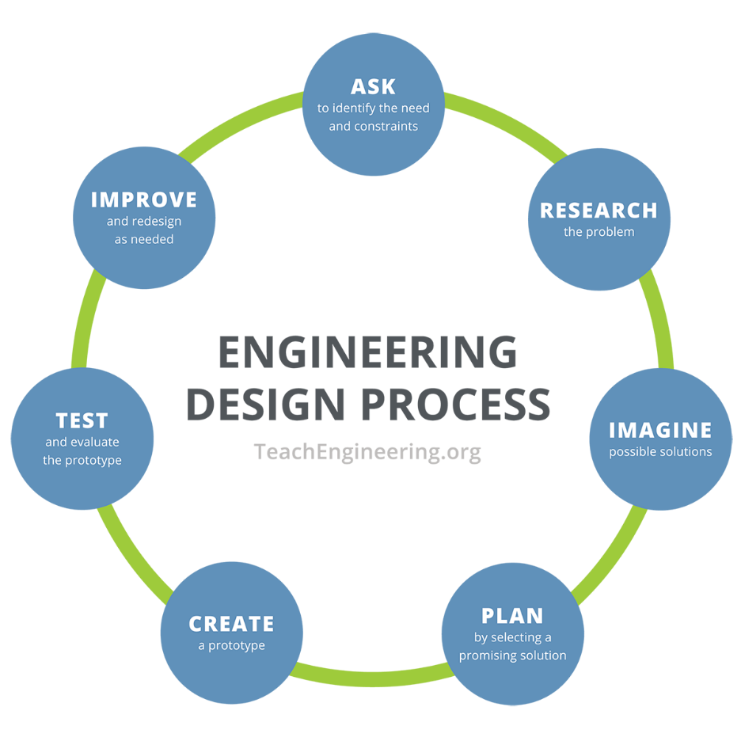
- Identify the problem

- List the problem constraints

- Brainstorm/create possible solutions as a group. List ALL ideas in the group and include sketches. Attach additional paper if necessary.

- Plan a solution. Based on the brainstormed ideas, choose one solution as a group. Describe the chosen solution and list as many details as possible.

- Collaboration. Write down any ideas you gained from conversing with the other groups.

- Update your brainstormed solution. Describe what changes you made.

- Create your planned solution. Keep track of what is working, what is not working, and any design changes that needed to be made.
- Evaluate your prototype. What worked? What didn’t work?

- Improve the design as needed. Discuss as a group what you would change if you had the time to redesign.

