Catching the Perfect SAR Waves: Radar System Evaluation
ANSWER KEY
Instructions: Using your “Radar” System find the missing distance. Verify the distance using the Pythagorean Theorem. Provide both answers then calculate the percent error.
Formulas: ${Pythagorean Theorem: a}^{2}+b^{2}=c^{2}$
$$Percent Error=\left(\frac{Theoretical Value-Experimental Value}{Theoretical Value}\right)× 100$$
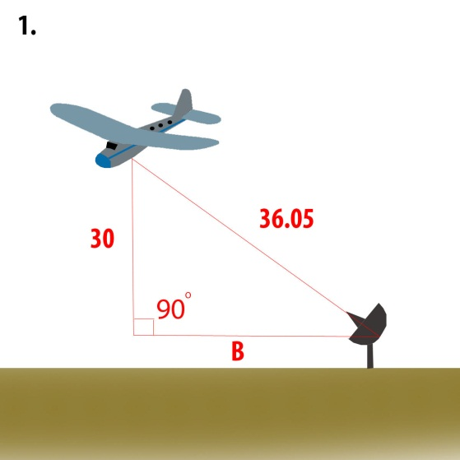  Theoretical B = 20 cm | 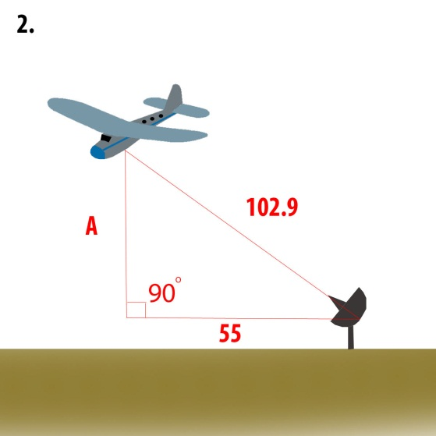  Theoretical B = 87 cm | 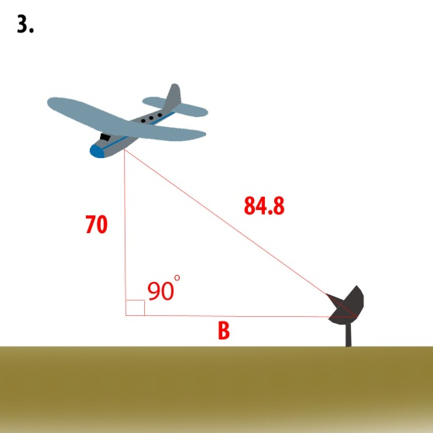  Theoretical B = 48 cm
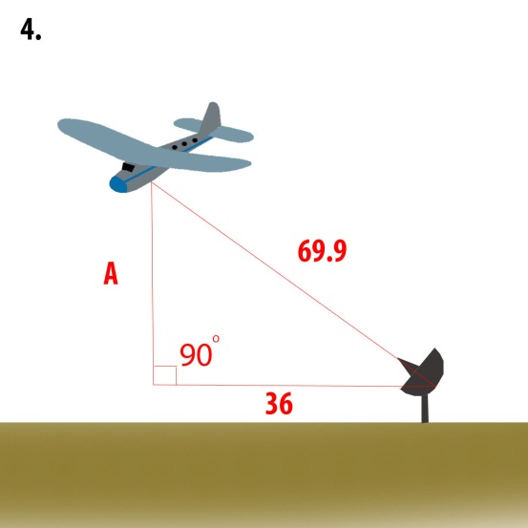  Theoretical B = 60 cm | 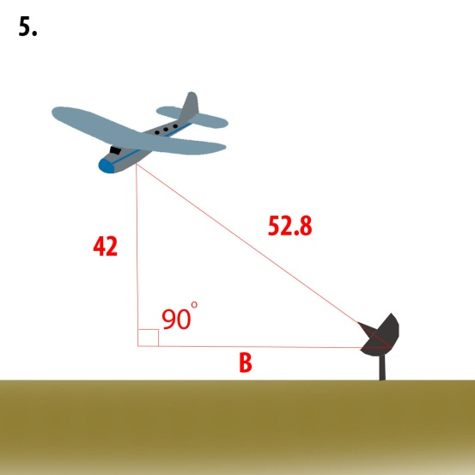  Theoretical B = 32 cm | 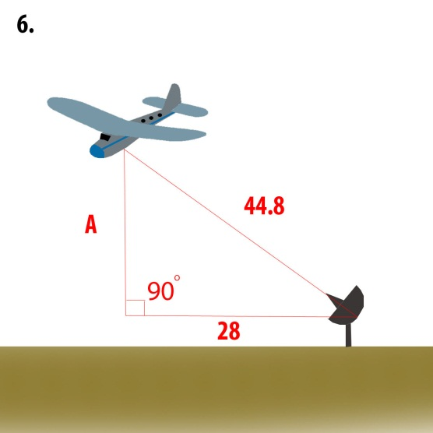  Theoretical B = 35 cm

Note: Experimental Values will vary slightly based on sensor calibration.

