Catching the Perfect SAR Waves: Radar System Evaluation

Instructions: Using your “Radar” System find the missing distance. Verify the distance using the Pythagorean Theorem. Provide both answers then calculate the percent error.

Formulas: ${Pythagorean Theorem: a}^{2}+b^{2}=c^{2}$

$$Percent Error=\left(\frac{Theoretical Value-Experimental Value}{Theoretical Value}\right)× 100$$
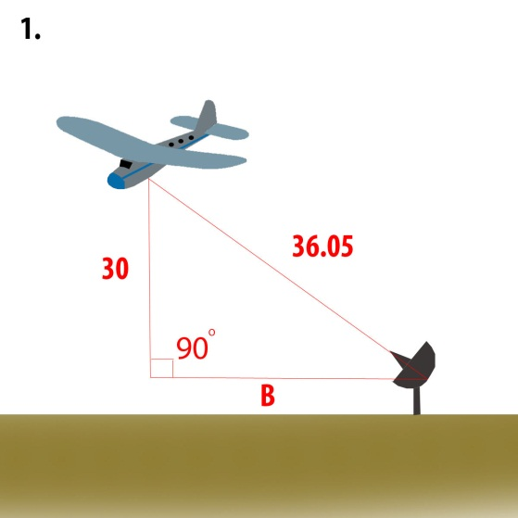 | 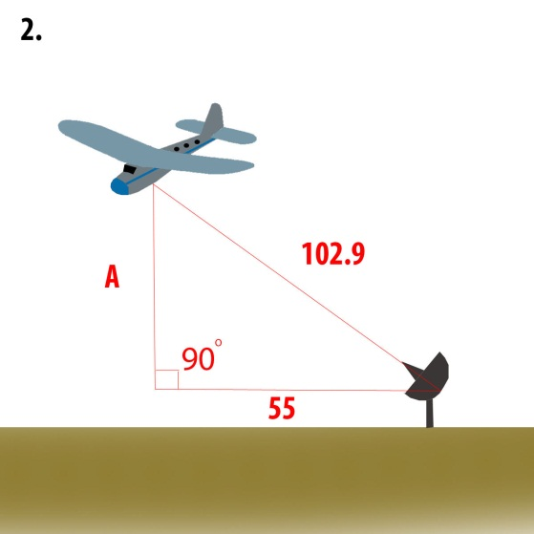 | 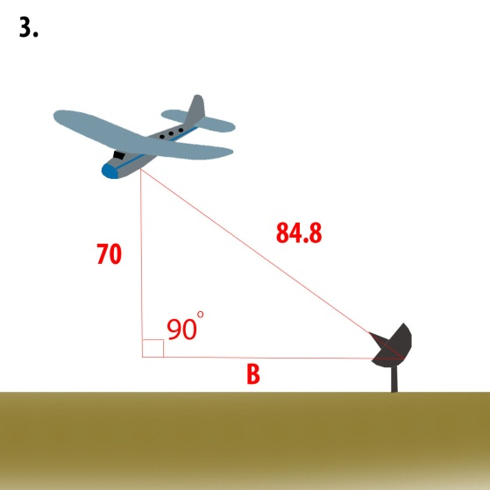
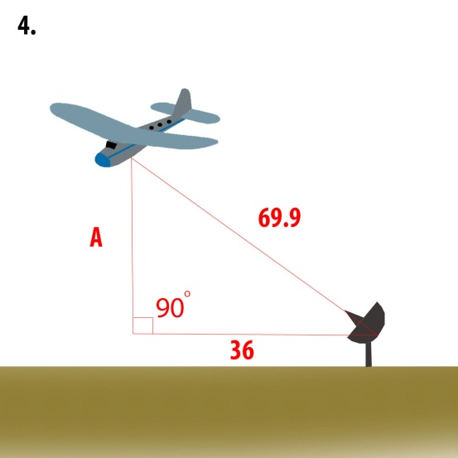 | 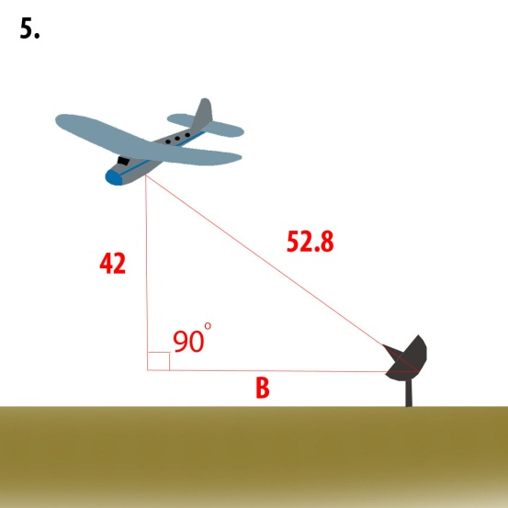 | 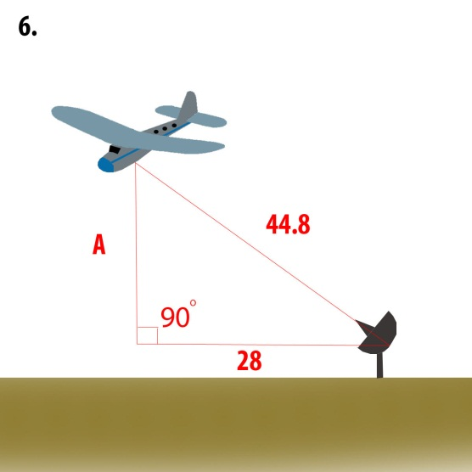

Note: Experimental Values will vary slightly based on sensor calibration.

