Building an Electric Circuit to Convert the Sensor Resistance into a Usable Voltage EVALUATION SHEET
Instructions: Use the voltage data collected from using the RGX-Glove X2 Circuit to produce a new table, graph and best fit line. Use a graphing calculator to produce a linear regression and write a linear equation.
Steps for calculating best fit lines using a TI-8X graphing calculator:
- Press STAT and select EDIT.
- Enter data into L1 and L2 using arrows.
- Press STAT again and choose CALC.
- Choose LinReg(ax+b) and press ENTER twice.

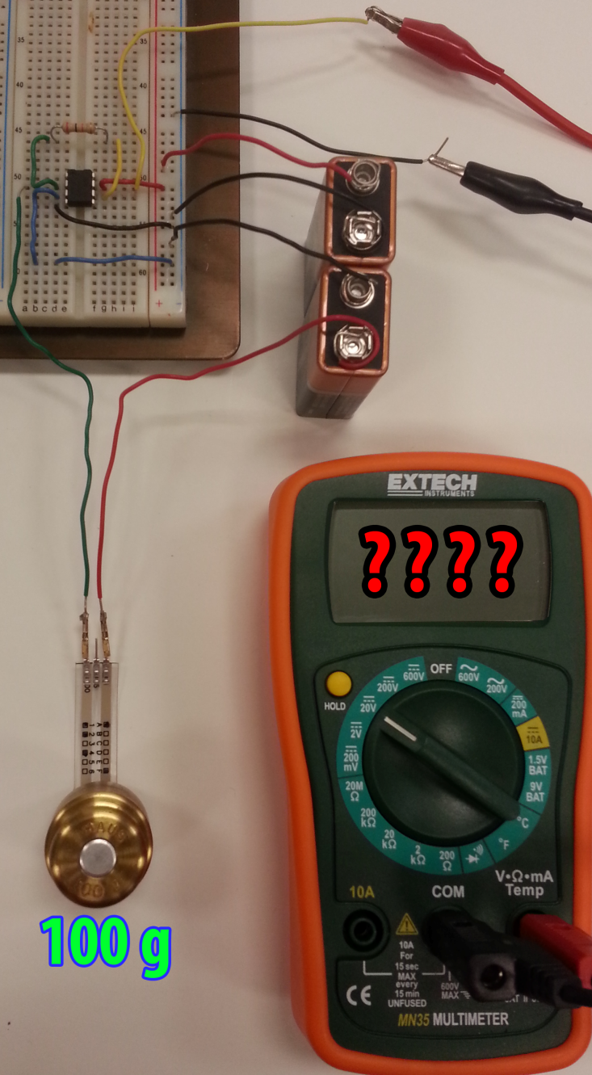
Calibration using Weights

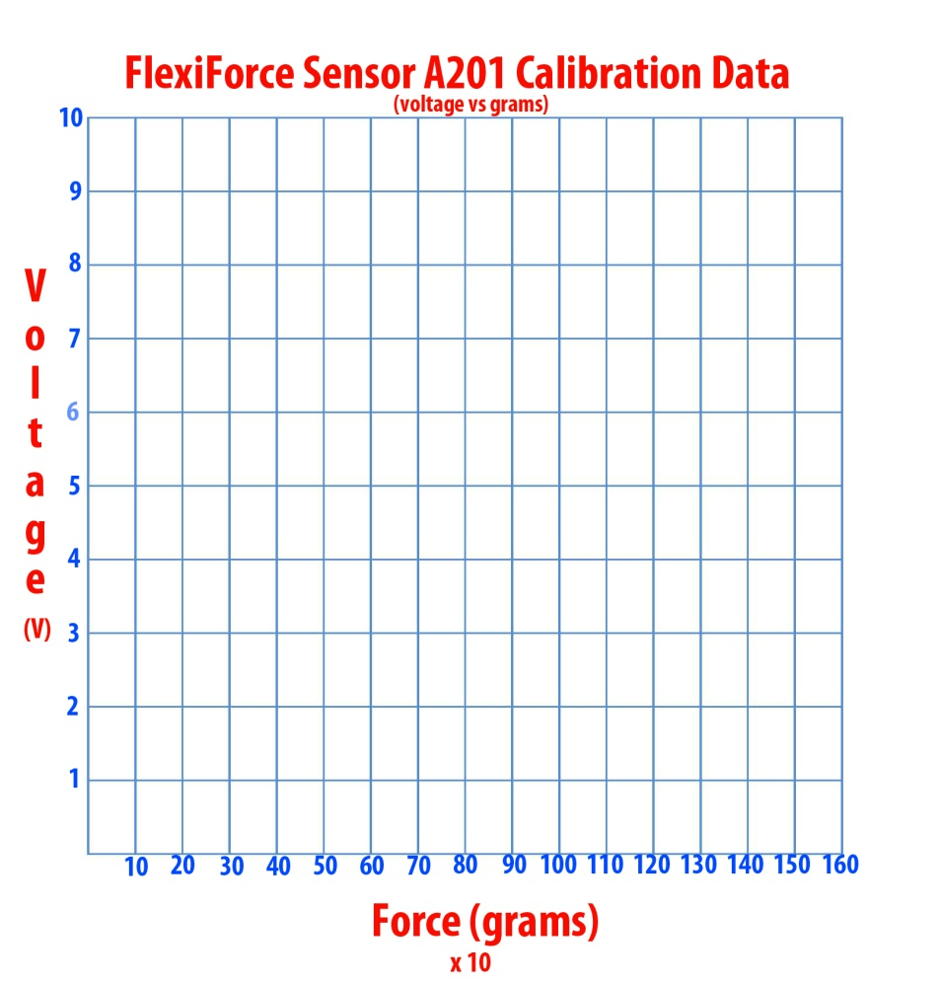

Force  (grams) | Voltage  (V)
 | 2.09
 | 2.45
 | 2.57
 | 2.79
 | 2.85
 | 3.00
 | 3.07
 | 3.11
 | 3.31
 | 3.91
 | 4.32
 | 4.33
 | 4.71
 | 5.55
 | 5.86

Instructions: Now that you know the best fit line, use it to calculate the minimum force required to crack an egg. The goal is to progressively add pressure to the egg, record the voltage and then calculate the pressure using the line of best fit.

Force Required to Crack an Egg
Voltage | Solve for Force | Force Applied | Cracked (Y/N)

