Calibrating the Force Sensor: Determining Relationships between Applied Force and Sensor Voltage
INSTRUCTIONS

Use this instruction manual to help you connect the electric circuit to the multimeter. Place a wooden puck and weights on top of the sensor to obtain sensor readings. The goal is to determine the relationships between applied force and sensor voltage output. Make sure you have these items:
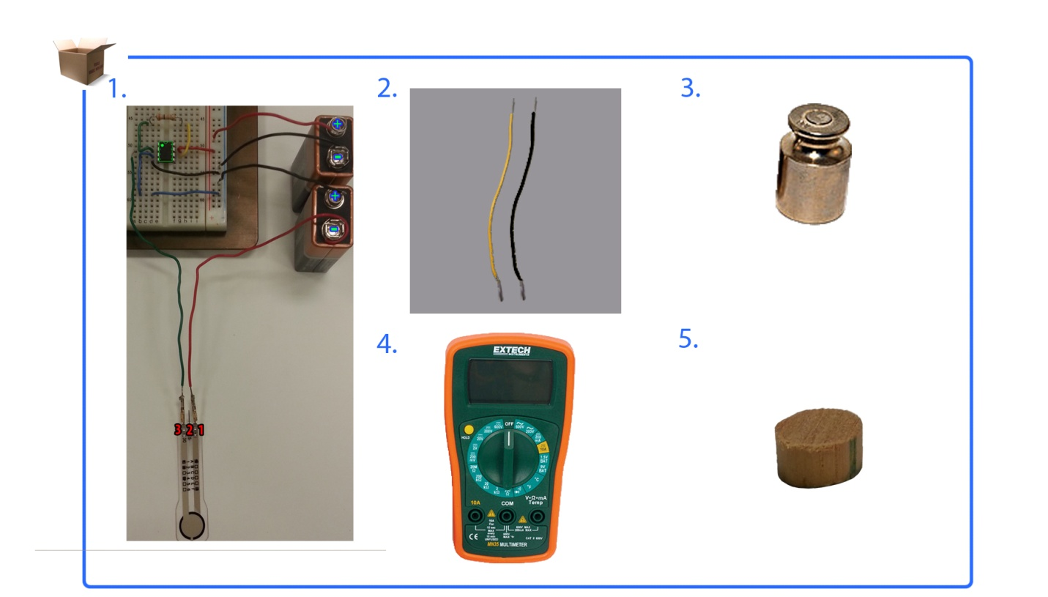
wood puck
multimeter
weight set
Two 6-in wires
(22 gauge)
RGX2 circuit

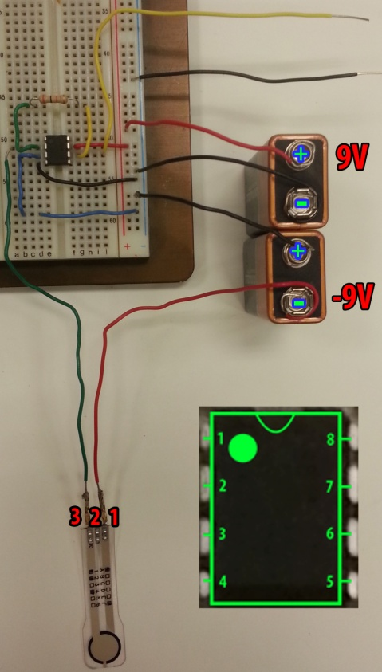
Figure 1

NOTE: Record all calibration data on the Building an Electric Circuit Evaluation Sheet

- Read Op Amp Output
  - Connect a wire in the same row as pin 7 from the op amp.
  - Connect a wire on the breadboard negative vertical row (ground).

- Multimeter Connection
  - Connect the op amp output to resistance (red) on multimeter.
  - Connect breadboard negative vertical row (ground) multimeter ground (black).
  - Set the multimeter to 20V.
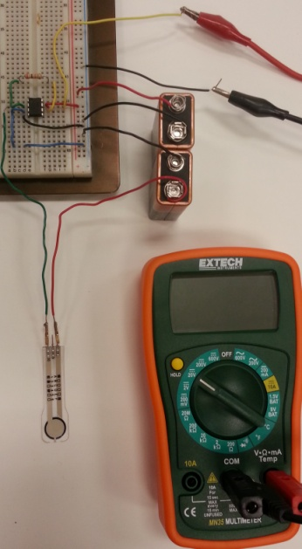
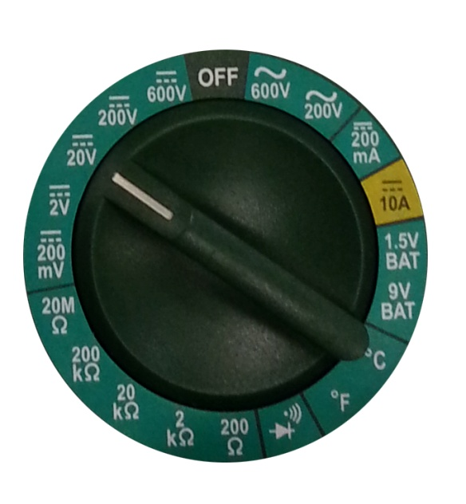

Figure 2B
Figure 2A

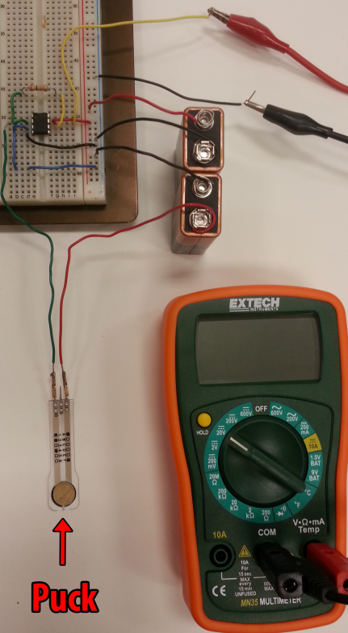
- Puck
Place a puck on the center of your sensor.
- A puck is an object that has the same diameter as the sensing area.
- A puck is used when the force area being applied is greater than the sensing area.
Figure 3

- Weights
  - Place a weight on the center of the sensor. NOTE: Make sure the weight is within your sensor’s weight maximum.
  - Record the force and resistance values on the Building an Electric Circuit Evaluation Sheet
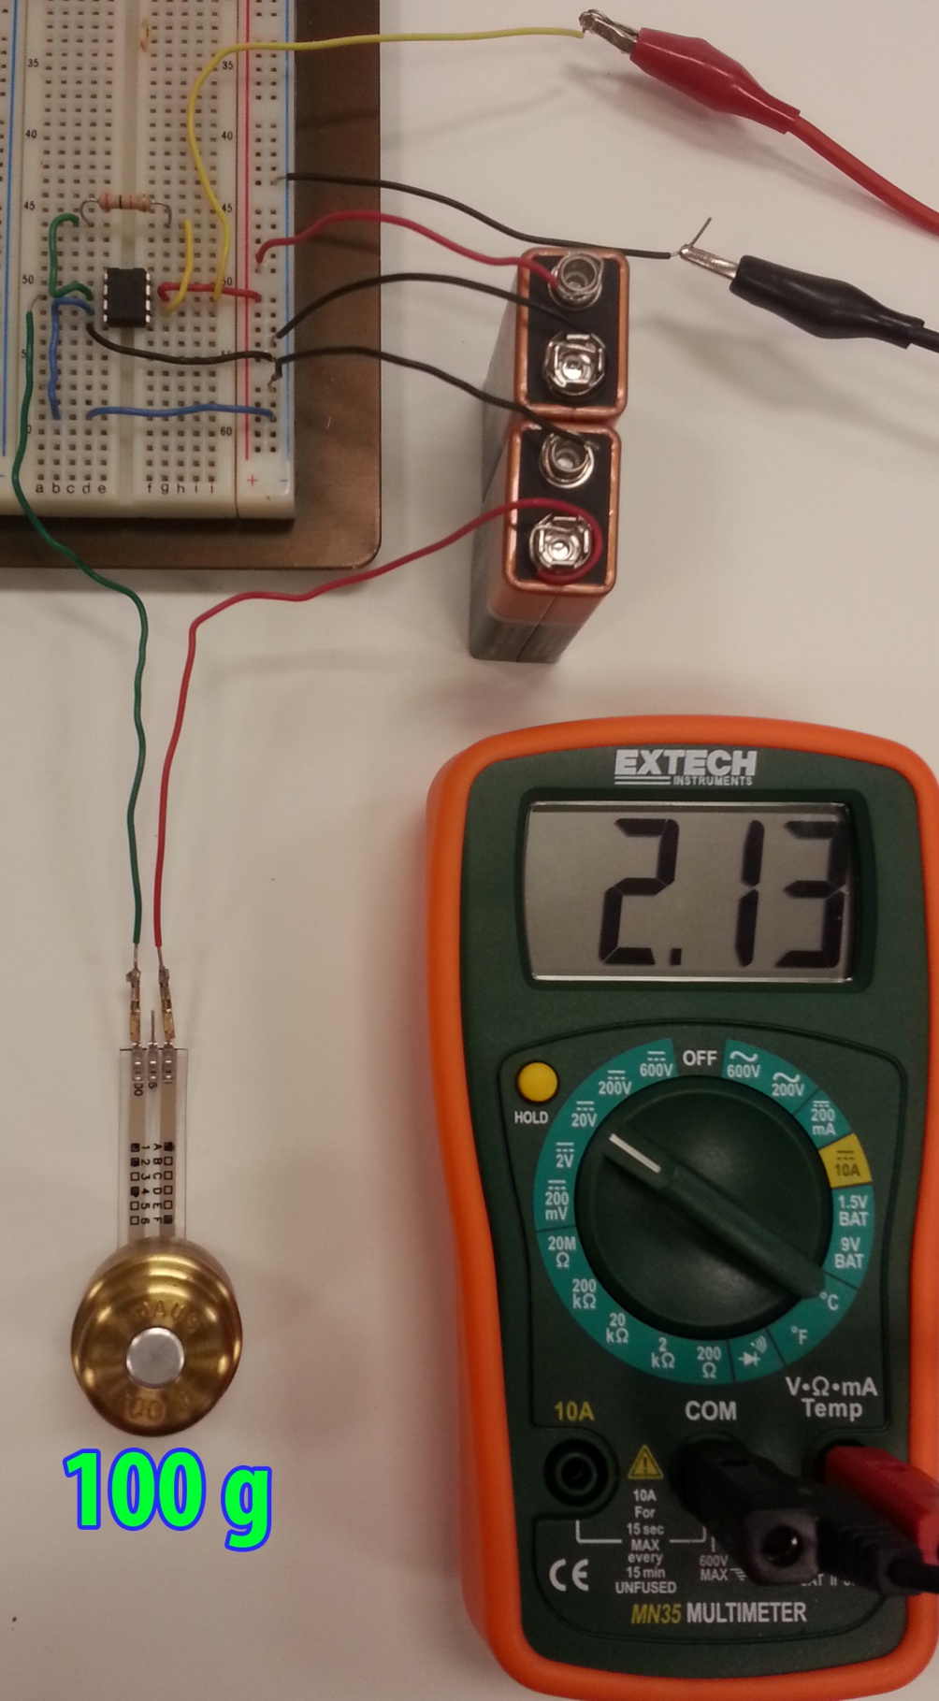
  - Repeat with different weight values.
Figure 4A
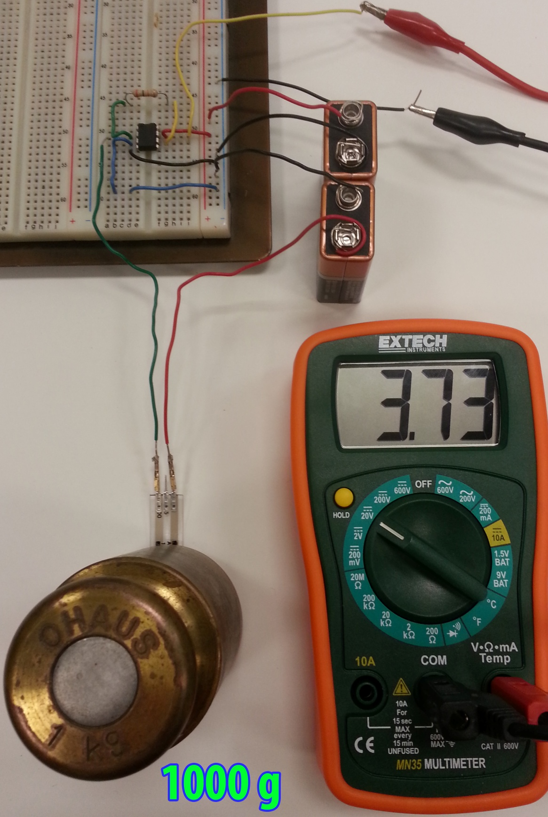
Figure 4B

