Calibrating the Force Sensor: Determining Relationships between Applied Force and Sensor Resistance/Conductance INSTRUCTIONS

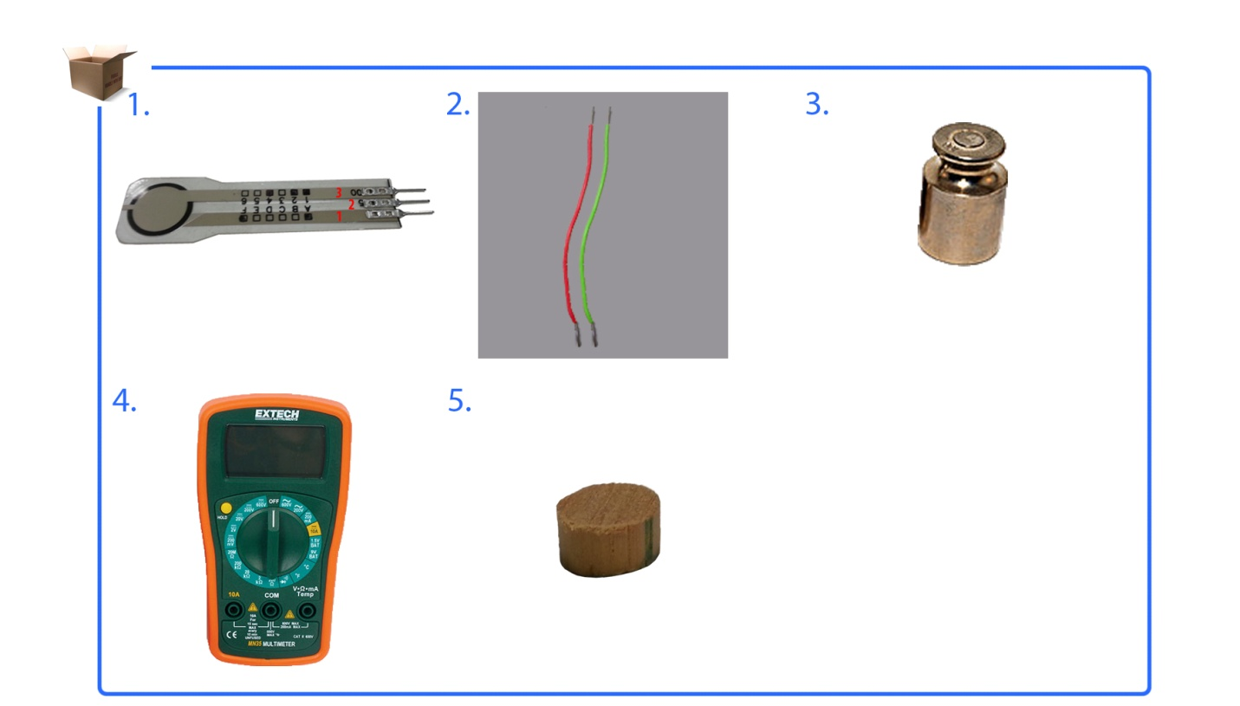
Use this instruction manual to help you connect the force sensor to the multimeter. Place a wooden puck and weights on top of the sensor to obtain a sensor reading. The goal is to determine the relationships between the applied force and sensor output. Make sure you have the following items:
FlexiForce sensor
two 6-inch wires (22 gauge)
weight set
wood puck
multimeter

NOTE: Record all calibration data on the Calibrating the Force Sensor Data Collection Sheet.

Instructions
- FlexiForce Sensor Pins
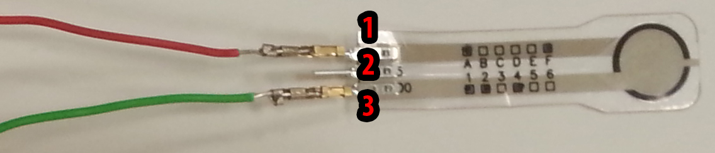
Figure 1

  - The middle pin is non-active.
  - Connect wires at FlexiForce sensor pin 1 and pin 3.
Make sure that pin 1 DOES NOT TOUCH pin 3.
  - To do this, use tape, solder or a pin connector.

- Breadboard Connection
  - Connect sensor pin 3 to ground (black) on the multimeter.
  - Connect sensor pin 1 to resistance (red) on the multimeter.
  - Set your multimeter to 20M ohms.
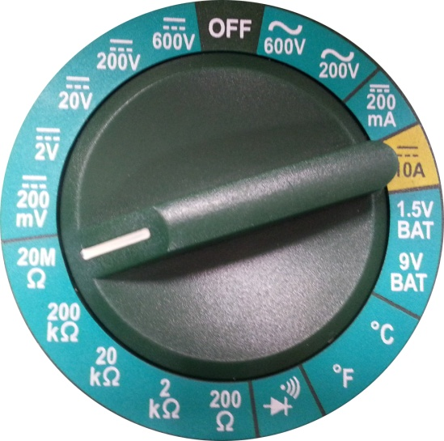
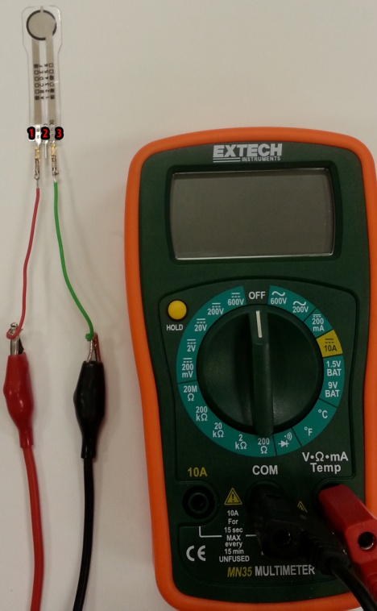
Figure 2A-B

Figure 2C

- Puck
Place a wooden puck on the center of your sensor.
- A puck is an object that has the same diameter as your sensing area.
- A puck is used when the force area being applied is greater than your sensing area.
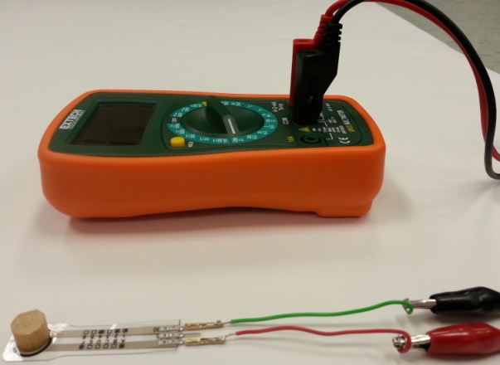
Figure 3

- Weights
Place a weight on the center of your sensor. Make sure the weight is within your sensor weight max.
  - Record the force and resistance values on the Calibrating the Force Sensor Data Collection Sheet.
  - Repeat with different weight values.

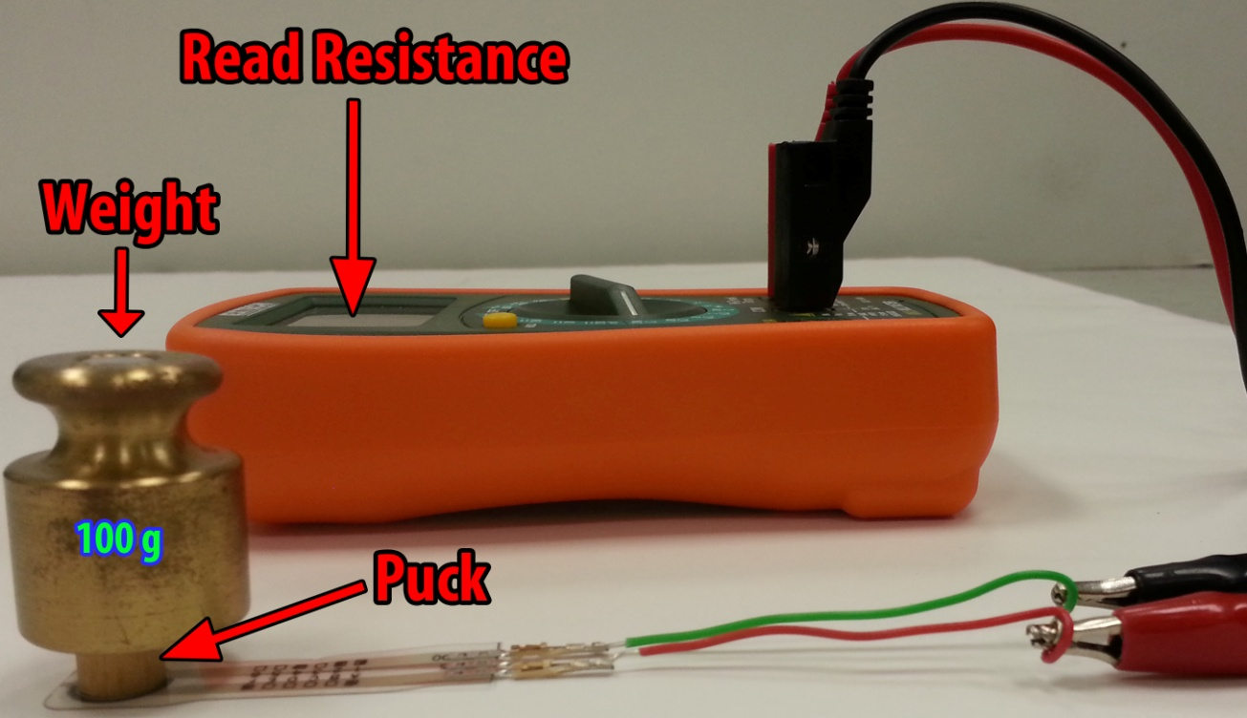
Figure 4A

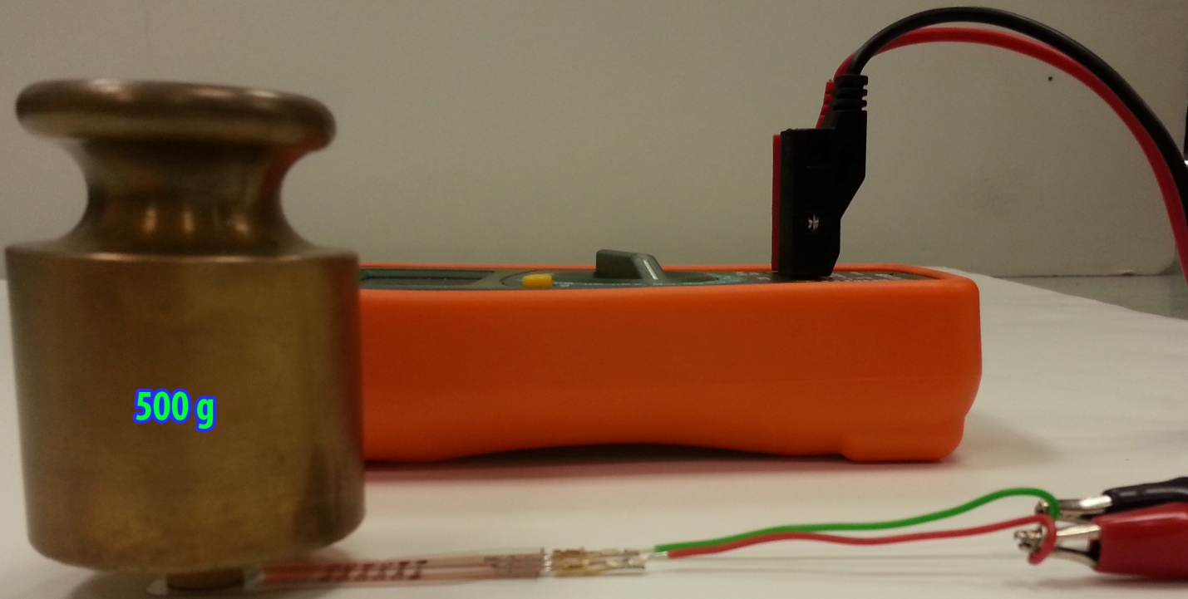
Figure 4B-1

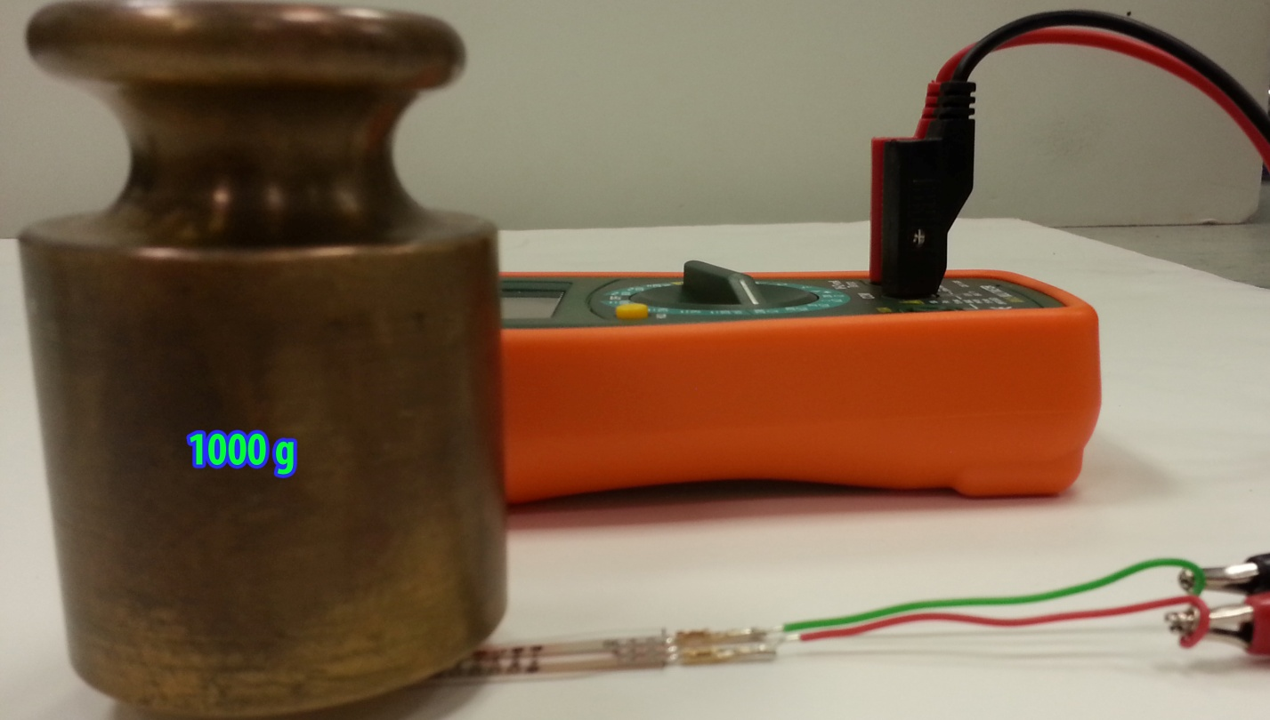
Figure 4B-2

