Let’s Get Breezy
Measuring Sand and Water Temperature Lab Template Answer Key
- Question (What do you want to discover in this experiment?)
Which material heats up faster? Sand or water?
- Purpose (What you intend to accomplish by the end of this experiment.)
We are doing this experiment to learn how land and sea breezes are created.
- Hypothesis (A statement expressing your expectations of this experiment. Write the statement as an answer to the question statement.)
We expect that sand will heat up faster.
Safety Precautions
Stay away from the hot lamp.

- Materials (List all the lab equipment and other materials needed to perform the experiment.)
Materials/Equipment
2 wireless temperature probes
lamp
water
sand
pan
- Variables
Control/Constant (the same) | Independent (different) | Dependent (results)
light (heat source)  pan | different probe | temperature

- Procedure
- Use paper, pen and tape to label your probes to distinguish them from the other probes.
- Complete the first page of the lab template, including sections A-E, safety precautions and materials list.
- Place your first probe in the pan of sand. Position the probe so it is submerged into the sand and its wire end is secured to one side of the pan with the probe tip extending to the center of the pan without touching the other probes. Make sure the probe is turned on.
- As soon as the lamp over the sand is turned on, record the temperature change observed in one-minute intervals for 10 minutes. Since all of the probes are within range, expect to see a variance in temperature readings. Always take the highest number when recording the temperature every minute. For example, if the temperature reading fluctuates as follows: 30, 32 and 31, then record the highest number, 32, as the current temperature. Record your data in your section G data chart titled “With lamp (sand probe).”
- After 10 minutes, turn off the lamp and remove it from over the pan of sand and record the temperature change of the sand every minute for another 10 minutes. If the lamp is not completely removed then the residual heat from the light bulb continues to heat the sand although the light is turned off. Remember to always take the highest temperature reading, as explained earlier. Record your data in the section G data chart titled “Without lamp (sand probe).”
- Place your second probe in the pan of water. Position the probe so it is submerged into the water and its wire end is secured to one side of the pan with the probe tip extending to the center of the pan. Make sure the probe is turned on.
- As soon as the lamp over the water pan is turned on, record the temperature change observed in one-minute intervals for 10 minutes. Note that you do not have to be too close to the water in order to take the data readings. Remember to always take the highest temperature reading, as explained earlier. Record your data in your section G data chart titled “With lamp (water probe).”
- After 10 minutes, turn off the lamp and remove it from over the pan of water and record the temperature change of the water every minute for another 10 minutes. Remember to always take the highest temperature reading, as explained earlier. Record your data in the section G data chart titled “Without lamp (water probe).”
- Use graph paper provided by the teacher to create a multi-line graph to display your data. Use the variables from section E of the lab template to label the x- and y-axes. Identify which line belongs to which data set.
See example graph on last page.
- Complete the questions in section H: Conclusion.

- Data/Results/Calculations (Include all measurements, graphs, & observations collected during the experiment. Does the data support/defend the hypothesis?)
 | Temperature (°C)  with lamp (sand probe) | Temperature (°C)  with lamp (water probe)
1 min | 26 | 21
2 | 27 | 21
3 | 28 | 22
4 | 29 | 24
5 | 30 | 24
6 | 31 | 24
7 | 32 | 24
8 | 32 | 24
9 | 36 | 24
10 | 45 | 26
 | Temperature (°C)  without lamp (sand probe) | Temperature (°C)  without lamp (water probe)
11 | 44 | 26
12 | 43 | 26
13 | 42 | 26
14 | 41 | 26
15 | 40 | 25
16 | 39 | 25
17 | 38 | 24
18 | 38 | 24
19 | 37 | 24
20 | 37 | 24
- Conclusion (Respond to the following post-lab assessment questions in your journal.)
- Which substance heated up faster? Sand heated up faster than water.
- Which substance cooled off faster? Sand cooled off faster than water.
- If both substances received the same amount of heat energy, why were there differences in their heating rates? Water needs to absorb a lot of energy before its temperature changes. Sand does not need as much energy for its temperature to change.
- Why are there differences between the cooling rates of sand and water? Sand cools off faster than water because sand is a solid.
- Share your group’s results to questions 1-4 with the class. You may now want to revise your ideas/answers, based on the discussion. Water heats up slower and cools off slower than sand. Sand heats up faster and cools off faster than water.
- Beneath your answers and data, explain any revisions you want to make to your original thinking. Answers will vary. Students may or may not have any revisions to make.
- Based on what you learned from this experiment, explain how it can help you in the “real world.” Accept all logical responses.
- If you would like to learn more about this topic explain why? Accept all logical responses.
- If you have a question about this topic please state it below. Accept all logical responses.
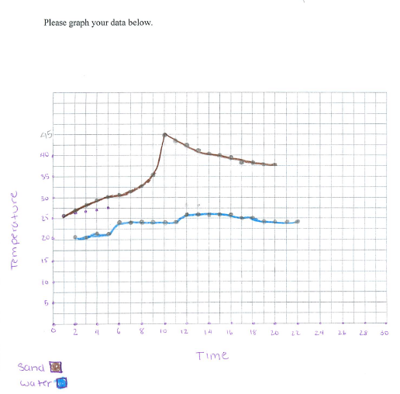
Example graph:

