GRADING CONGESTION WORKSHEET

Part 1 – Data Collection

- Form your track using the ropes, cones, or other materials so 2 to 3 individuals can walk beside one another.

- Measure the length of your track from the middle of the lane

Length = ___________

- Have a person walk leisurely through the track and time how long it takes him/her to complete 8 laps.

Time = __________________

- Have the same person walk leisurely through the track again, but with an additional 7 people on the track walking in the same direction. Now time how long it takes him/her to complete 8 laps.

Time = ___________________

Part 2 – Calculations based on 1 person on the track.

- Calculate the individual’s speed in feet per second and mph.

Distance Traveled = (# laps)*(Length)

Length = _____________ (From step 2)
# of Laps = 8 laps

Distance Traveled = ___________________

Time = _______________ (From step 3)

Speed = Distance / Time

Speed = _______________________

Convert to mph:

Speed = _______________________

- Calculate how fast that would be if you were a car.

Speed = ___________________________

- Calculate density of the roadway assuming only 1 lane.

# of Persons on the Track = _______________

Density = (# of Persons) / [(Distance)*(# of lanes)]

Density = __________________________________

- Let us see the density if you were a car.

Density = __________________________________

- Use the density from step 8 and the Table 1 to find level of service (LOS).

Table 1: LOS Density Levels

Finding LOS
LOS | Max Density | Range
A | 11 | 0 - 11
B | 18 | 11 - 18
C | 26 | 18 -26
D | 35 | 26 -35
E | 45 | 35 -45
F | >45 | >45
Density = _______________

Which range does the density
fall within? ______________

LOS = _____________

- Let us try finding LOS through flow and speed.

Flow = Density*Speed

Density = ________________ (Find from step 8)
Speed = _________________ (Find from step 6)

Flow = _________________________

- Using the Figure 1, determine LOS .

Flow = ___________________ (Find from step 10)
Speed = __________________ (Find from step 6)

LOS = _______________

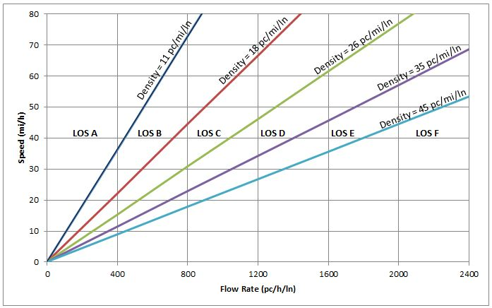
Figure 1: LOS for Freeway Segments

- Are the LOSs from steps 9 and 11 the same? _______________

LOS = __________ (From step 9)
LOS = __________ (From step 11)

Part 3 – Calculations based on 8 people on the track.

- Calculate the individual’s speed in feet per second and mph.

Distance Traveled = (# laps)*(Length)

Distance Traveled = _______________________________

Time = ____________ (From Step 4)

Speed = Distance / Time

Speed = _________________________________________

Convert to mph

Speed = _________________________________________

- Calculate how fast that would be if you were a car.

Speed = _________________________________________

- Calculate density of the roadway assuming only 1 lane.

# of Persons on the Track = ________________

Density = (# of Persons) / [(Distance)*(# of lanes)]

Density = _____________________________________

- Calculate density if you were a car.

Density = _____________________________________

- Use the density from step 16 and the Table 2 to find level of service (LOS).

Table 2: LOS Density Levels

Finding LOS
LOS | Max Density | Range
A | 11 | 0 - 11
B | 18 | 11 - 18
C | 26 | 18 -26
D | 35 | 26 -35
E | 45 | 35 -45
F | >45 | >45
Density = ______________

Which range does the density
fall within? ______________

LOS = _______________

- Let us try finding LOS through flow and speed.

Flow = Density*Speed

Density = ________________ (Find from step 16)
Speed = _________________ (Find from step 14)

Flow = ______________________________

- Using the Figure 2, determine LOS.

Flow = ___________________ (Find from step 18)
Speed = __________________ (Find from step 14)

LOS = ________________

Figure 2: LOS for Freeway Segments

- Are the LOSs from steps 17 and 19 the same? ___________

LOS = __________ (From step 17)
LOS = __________ (From step 19)

- Are the LOSs from Part 2 and Part 3 Different? _____________

LOS = __________ (From part 2)
LOS = __________ (From part 3)

- If they are different, why? Incorporate discussion on times, speeds, and densities.

- What have you learned from this activity and how can it be useful?

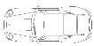

- Draw a picture of your congested roadway (track and students on the track).

- Engineering Design Problem: Currently there is a 2 mile segment of a 6 lane divided highway (3 lanes in each direction) where the posted speed limit is 55 mph. Local residents are complaining about a proposed new residential development off the highway will increase congestion. They have asked you, the county engineer, to stop the project by analyzing the situation and recommend the development not to be constructed. You have performed a site visit and recorded the number of vehicles in the busiest direction during a 60 minute period, 66 vehicles, and you noted the vehicles were traveling at the speed limit, 55 mph. Through analysis, the combined existing and new traffic levels will produce a flow of 800 pc/h/ln with an average speed of 50 mph. Use the knowledge you obtained through this activity and lesson to solve the problem. (Hint: Determine the current LOS and how it will change with the new development.)

Finding LOS
LOS | Max Density | Range
A | 11 | 0 - 11
B | 18 | 11 - 18
C | 26 | 18 -26
D | 35 | 26 -35
E | 45 | 35 -45
F | >45 | >45

Existing Conditions:
$$Speed=$$
$$Density=\frac{\# of vehicles}{\left(lane\right)(mile)}=$$
$LOS=$

Finding LOS
LOS | Max Density | Range
A | 11 | 0 - 11
B | 18 | 11 - 18
C | 26 | 18 -26
D | 35 | 26 -35
E | 45 | 35 -45
F | >45 | >45

Proposed Conditions:
$$Speed=$$
$$Flow=$$
$$Density=\frac{Flow}{Speed}=$$
$LOS=$

From your calculations, the current level of service of the roadway is ___________ .
The proposed development would drop that to a _____________ .
Would you recommend allowing the development to proceed? Why or why not?

