Electromagnetic Exploration Chart

Device | Frequency rank (lowest to highest) | From your research, how might this device use electromagnetic radiation? (1-2 sentences)
Tanning Bed

Laser Pointer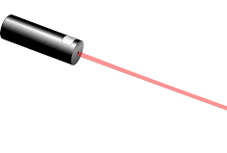
Cellphone
Remote Control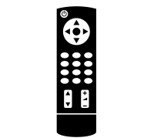
Radio

X-ray machine

After conducting your research, write 2-4 interesting facts that you learned. Make sure to write in complete sentences.

