**Suggested Poster Design Layout**

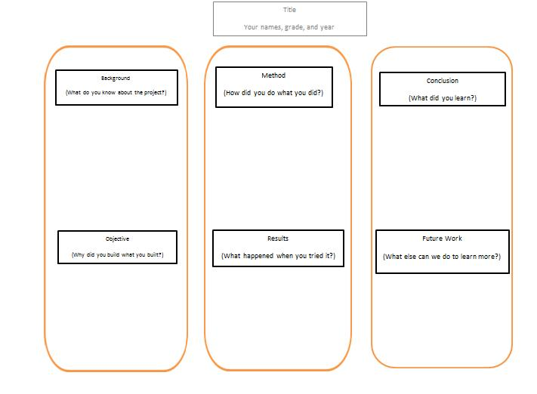

**Title**

Group member names, grade and year

**Background**

(What do you know about the project?)

**Method**

(How did you do   
what you did?)

**Conclusion**

(What did you learn?)

**Objective**

(Why did you build what you built?)

**Results**

(What happened when you tried it?)

**Future Work**

(What else can we do to learn more and make improvements?)