GeoGebra Measuring Interface Manual
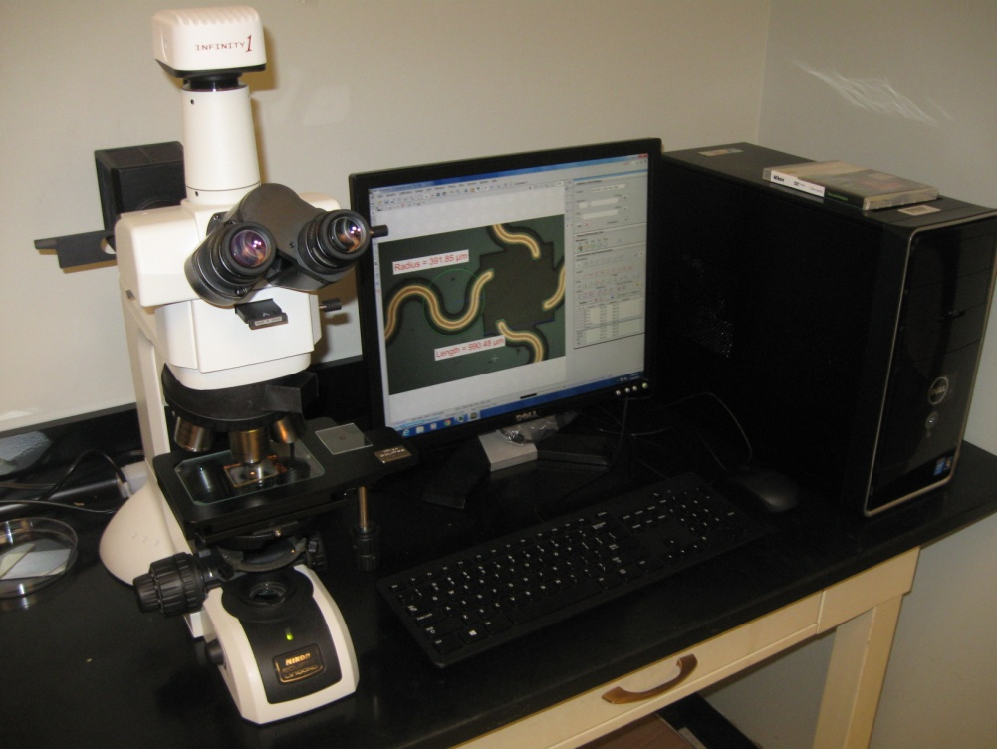

Background Information
This document contains basic instructions on how to efficiently use the GeoGebra Measuring Interface, which was created to simulate high-resolution microscope imaging software.
This interface enables you to perform measurements on nano-circuit pictures taken with an Eclipse LV100ND microscope with attached Lumenera Infinity1 video camera and personal computer with NIS-Elements 4.20 imaging software. The working scale factor in this interface is useful only for images coming from the described equipment.
This interface can be used to measure different objects, but the scale factor must be recalculated for the new situation.
The main advantage of this interface is that it avoids errors in measurement. When you zoom in or out on an image in the GeoGebra graphing window, the x and y scales also zoom in or out. To work with a new image and use the same scale factor as the previous image, the graphing window must be reset to the original size because GeoGebra inserts images in the same portion on the screen. Thus, inserting images without resetting the graphing window is equivalent to changing the scale factor for the new image.

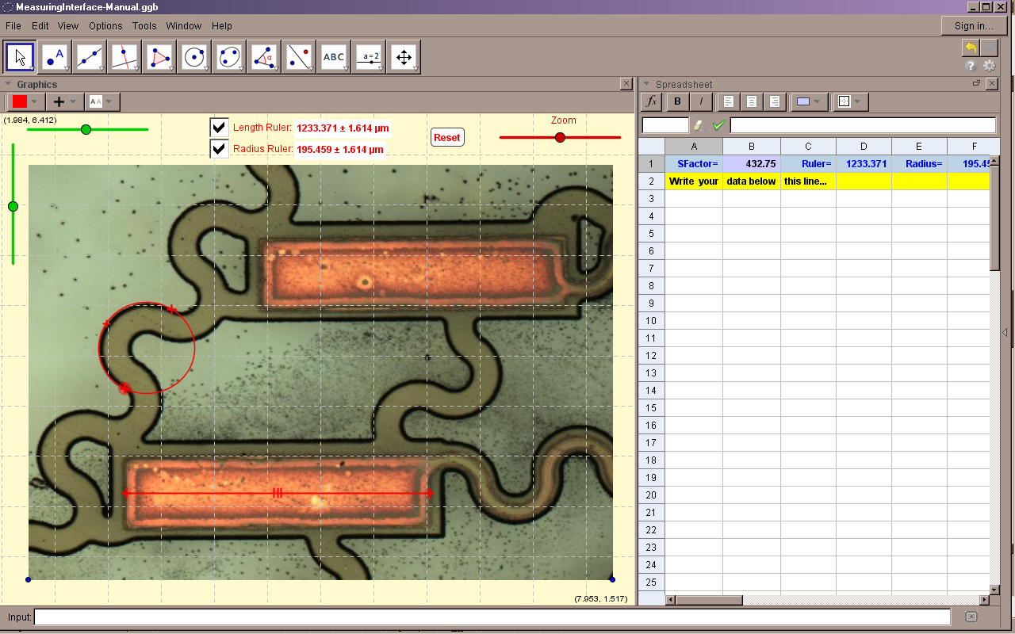

Figure 1. GeoGebra Measuring Interface main window.
By default, only the Graphing view and the Spreadsheet are displayed.
Inserting a Picture File
Use the sequence: Edit ► Insert Image from ► File
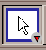
Once your picture is inserted in the Graphing view, it is not necessary to translate it to the origin, but it is extremely important to set the inserted image as the background using the following steps:
Left click on Toolbar Move ► Right click on picture ► ►
Then, fix the lower right vertex of the picture, using the next command sequence:
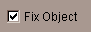
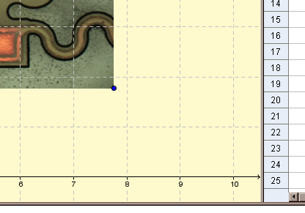
Right click on vertex.
► ►

It is very important to fix this vertex; deleting this point produces an enlargement of the image, and consequently, an error in the measurements.
Once you see the coordinate system gridlines on your picture, and the vertex is fixed, the image is ready to be measured.

Toolbar Notes
Although the Toolbar is fully active, it is not necessary to use any of these tools to measure objects on the picture. By default, this interface has two rulers that give the real dimensions of the circuits because they work with the appropriate scale factor.
Measuring Interface Tools

This slider controls the horizontal translation of the image. Left click on the green circle and drag left or right.
Left click on this box to display the length ruler.
This slider controls the zoom of the image. Left click on the green circle and drag left or right.

Left click on this box to display the radius ruler.

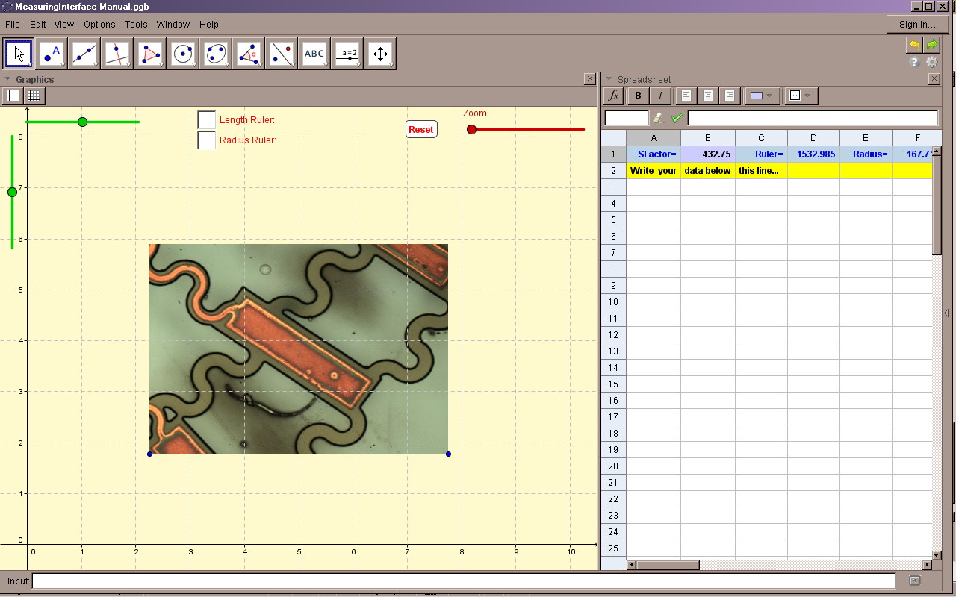

This button resets the graphing window to its original dimensions. Always reset the screen before you insert an image.

This slider controls the vertical translation of the image. Left click on the green circle and drag up or down.
Write in this spreadsheet the measurements performed. Later, the created data table can be exported or copied and pasted to Excel.

Spreadsheet
Graphing View

Figure 2. GeoGebra Measuring Interface objects.
About the Measuring Interface Rulers
The length and radius rulers are the only Measuring Interface objects that can be manipulated freely once displayed (see Figure 3). Thus, beware that these objects can be accidentally deleted.

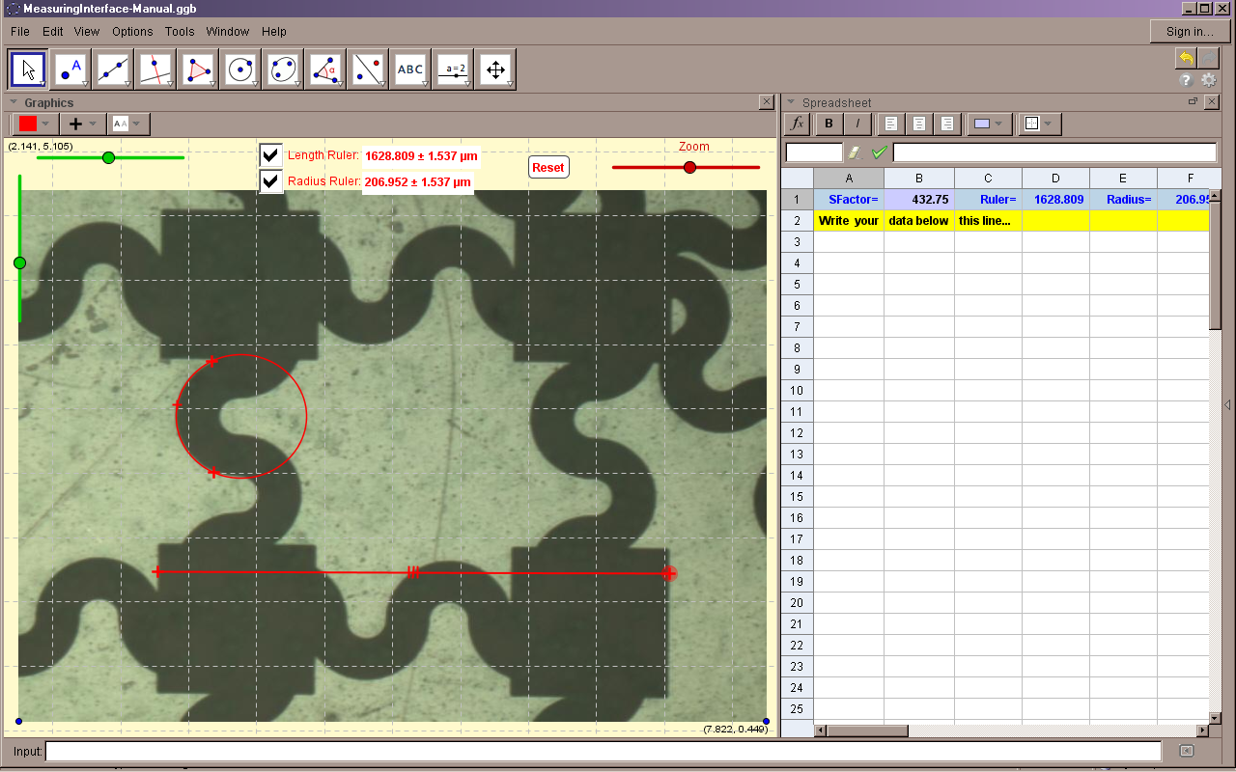

radius ruler

length ruler

Figure 3. GeoGebra Measuring Interface rulers.
In case of accidental deletion or loss of one of these rulers:
- Press the Reset button (perhaps it is only outside of the viewable window).
- Try: Edit ► undo (several times, as necessary)
- If unable to undo, close the program without saving the file.
Inserting a New Image
If a new image is inserted and set as the background (refer to Inserting a Picture File), the new image will overlap the previous one. If image overlapping is not desired, remove the existent background image by these steps:
- Place the cursor on Algebra window Point label, and click the right mouse button; on menu, select Object Properties.
- On the objects list window (at left), select the corresponding picture name under the label Image, and press the Delete key.
- At this same time, delete the two points associated with the deleted image, select them and press Delete again.
References
GeoGebra Manual: http://wiki.geogebra.org/en/Manual%3AMain_Page
GeoGebra channel at YouTube: https://www.youtube.com/user/GeoGebraChannel

