Pre-Activity Test Answer Key
- A food industry group asked 3,368 people to guess the number of calories in each of several common foods. The table below provides average of their guesses and the correct number of calories:
Food | Guessed Calories | Actual Calories
8 oz. whole milk | 196 | 159
5 oz. spaghetti with tomato sauce | 394 | 163
5 oz. macaroni with cheese | 350 | 269
1 slice wheat bread | 117 | 61
1 slice white bread | 136 | 76
2 oz. candy bar | 364 | 260
1 saltine cracker | 74 | 12
1 medium-size apple | 107 | 80
1 medium-size potato | 160 | 88
1 cream-filled snack cake | 419 | 160
- Make a clustered bar graph using the data in the table. Was the estimation over or under?
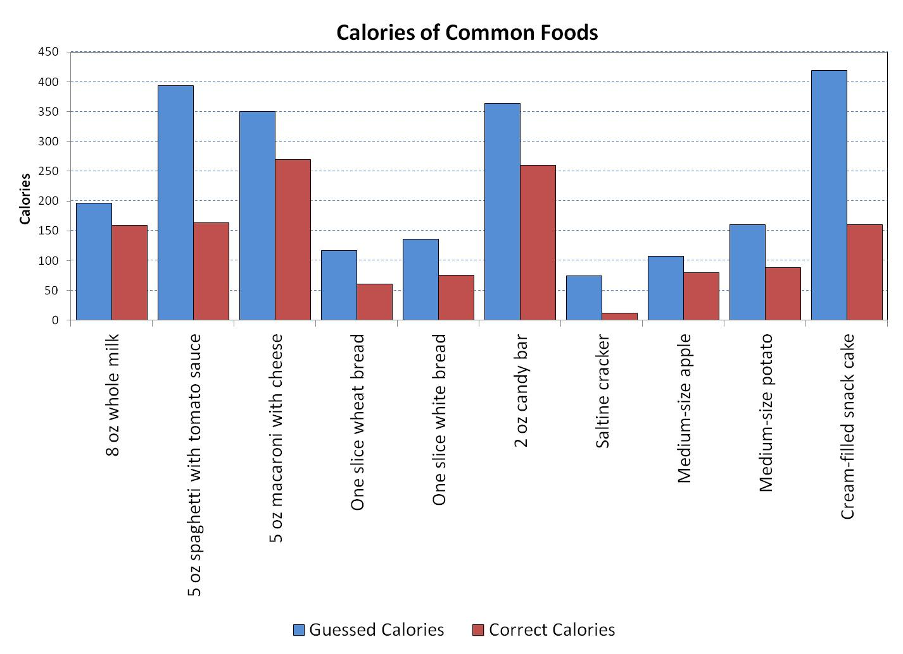

Answer: The guessed values by the surveyed people were all more than the real values, that is, they were overestimated.

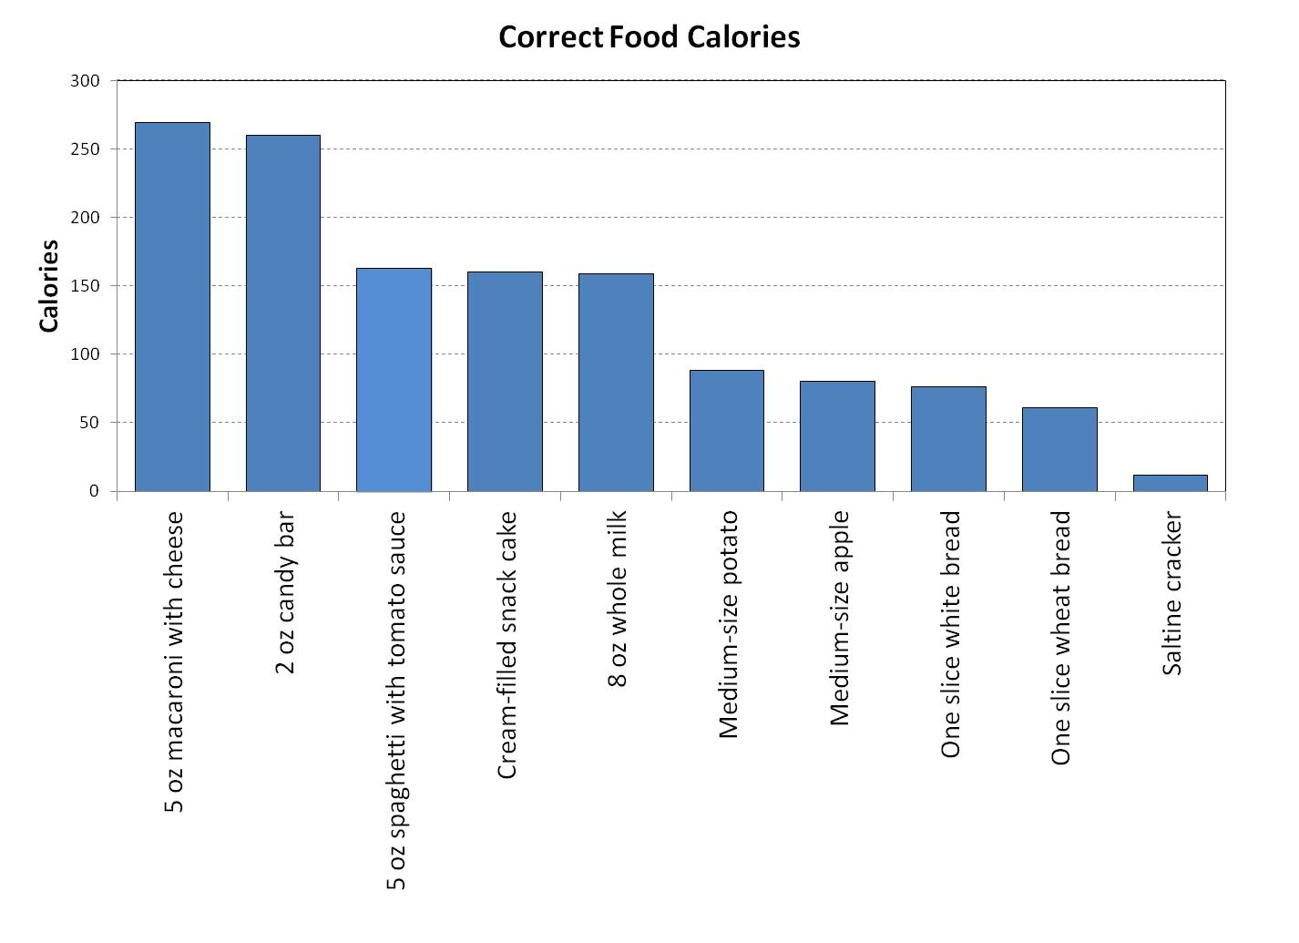
- Use a Pareto chart to determine the two foods with the highest calories content.

Answer: The two foods in the above table with the highest caloric content are the macaroni with cheese and the candy bar.
- Three groups of AP Statistics students were asked how many minutes they studied on typical weeknight. The responses of random samples of 30 female and 30 male students are in the table.
Girls |  |  |  |  | Boys
180 | 120 | 180 | 360 | 240 | 90 | 120 | 30 | 90 | 200
120 | 180 | 120 | 240 | 170 | 90 | 45 | 30 | 120 | 75
150 | 120 | 180 | 180 | 150 | 150 | 120 | 60 | 240 | 300
200 | 150 | 180 | 150 | 180 | 240 | 60 | 120 | 60 | 30
120 | 60 | 120 | 180 | 180 | 30 | 230 | 120 | 95 | 150
90 | 240 | 180 | 115 | 120 | 0 | 200 | 120 | 120 | 180
For each of the above data sets compute:
- The sample mean
- The standard deviation, and the coefficient of variation
- The five-number summary
- The 10% trimmed mean
Using modified box-and-whisker plots, compare the above data. Include the mean values on your graphs. Draw conclusions about the study habits of the AP Statistics students.

Statistics |  | Girls | Boys | Differences
Sample mean: |  | 165.167 | 117.167 | 48
Sample std. dev: | S_{x} = | 56.515 | 74.240 | -17.7247
C. variation (%): | C_{v} = | 34.217 | 63.362 | -29.1455
Minimum | Min = | 60 | 0 | 60
First quartile: | Q₁ = | 120 | 60 | 60
Median: | Q₂ = | 175 | 120 | 55
Third quartile: | Q₃ = | 180 | 150 | 30
Maximum | Max = | 360 | 300 | 60
10% trim mean: |  | 160.417 | 111.458 | 48.95833
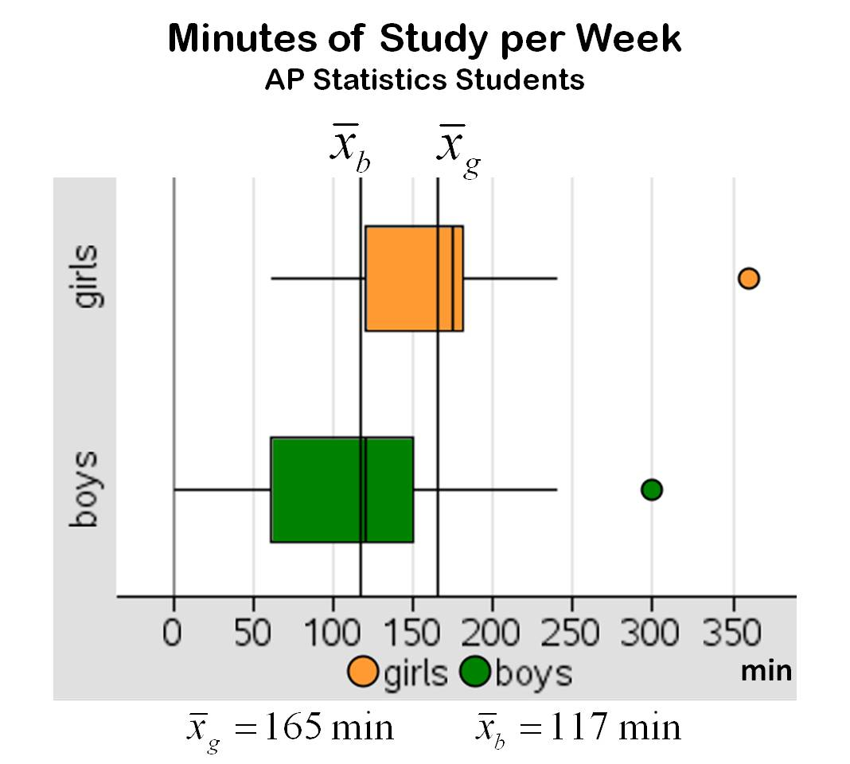

Answer: Comparing the sample means, girls study 48 more minutes per week than boys; excluding the outliers, the trimmed mean difference is about the same, 49 minutes. But comparing the medians, girls study 55 more minutes per week than boys. From the graph it can be seen that 75% of the girls are above the boys’ median study time: 120 minutes, and about 25% of boys are below the girls’ minimum study time: 60 minutes. About the variability of the study times, both the standard deviation and the coefficient of variation indicate that the girls’ study times are more consistent with the mean, having (according to Chebyshev’s theorem) about 75% of the girls study between 52 and 278 minutes (4 hours 40 min) per week, meanwhile about 75% of the boys study between 0 and 265 minutes (4 hours 24 min) per week. In conclusion, girls study AP Statistics more times per-week than boys.

