**Experimental Data Sets**

**Patched vs. Cracked Unpatched Fatigue Mean Life Data Sets**

The following pages provide the experimental data from seven different research centers. See the project guidelines for details about the statistical analysis you will need to perform on the data sets.

All the specimens tested in the various research centers were one-quarter inch cold-rolled A36 steel bars.Holes were drilled and/or notches were cut to induce cracks or fractures; about half of them were patched on the induced fractures using CFRP bonded with epoxy.

All the specimens, patched and unpatched, were tested in hydraulic test systems (Figure 1) that were programmed to apply a constant force or stress periodically. A connected computer system records the testing process and the number of cycles at which the specimen breaks. This number is taken as the fatigue life of the specimen. Following are the data sets to be analyzed.

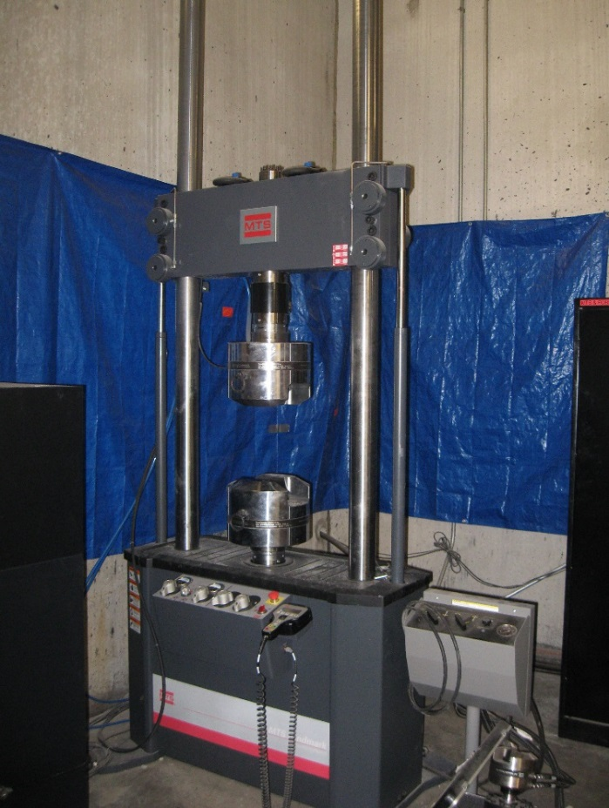

**Figure 1.** A servo hydraulic test system is used to apply constant and periodic forces on rigid objects such as steel bars. A connected computer system records the entire process until the tested element fails.

*Image source:* © 2015 A MTS Landmark® servo hydraulic test system, Structural Research Laboratory, Civil and Environmental Engineering Department, South Annex, University of Houston

**Team member names:**

**Notes and team plans:**

***Department of Civil and Environmental Engineering, University of Massachusetts*, MA, USA**

Two different experimental setups were implemented. On a set of 33 specimens, two triangular notches at opposite edges were cut (22.5% of specimen’s width) and unstressed CFRP patches were applied on 18 specimens (*Data Set* 1) on one side only. On a second set of 32 specimens, holes were drilled at the center plus two additional little cuts were made (22.5% of specimen’s width). Unstressed CFRP patches covering the two little cuts were applied at both sides of 16 specimens.

|  |  |  |
| --- | --- | --- |
| **Data Set 1**  Unstressed patches on one side only | | |
| **Patching Configuration** | **Fatigue Life (Cycles)** | |
|  | *Unpatched* | *Patched* |
| 198,140 | 159,747 |
| 167,349 | 182,829 |
| 114,189 | 192,075 |
| 127,733 | 200,851 |
| 154,586 | 212,374 |
| 157,130 | 222,731 |
| 186,956 | 223,045 |
| 193,901 | 245,521 |
| 194,960 | 254,856 |
| 178,197 | 257,288 |
| 205,253 | 265,487 |
| 208,705 | 266,759 |
| 212,164 | 323,509 |
| 178,796 | 360,752 |
| 123,215 | 377,575 |
|  | 385,526 |
|  | 392,902 |
|  | 457,370 |

Stress applied on all specimens:

 80 MPa

Stress frequency:

15 Hz

|  |  |  |
| --- | --- | --- |
| **Data Set 2**  Unstressed patches on both sides | | |
| **Patching Configuration** | **Fatigue Life (Cycles)** | |
|  | *Unpatched* | *Patched* |
| 410,671 | 274,551 |
| 283,173 | 366,104 |
| 321,312 | 398,359 |
| 363,126 | 452,973 |
| 314,159 | 498,150 |
| 355,113 | 617,712 |
| 375,927 | 434,733 |
| 391,929 | 433,360 |
| 330,973 | 344,156 |
| 367,413 | 530,470 |
| 345,480 | 402,994 |
| 339,783 | 467,906 |
| 337,448 | 321,621 |
| 295,788 | 549,137 |
| 349,082 | 387,923 |
| 369,377 | 465,744 |

***School of Civil Engineering, Southwest Jiaotong University, China***

***Institute for Rehabilitation of Buildings and Structures, University of Braunschweig, Germany***

On 36 specimens, two circular notches at opposite edges were drilled and two little cuts were made (41% specimen’s width). On 12 of the specimens (*Data Set* 3), unstressed CFRP patches were applied; on 12 specimens (*Data Set* 4), stressed patches were applied. Patches were applied on only one side of the specimens.

|  |  |  |
| --- | --- | --- |
| **Data Set 3**  Unstressed patches on one-side | | |
| **Patching Configuration** | **Fatigue Life (Cycles)** | |
|  | *Unpatched* | *Patched* |
| 173,000 | 198,000 |
| 189,000 | 209,000 |
| 170,000 | 222,000 |
| 160,000 | 228,000 |
| 180,000 | 215,000 |
| 161,000 | 218,000 |
| 173,000 | 219,000 |
| 171,000 | 225,000 |
| 160,000 | 255,000 |
| 148,000 | 243,000 |
| 136,000 | 245,000 |
| 163,000 | 235,000 |

Stress applied on all specimens:

117 MPa

Stress frequency:

25 Hz

|  |  |  |
| --- | --- | --- |
| **Data Set 4**  Stressed patches @ 1200 MPa on one-side | | |
| **Patching Configuration** | **Fatigue Life (Cycles)** | |
|  | *Unpatched* | *Patched* |
| 173,000 | 544,000 |
| 189,000 | 564,000 |
| 170,000 | 474,000 |
| 160,000 | 608,000 |
| 180,000 | 551,000 |
| 161,000 | 574,000 |
| 173,000 | 580,000 |
| 171,000 | 595,000 |
| 160,000 | 639,000 |
| 148,000 | 515,000 |
| 136,000 | 499,000 |
| 163,000 | 535,000 |

***School of Naval Architecture and Marine Engineering, National Technical University of Athens, Greece***

A set of 24 specimens having through thickness notches 60 mm long (30% of specimen’s width) were tested. CFRP unstressed patches completely covering the notch were applied on 14 specimens, on one side only.

|  |  |  |
| --- | --- | --- |
| **Data Set 5**  Unstressed patches | | |
| **Patching Configuration** | **Fatigue Life (Cycles)** | |
|  | *Unpatched* | *Patched* |
| 38,035 | 63,385 |
| 40,067 | 62,408 |
| 38,865 | 47,053 |
| 39,065 | 59,306 |
| 39,211 | 59,560 |
| 40,917 | 60,081 |
| 41,375 | 55,383 |
| 41,964 | 57,476 |
| 39,680 | 60,664 |
| 42,251 | 67,494 |
|  | 69,789 |
|  | 73,202 |
|  | 77,682 |
|  | 80,963 |

Stress applied on specimens:

100 MPa

Stress frequency:

2 Hz

***Department of Civil Engineering, Technical University of Denmark, Brovej, Denmark***

Two different experimental setups were used. At the center of 40 specimens, holes were drilled and two little notches were cut (17% of specimen’s width). CFRP patches were applied at the tips of the notches. Stressed patches were used on 14 specimens and unstressed patches on other the 14 specimens. Specimens were patched on both sides.

|  |  |  |
| --- | --- | --- |
| **Data Set 6**  Unstressed patches on both sides | | |
| **Patching Configuration** | **Fatigue Life (Cycles)** | |
|  | *Unpatched* | *Patched* |
| 470,000 | 1,150,000 |
| 477,000 | 1,250,000 |
| 456,000 | 1,470,000 |
| 463,000 | 1,510,000 |
| 469,000 | 1,760,000 |
| 479,000 | 1,710,000 |
| 474,000 | 1,401,000 |
| 472,000 | 1,321,000 |
| 478,000 | 1,380,000 |
| 481,000 | 1,520,000 |
| 467,000 | 1,200,000 |
| 454,000 | 1,330,000 |
|  | 1,380,000 |
|  | 1,610,000 |

Stress applied on all specimens:

97.5 MPa

Stress frequency:

13.5 Hz

|  |  |  |
| --- | --- | --- |
| **Data Set 7**  Stressed patches @ 13.5 KN (Kilo-Newtons) on both sides. | | |
| **Patching Configuration** | **Fatigue Life (Cycles)** | |
|  | *Unpatched* | *Patched* |
| 470,000 | 3,780,000 |
| 477,000 | 4,930,000 |
| 456,000 | 15,980,000 |
| 463,000 | 8,560,000 |
| 469,000 | 10,500,000 |
| 479,000 | 7,410,000 |
| 474,000 | 6,070,000 |
| 472,000 | 6,730,000 |
| 478,000 | 8,340,000 |
| 481,000 | 8,390,000 |
| 467,000 | 7,990,000 |
| 454,000 | 8,340,000 |

***Department of Civil Engineering, Monash University, Clayton, Victoria, Australia***

Two different experimental setups were used. At the center of 36 specimens, holes were drilled and two little notches were cut (13.3% of specimen’s width). Unstressed CFRP patches covering holes and notches were applied on 24 specimens, 12 specimens were patched one side only (*Data Set* 8), and 12 specimens were patched on both sides (*Data Set* 9).

|  |  |  |
| --- | --- | --- |
| **Data Set 8**  One side patched. Unstressed patches | | |
| **Patching Configuration** | **Fatigue Life (Cycles)** | |
|  | *Unpatched* | *Patched* |
| 244,950 | 298,757 |
| 238,333 | 339,823 |
| 241,974 | 333,091 |
| 240,825 | 345,684 |
| 241,071 | 350,867 |
| 238,881 | 390,034 |
| 244,019 | 446,456 |
| 242,554 | 478,351 |
| 241,755 | 447,372 |
| 241,474 | 346,657 |
| 240,918 | 353,746 |
| 242,944 | 350,757 |

Stress applied on all specimens:

135 MPa

Stress frequency:

30 Hz

|  |  |  |
| --- | --- | --- |
| **Data Set 9**  Two sides patched; unstressed patches | | |
| **Patching Configuration** | **Fatigue Life (Cycles)** | |
|  | *Unpatched* | *Patched* |
| 244,950 | 542,353 |
| 238,333 | 656,712 |
| 241,974 | 1,135,592 |
| 240,825 | 1,219,451 |
| 241,071 | 1,604,008 |
| 238,881 | 1,484,145 |
| 244,019 | 1,920,000 |
| 242,554 | 1,305,694 |
| 241,755 | 1,723,519 |
| 241,474 | 1,280,782 |
| 240,918 | 953,603 |
| 242,944 | 1,518,752 |

***Department of Architecture, Built Environment and Construction Engineering, ABC Politecnico di Milano, Milan, Italy***

Two different experimental setups were used. On 25 specimens, 6 mm long side notches were cut (12% of specimen’s width); on the other 25 specimens, 15 mm long side notches were cut (30% of specimen’s width). Unstressed CFRP patches were applied covering the notches only on one side of the specimen.

|  |  |  |
| --- | --- | --- |
| **Data Set 10**  Notch length: 6 mm. Patched half of specimen’s width | | |
| **Patching Configuration** | **Fatigue Life (Cycles)** | |
|  | *Unpatched* | *Patched* |
| 196,714 | 58,400 |
| 194,166 | 512,000 |
| 187,214 | 565,000 |
| 181,171 | 605,000 |
| 191,649 | 344,838 |
| 187,415 | 616,695 |
| 199,561 | 409,475 |
| 201,374 | 438,402 |
| 204,627 | 301,521 |
| 213,690 | 440,671 |
| 206,273 | 448,455 |
|  | 378,037 |
|  | 499,095 |
|  | 473,951 |

Stress applied on all specimens:

90 MPa

Stress frequency:

18 Hz

|  |  |  |
| --- | --- | --- |
| **Data Set 11**  Notch length: 15 mm. Patched all of specimen’s width | | |
| **Patching Configuration** | **Fatigue Life (Cycles)** | |
|  | *Unpatched* | *Patched* |
| 29,264 | 66,800 |
| 29,693 | 77,000 |
| 29,533 | 81,184 |
| 29,507 | 86,199 |
| 30,961 | 91,132 |
| 26,899 | 94,977 |
| 30,357 | 103,457 |
| 29,106 | 111,354 |
| 29,294 | 114,627 |
| 28,818 | 124,075 |
| 28,472 | 129,331 |
|  | 133,000 |
|  | 151,504 |
|  | 172,000 |

***Department of Civil Engineering, Cullen College of Engineering, University of Houston, TX, USA***

On 28 specimens were cut triangular side notches of 10 mm long (11.1% of specimen’s width). Stressed CFRP-NiTiNB patches were applied on one side only. Nitinol-Niobium wires (NiTiNB = nickel-titanium-niobium) were used to pre-stress the patches.

|  |  |  |
| --- | --- | --- |
| **Data Set 12**  Stressed Patch @ 30 MPa – One side patching | | |
| **Patching Configuration** | **Fatigue Life (Cycles)** | |
|  | *Unpatched* | *Patched* |
| 48,172 | 960,000 |
| 49,868 | 1,140,000 |
| 44,265 | 840,000 |
| 48,181 | 1,045,000 |
| 48,622 | 1,078,000 |
| 49,190 | 1,039,000 |
| 48,454 | 956,000 |
| 44,761 | 932,000 |
| 45,337 | 1,108,000 |
| 45,625 | 1,008,000 |
| 49,525 | 980,000 |
| 47,416 | 989,000 |
| 46,243 | 880,000 |
| 48,431 | 905,000 |

Stress applied on all specimens:

153 MPa

Stress frequency:

10 Hz