Solar Dryer and Heat Transfer Worksheet Answer Key

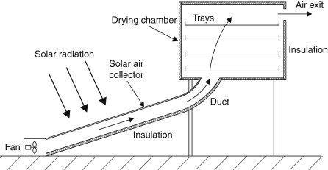
Instructions: Below is an example of a food solar dryer. From the drawing, where is conduction, convection and radiation applied or used?

- Conduction

Between the trays and the food

- Convection

Heat transfer by moving air in the solar air collector.

- Radiation

Direct heat/radiation from the sun

