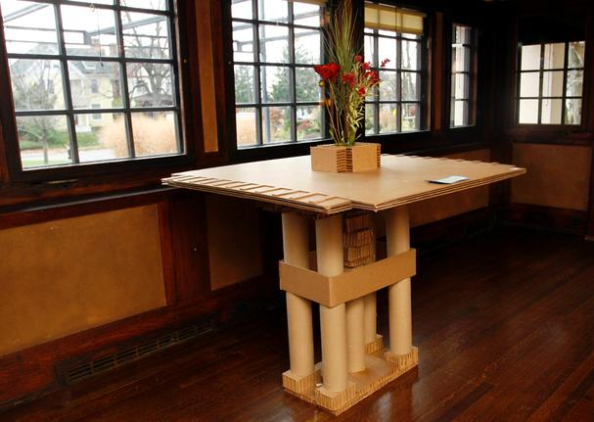

Out-of-the-Box

Design Challenge
- Identify the need
- Research the problem
- Imagine possible solutions: quick prototyping
- Plan: select a promising solution
- Create: build a scale prototype
- Test + evaluate prototype: peer / professional critique
- Improve + redesign as needed
Follow the Engineering Design Process
+
Your prototype must…
- Serve its purpose; that is, be functional
- Be to scale
- Reflect essential design elements of the selected architect’s style
- Be well crafted

Your team challenge is to design a piece of furniture that is inspired by the style of a famous architect. After researching the architect, decide what type of furnishing you will build—table, chair, bookshelf, etc.—to occupy a particular room or space in your school building—classroom, conference room, student lounge or commons area, library, etc.
+
Your prototype must…
- Be made entirely of cardboard
- Maintain the original color of the boxes
(no painting or coloring)
- Use no fasteners other than glue
and paper Kraft tape
Criteria
Constraints
Out-of-the-Box Engineering Log
Document your work by taking photographs, making and attaching detailed sketches, and completing this log throughout the entire design process.
Team name:
Team members:
///
Identify the Need
What is the problem to solve?
What are the project requirements? What are the limitations?
Which architect do we want to choose?
What furnishing do we want to design?
Where will it reside?
Who would use it?
Other factors to consider:
Notes:

Research the Problem
What is the function of the furnishing?
What are essential design elements/stylistic features of the architecture that we want to include?
What are essential structural features that need to be included?
What should the furnishing dimensions be?
Other questions to research:
Notes:

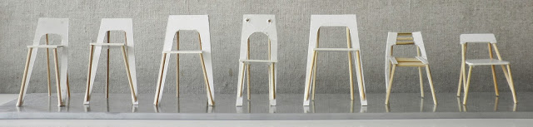

Example design exploration: Many versions of mini chair designs made from toothpicks and foam board.
Source: Karina Larsen + Christina Wadstrom Design, http://karinalarsendesign.dk/work/chair.html. Used with permission.
Imagine Possible Solutions: Quick Prototyping
This is the time to brainstorm since all ideas are viable at this point! Grab some heavy-weight paper, cardstock, chipboard, lightweight foam board, toothpicks, tape, glue, x-acto knives, self-healing mat boards and play! Make as many possible small scale (think 1:1, that is 1 inch =1 foot) models of as many ideas as you can in one class session.
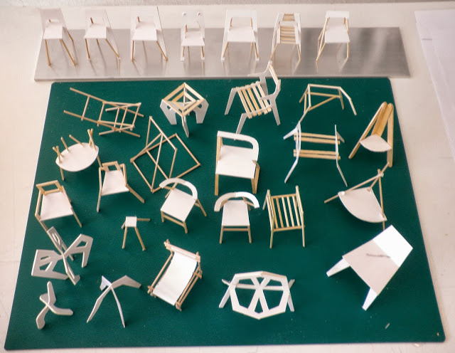

More design exploration: Many versions of small-scale chair
designs made from toothpicks and foam board.
Source: Karina Larsen + Christina Wadstrom Design, http://karinalarsendesign.dk/work/chair.html. Used with permission.
Notes:

Plan: Select a Promising Solution
Spend some time looking at and considering which of the small-scale quick prototypes meet the requirements and seem feasible within the given constraints. As a team, decide which model to develop as your ultimate prototype. Considerations:
- Consider design features such as interlocking shapes for support, positive and negative spaces, angles and proportions.
- Consider structural features that provide strength and durability, functionality, weight distribution, withstand expected forces and load requirements, brace and support types, and comfort/ergonomics, as applicable.
Identify which prototype you have selected to pursue and explain why:

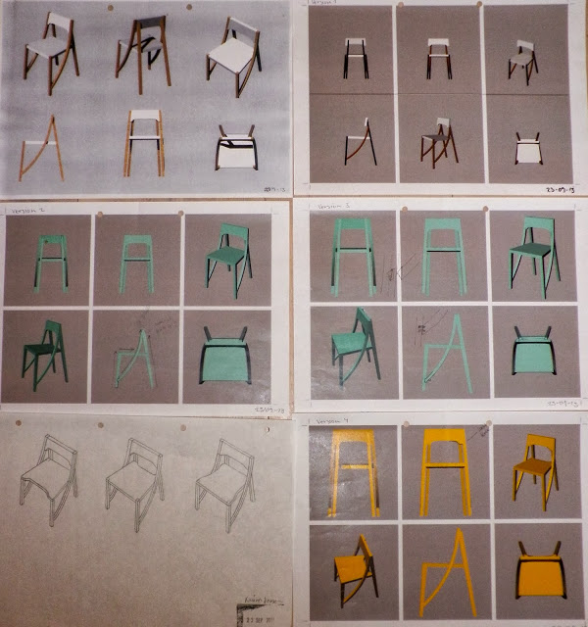

Example chair design sketches showing top and side views.
Source: Karina Larsen + Christina Wadstrom Design, http://karinalarsendesign.dk/work/chair.html. Used with permission.
Create front, side and plan (top) view drawings of your final prototype design.
- Include dimensions.
- Attach the drawings to this log.
- Attach any additional sketches, photographs, inspirational images or other source material.

Create: Build a Scale Prototype
Build your full-size, to-scale cardboard prototype! Take photographs along the way.
Record any challenges you encounter, and changes you decide to make and why, and attach them to this log.

Test + Evaluate Prototype: Peer / Professional Critique
Designate one team member to record feedback during the critique.
Share your prototype with the class. Describe your goals for the furnishing, any challenges and solutions, and explain how you met the criteria for aesthetic design as well as functionality.
Test the prototype—does it work/serve its purpose? (For example, does a chair support the weight of a person? Is it comfortable? Does a bookshelf hold the weight of books, etc.?
- What is working well? Why?
- What needs improvement? Why?
What (if any) re-designs do we plan?

Improve + Redesign as Needed
Record and explain any changes and or improvements here.

