Appendix A: Pre/Post Speed Quiz

- A submarine travels 600 meters in 2 hours, what is the speed of the submarine? Once speed is solved, convert the speed to cm per hour (circle your answer).

- If Johnny Football runs 40 yards in 6.3 seconds, how fast is he moving? Round your answer to the nearest hundredth.

- If I live 3 miles from school and leave my house at 8:20am, how fast will I need to drive to be there by 8:30am? (Your answer can be in miles per minute or miles per hour)

- If Justin Bieber is driving his car 55 miles per hour for 5 hours, how far will he have traveled?

- SpongeBob swims 10 miles per hour and gets to a town 75 miles away. How long did it take him?
On the graph below, graph the following points and label them. A (1,7) B (9,5) C (3,0)
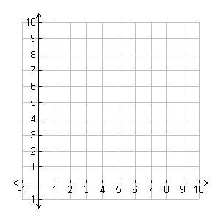
- Which vehicle is moving faster, A or B?

