Appendix A: Pre/Post Speed Quiz Answer Key

- A submarine travels 600 meters in 2 hours, what is the speed of the submarine? Once speed is solved, convert the speed to cm per hour (circle your answer).
Speed = Distance / Time
$$v=\frac{x}{t}=\frac{600 m}{2 hr}=300 \frac{m}{hr}$$

$$300 \frac{m}{hr}× \left(\frac{100 cm}{m}\right)=30,000 \frac{cm}{hr}$$

- If Johnny Football runs 40 yards in 6.3 seconds, how fast is he moving? Round your answer to the nearest hundredth.
$$v=\frac{x}{t}=\frac{40 yd}{6.3 s}=6.35 \frac{yd}{s}$$

- If I live 3 miles from school and leave my house at 8:20am, how fast will I need to drive to be there by 8:30am? (Your answer can be in miles per minute or miles per hour)
$$v=\frac{x}{t}=\frac{3 mi}{10 min}=0.3 \frac{mi}{min}$$
$$0.3 \frac{mi}{min}×\left(\frac{60 min}{hr}\right)=18 mph$$

- If Justin Bieber is driving his car 55 miles per hour for 5 hours, how far will he have traveled?
$$x=v×t=\left(55 mph\right)×\left(5 hr\right)=275 miles$$

- SpongeBob swims 10 miles per hour and gets to a town 75 miles away. How long did it take him?
On the graph below, graph the following points and label them. A (1,7) B (9,5) C (3,0)
$$t=\frac{x}{v}=\frac{75 mi}{10 mph}=7.5 hr$$

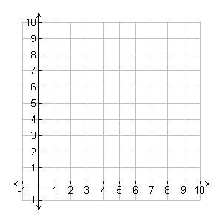
C
B
A
- Which vehicle is moving faster, A or B?

