Background Sheet

Station 3: Density of Plastic

Background:
Plastics enter our oceans and lakes from a variety of sources, and these plastics come in all different types and sizes. Once plastics enter these waterways, they then end up in the water column, which is defined as the surface of a sea, river, or lake to the bottom sediment level. Different plastics have different densities, which results in different plastics floating at different levels in the water column. At the same time, different organisms live in each of these levels. For example, plankton and zooplankton, many turtles and blue sharks live near or at the surface of the ocean, while sperm whales and octopi live towards the central, or twilight section, of the water column, and then angler fish and sea cucumbers live near the ocean floor. Depending on where this plastic is found it may or may affect the organisms that live at those levels.

The density of an object determines whether that object sinks or floats. Density is defined as mass divided by volume (d = m / v). The density of water is 1.00 and the density of sea water is 1.03. If the plastic is more dense than water it sinks, however if it less dense it floats. For example, a plastic with a density of 0.9 is less dense than water and floats, while a plastic with a density of 1.14 is denser than water and sinks.

Knowing the density of different plastics helps determine where they can be found in the water column. Since different organisms feed at different levels of the water column, different organisms are affected by the presence of each of the densities of plastics.

When identifying plastic, we use an SPI code or resin ID code. There are seven codes, each representing a density range. These codes help to identify whether the item will sink or float in water.
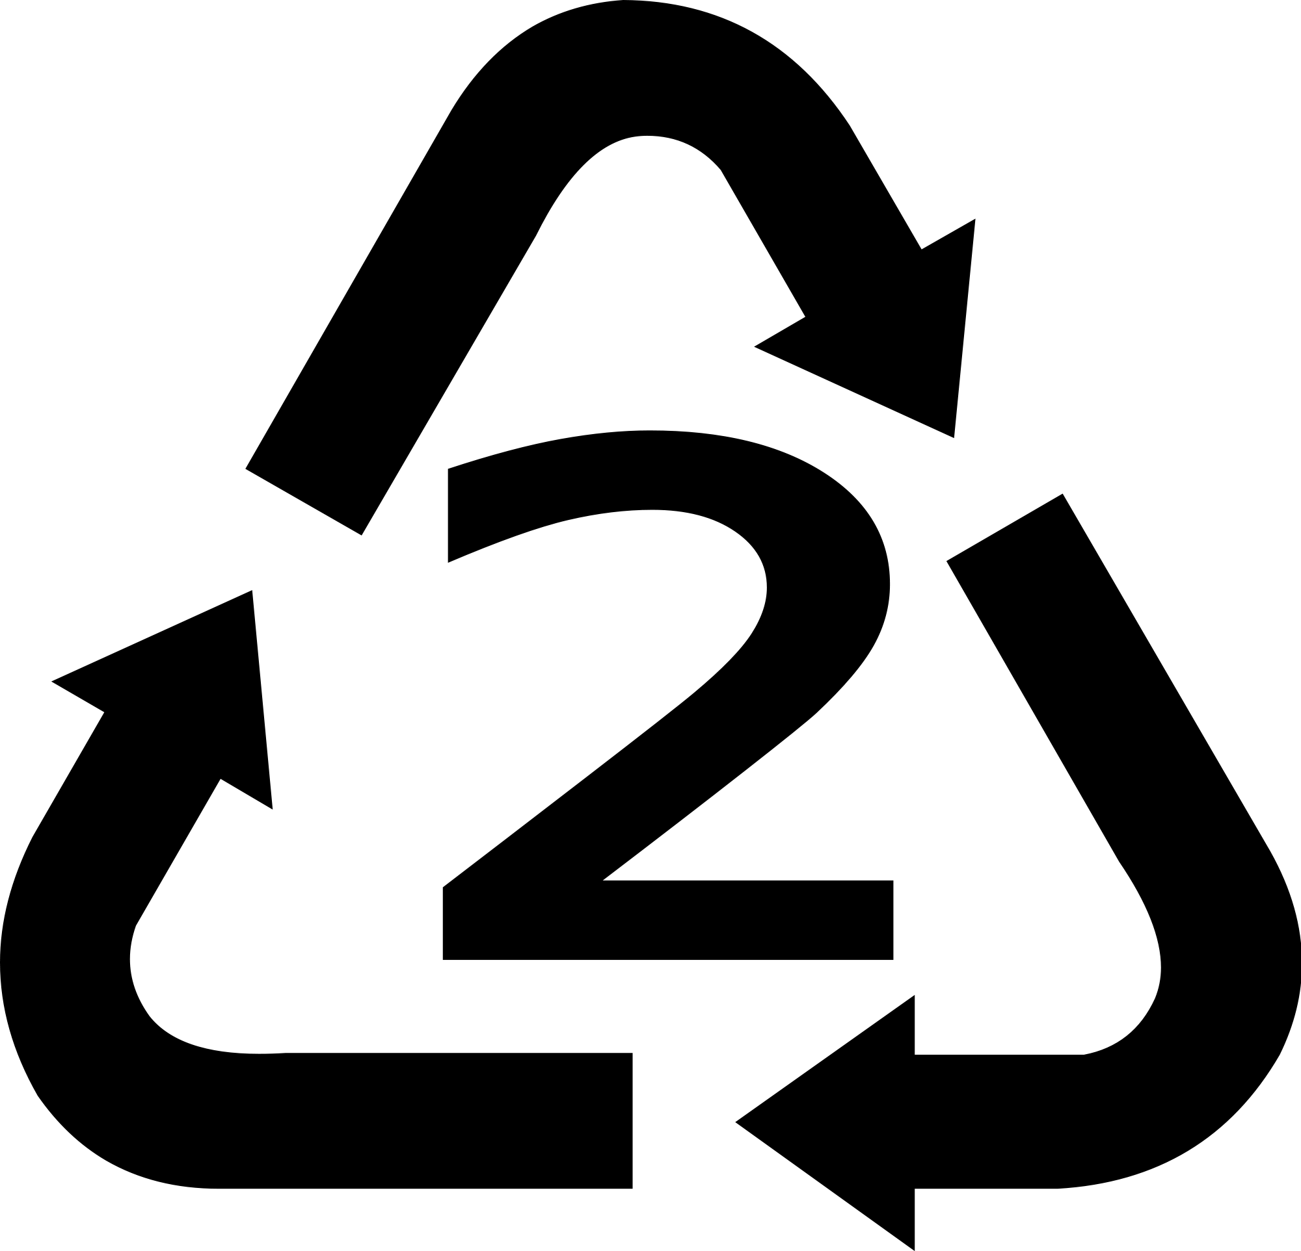
Source: Monterey Bay Aquarium

Plastics Density Table
SPI Code | Name | Density (g/mL) | Uses
1 | PETE, Polyethylene,  terephthalate | 1.38-1.39 | Soft drinks and water bottles, peanut butter containers, salad dressing and vegetable containers
2 | HDPE, high-density polyethylene | 0.95-0.96 | Milk jugs, detergents, household cleaners, motor oil containers, some garbage bags, butter and yogurt tubs, grocery bags
3 | PVC, polyvinyl chloride | 1.16-1.45 | Clear food packaging, medical equipment, siding, piping, windows, shampoo bottles
4 | LDPE Low-density polyethylene | 0.92-0.94 | Squeezable bottles, various bags (For bread, frozen food, shopping and dry cleaning), clothing, furniture
5 | PP polypropylene | 0.90-0.91 | Syrup bottles, ketchup bottles, caps, straws, medicine bottles
6 | PS Polystyrene (two kinds) | 0.02-1.07 | CD cases, meat trays, egg cartons, disposable plates, and cups, packing peanuts
7 | Other kinds | Varies | DVD cases, iPod packaging, nylon

Other: Fresh Water- 1.00 Sea Water- 1.03

Source: Monterey Bay Aquarium

Aquatic Organisms and Where They Are Found in the Water Column

Surface Feeders

Plankton Sea Turtle Blue Shark

Pelagic Feeders

Octopus Sperm Whale

Benthic (bottom) Feeders

Angler Fish Sea Cucumber

Adapted from Monterey Bay Aquarium “Plastics in the Water Column”

