What is an ECG? Jupyter Notebook Activity

Directions
Open the file WhatIsAnECG_NOTEBOOK.ipynb in Google Colaboratory by selecting “File->Open Notebook” (NOTE: You will need a Google Account to use Google Colaboratory.) Read each cell (block) of text and run each cell of code by clicking the play button on the left side of the block as indicated by the red circle in the figure below.

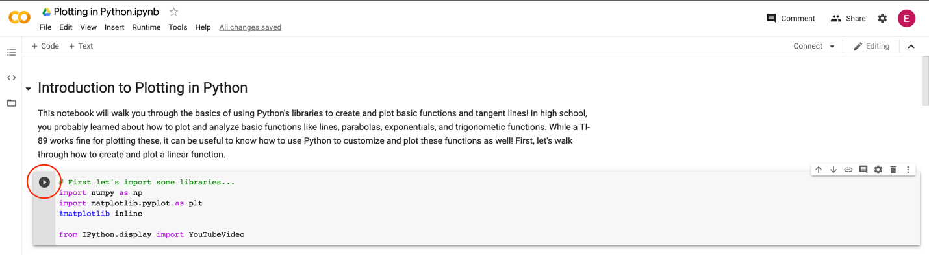

Important note: The data you will examine in this worksheet is actual ECG data collected for research. This data will not perfectly resemble the waves we saw in the slides—there is noise in the data, making it harder to read. When you complete this notebook and worksheet, keep this in mind!

As you read, watch, and run each cell, answer the following questions. This is a graded assignment.

- ECG Background. Watch the video on “ECG Basics” by Osmosis that is linked in the notebook.

  - What does an ECG measure?

  - Briefly describe how an electrical signal flows through the heart at the cellular level. (HINT: Go to the 1:00 timestamp in the video.)

  - How can a doctor determine if a heart issue is present in a specific area of the heart? (HINT: Think about how the ECG is being measured.)

- Examining your first ECG data. Run the first code block. When you are prompted to open a file, select ECG_Example1.csv. Then, run the remaining two code blocks to view the plot.

  - Move the Zoom horizontal slider all the way to the right and move the X position slider so that the x range in the plot is about [2.0, 3.0]. Compared with other segments of the plot, does this segment have more electrical activity or less electrical activity? How do you know? (HINT: Think about the peak magnitude/height.)

  - Move the X position slider until you find a portion with a recognizable ECG wave like the one shown at the top of the notebook (NOTE: it won’t be perfect, just find a pattern that looks similar). Sketch the wave segment below and label the values on the x-axis.

- Examining more ECG data. Now, re-run the first code block. When you are prompted to open a file, select ECG_Example2.csv. Then, run the remaining two code blocks to view the plot.

  - Move the Zoom horizontal slider all the way to the right and move the X position slider so that the x range in the plot is about [38.0, 39.0]. Compared with other segments of the plot, does this segment have more electrical activity or less electrical activity? How do you know? (HINT: Think about the peak magnitude/height.)

  - Compare this segment to the segment you analyzed in Problem 2a from ECG_Example1. How is this segment different from the previous segment? (HINT: Think about peak magnitude/height—you may need to re-run the code with ECG_Example1.)

  - Move the X position slider until you find a portion with a recognizable ECG wave like the one shown at the top of the notebook (NOTE: it won’t be perfect, just find a pattern that looks similar). Sketch the wave segment below and label the values on the x-axis.

