What is an ECG? Post-Quiz Answer Key

Directions
Answer the following questions the best you can.

- List one reason we use electrocardiograms.
Monitor the heart’s rhythms for irregularities
Identify known irregularities to lead to a diagnosis of the problem
(NOTE: Students may list other reasons, as long as they are valid they should receive full credit.)

- Label the 3 main parts of an ECG wave in the figure below.

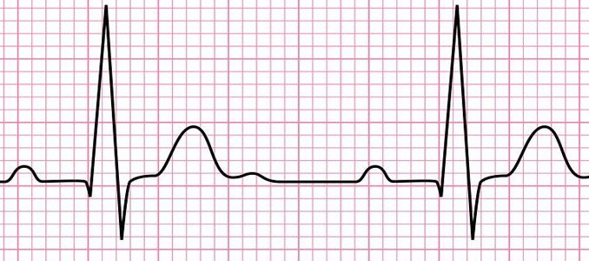
T
QRS Complex
P

https://www.onlinebiologynotes.com/wp-content/uploads/2018/08/ECG-678x300.jpg

- What action of the heart is represented by the QRS complex?
Depolarization of the right and left ventricles of the heart

