Jupyter Notebook Activity Sheet

Directions
Open the file WhatisAWave_NOTEBOOK.ipynb in Google Colaboratory by selecting “File->Open Notebook” (NOTE: You will need a Google Account to use Google Colaboratory.) Read each cell (block) of text and run each cell of code by clicking the play button on the left side of the block as indicated by the red circle in the figure below.

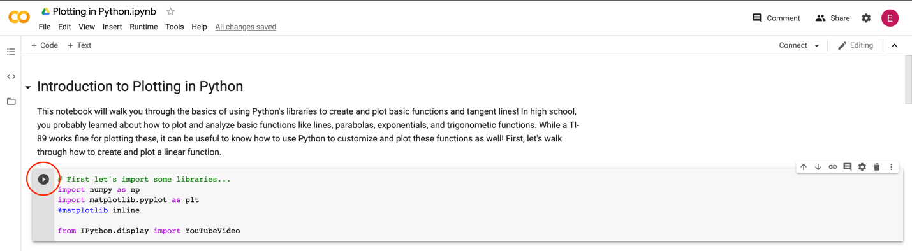

As you read and run each cell, answer the following questions. This is a graded assignment.

- Set the amplitude of the wave to 0. Describe the graph.

- Now, set the amplitude to a positive value. Then, set the amplitude to a negative value of the same magnitude (i.e. if you used a +2 in the previous step, you should use -2 for this step). How does the plot with a positive amplitude differ from the plot with the negative value?

- Reset the plot (re-run the code cell). Now, set the frequency to 0 and adjust the phase shift. Describe the graph and how it changes in response to a change in phase shift.

- Reset the plot. Now, set the amplitude to 2 and the frequency to 0.1. How many zeroes are in the plot? How does the number of zeroes change when you double the frequency?

- Create your own sine wave by adjusting all four properties to values of your choice. Provide the equation below, along with a sketch of the graph.

