Step-By-Step How to Build the Sensor Guide

Directions: Follow each step in order below to create your capacitance sensor. Use the images next to the steps for reference.

Materials you will need to build your sensor:
- 3 pieces of wax paper
- 3 pieces of tin foil
- 1 clear sheet protector
- 2 paperclips
- A marker
- A ruler
- Clear tape
- A pair of scissors

Building your capacitance sensor:
- Use the ruler to measure and mark a roughly 29 cm x 21.5 cm (11.5 in x 8.5 in) rectangle on each piece of wax paper using a marker.

- Cut out each wax paper rectangle and set them to the side.

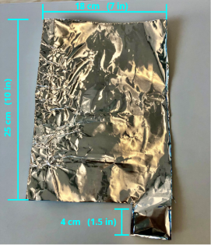
- Use the ruler to measure and mark a roughly 25 cm x 18 cm (10 in x 7 in) rectangle in one piece of tin foil.

- Cut out the tin foil rectangle and set to the side.

- Use the ruler to measure and mark the remaining 2 pieces of tin foil in the shape of a “rectangle with a tail” that measures roughly 25 cm x 18 cm (10 in x 7 in) with the tail sticking out about 4 cm (1.5 in) from the rectangle). See picture to the right for reference

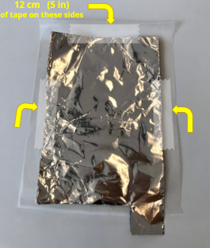
- Cut out both of the pieces of tin foil and set to the side.

- Place the first piece of tin foil with a tail in the middle of one of the pieces of wax paper. Use about 12 cm (about 5 inches) of tape to tape down the 3 sides that do NOT have the tail. See picture for reference

- Place the rectangular piece of tin foil in the middle of one of the pieces of wax paper. Use about 12 cm (about 5 inches) of tape to tape down 3 of the sides, leaving one side untapped.

- Place the second piece of tin foil with a tail in the middle of one of the other pieces of wax paper. The tail should be on the opposite side of the other piece of tin foil with the tail- see picture for reference. Use another 12 cm (about 5 inches) of tape to tape down the 3 sides that do NOT have the tail.

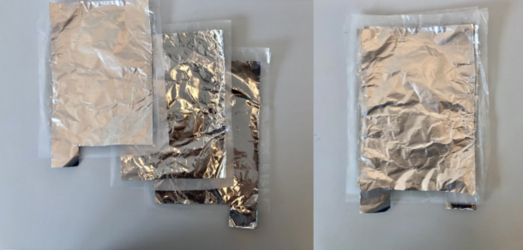
- Stack each tin foil/wax paper onto each other as such: On the bottom should be one of the pieces of tin foil with the tail, in the middle should be the rectangular piece of tin foil, on the top should be the other piece of tin foil with the tail. See picture for reference

- Place a paper clip on each of the tails of the tin foil only.

- Place all of the sheets of tin foil and wax paper into the clear sheet protector, with the tin foil tails sticking out of the slot at the top.

Materials you will need to test your sensor:
- 2 alligator clips – 1 red and 1 black
- 1 digital multimeter that measures capacitance in nanofarads (nF)

Testing your capacitance sensor:
- Plug your alligator clips into your digital multimeter and turn the multimeter on to read capacitance in nanofarads (nF).
  - Turn the multimeter to read 200 nF, if using the multimeter that just measures capacitance

- Attach one alligator clip to one paper clip and the other alligator clip to the other paper clip. See picture for reference
  - You will likely see a reading in the 0.3 – 0.8 nF range. This value includes the capacitance in the wires and the meter.
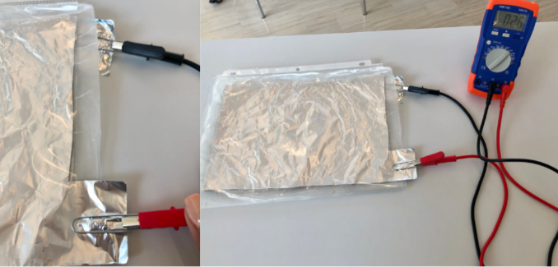

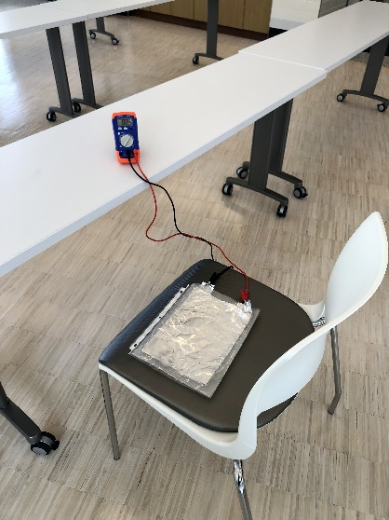
- Record the capacitance value you see without anything on the sensor.

- Place an object onto the sensor you should see the reading increase. Record the capacitance you see.

- To find the capacitance of that object, subtract the final reading – initial reading.

- To use your capacitance sensor to measure the pressure of sitting, set it up in the middle of a chair. Make sure the alligator clips and multimeter are away from the sitting individual. See picture for reference

