I Don’t Wanna Be Chicken Worksheet

Fracture Data Analysis of 3-Point Bending on a Chicken Bone
In a three-point bend test, a beam (in this case a brittle chicken bone) is supported on both ends while a concentrated load, or force, is applied at the center. This test requires stronger equipment than is available in
the classroom. The applied force results in compression on the top of the bone and tension on the bottom of the bone as shown. You will be given a table of information which represents force versus displacement data from a 3-point bend test collected in a lab with appropriate equipment. (Your teacher will assign your group Specimen A, B, or C.)
- Use Desmos to create a scatterplot of the data. Use the wrench tool to adjust the window appropriately so all data points are visible.
- From previous learning we know that the stress-strain graph can be divided into different regions. The same is true for the force-displacement graph. The three regions are:
the elastic region, the deformation region, and the point of fracture as shown by the sample graph.
(Your graph will look different.)
- Using your scatterplot as a reference, circle the points on the data table that best represent the different regions. Label the corresponding sections in the table.
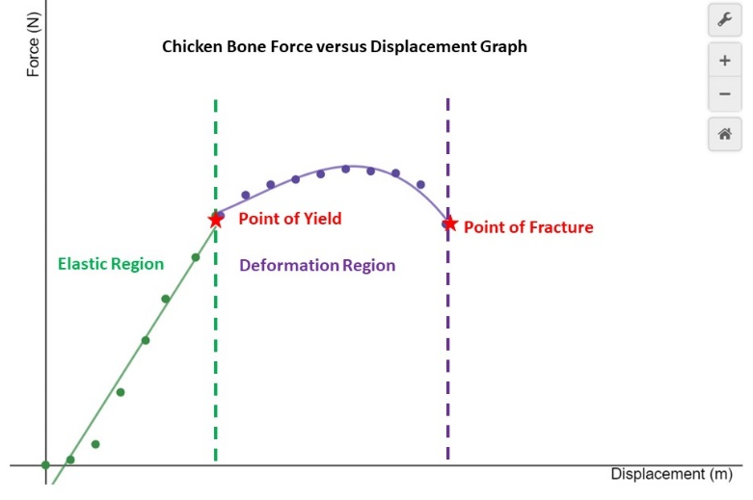
- From your data and graph,
what is the force at the YIELD point?
Be sure to include units.
- From your data and graph,
what is the force at the FRACTURE point?
Be sure to include units.
- Just like we practiced in class, break the data into two different tables in Desmos. The first table hold the linear data and the second the non-linear data in the ductile region. Make sure the tables have different colors.
- Insert an expression underneath the data table and run a linear regression on the first data set. Be sure to restrict the domain appropriately and to match the color of the line to the data set.
- Write the slope-intercept equation along with the restricted domain using interval notation:
____________________________________
- What is the stiffness of your chicken bone sample? Be sure to include units.
_____________________________________
- Ask the other groups for their stiffness calculations and then average all of them. Complete the table below and include units. You may have to wait a day for all groups to rotate through this station.
Group | Stiffness
1
2
3
4
5
6
Average

- Look at the data table and find the Young’s Modulus given for your data set keeping in mind the average age of a chicken at slaughter is 6 weeks. Six-week old chicken YM =
How does this value compare to the Young’s Modulus of a two-month old female mouse from the following scholarly article: Two-month old mouse YM =
http://www.musculoskeletalcore.wustl.edu/mm/files/Understanding%203pt%20Bending%20outcomes.pdf Does this make sense? Explain why or why not?
- How does the Young’s Modulus in this activity compare with the Young’s Modulus of a 20-month old female mouse from the article referenced in the previous question?
Twenty-month old mouse YM =
Note that in the wild, mice tend to live only five or six months; however, in ideal indoor conditions they can live up to two years. Does this make sense? Explain.
- Use Desmos to run a higher-order polynomial regression on the second data set representing the ductile region. You will have to experiment with regression functions to determine if the function is best modeled by a quadratic, cubic, or quartic. Notice the R² value; however, if the value does not change much, there is no point in adding complexity using a higher-ordered function. Which model did you choose?
- Write the deformation region’s best-fit polynomial along with the restricted domain, using interval notation. Note: Since the domain starts with where you left off the linear restriction, one should be closed and the other open in the interval notation. (You may have to use closed notation in Desmos in order for the graph to show.)
- Write a complete piece-wise defined function for the entire data set:
Sample A |  | Sample B |  | Sample C
Displacement (m) | Force  (N) | Displacement (m) | Force  (N) | Displacement (m) | Force  (N)
0 | 0 | 0 | 0 | 0 | 0
.00025 | 5 | .00025 | 5 | .00025 | 5
.0005 | 10 | .0005 | 20 | .0005 | 20
.00075 | 40 | .00075 | 70 | .00075 | 70
.001 | 75 | .001 | 85 | .001 | 120
.0012 | 110 | .0012 | 145 | .0012 | 160
.0015 | 150 | .0015 | 200 | .0015 | 180
.00175 | 185 | .00175 | 240 | .00175 | 220
.0020 | 220 | .0020 | 265 | .0020 | 240
.00225 | 245 | .00225 | 310 | .00225 | 235
.0025 | 275 | .0025 | 330 | .0025 | 237
.00275 | 295 | .00275 | 350 | .00275 | 245
.003 | 310 | .003 | 360 | .003 | 252
.00325 | 320 | .00325 | 365 | .00325 | 244
.0035 | 330 | .0035 | 370 | .0035 | 237
.00375 | 325 | .00375 | 362 | .00375 | 233
.004 | 315 | .004 | 360 | .004 | 232
.00425 | 300 | .00425 | 355 | .00425 | 231
.0045 | 280 | .0045 | 350 | .0045 | 227
Young’s Modulus |  | Young’s Modulus |  | Young’s Modulus
3.77E+08 N/m² |  | 4.34E+08 N/m² |  | 3.63+08 N/m²

Specimen A
Displacement (m) | Force (N)
0 | 0
.00025 | 5
.0005 | 10
.00075 | 40
.001 | 75
.0012 | 110
.0015 | 150
.00175 | 185
.0020 | 220
.00225 | 245
.0025 | 275
.00275 | 295
.003 | 310
.00325 | 320
.0035 | 330
.00375 | 325
.004 | 315
.00425 | 300
.0045 | 280
Young’s Modulus
3.77E+08 N/m²

Specimen B
Displacement (m) | Force (N)
0 | 0
.00025 | 5
.0005 | 20
.00075 | 70
.001 | 85
.0012 | 145
.0015 | 200
.00175 | 240
.0020 | 265
.00225 | 310
.0025 | 330
.00275 | 350
.003 | 360
.00325 | 365
.0035 | 370
.00375 | 362
.004 | 360
.00425 | 355
.0045 | 350
Young’s Modulus
4.34E+08 N/m²

Specimen C
Displacement (m) | Force (N)
0 | 0
.00025 | 5
.0005 | 20
.00075 | 70
.001 | 120
.0012 | 160
.0015 | 180
.00175 | 220
.0020 | 240
.00225 | 235
.0025 | 237
.00275 | 245
.003 | 252
.00325 | 244
.0035 | 237
.00375 | 233
.004 | 232
.00425 | 231
.0045 | 227
Young’s Modulus
3.63+08 N/m²

