Newton's First and Second Laws Homework Answer Key
Concepts: Forces Acting on Masses and Newton’s First and Second Laws
- Write a paragraph of at least 25 words using Newton’s first law to help you explain why a seatbelt can help save your life if you get into a car accident.
Example answer: Newton’s first law states that “an object in motion tends to stay in motion, and an object at rest tends to stay at rest, unless acted upon by an unbalanced force(s).” When a car and its occupant(s) are moving at a given velocity and then hit something, they are acted upon by an unbalanced force (which is the product of the mass and the acceleration of the object that they crash into). The velocity of the car will change as a result of the new net force upon the car, that is, it will accelerate with a new trajectory as a result of the unbalanced force. The occupants, however, are not attached to the car unless they are wearing seatbelts. So they continue in motion along the previous trajectory, and are likely to collide against parts of the car, or be ejected out of the car, unless they are wearing restraints to keep them with the car. The seatbelts “catch” the occupants of the car and distribute the impact of the unbalanced force across their bodies, thus minimizing injury. They also prevent the occupants from colliding into other parts of the car or each other, and from being ejected out of the car.

- Draw an arrow (vector) to show the direction of the velocity of the object in motion in the following images. The first example has been done for you.
Example:
A satellite orbiting Earth.

A biker going down a mountain. A soccer player kicking a soccer ball.
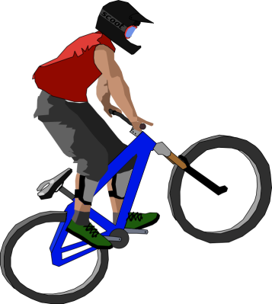
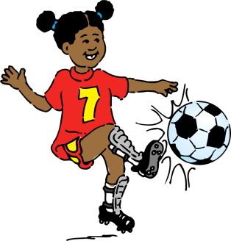

- A boy lets go of a feather. The feather is acted upon directly downward by the force of gravity with 5 Newtons and by the force of air resistance in the opposite direction (upwards) with 2 Newtons. The net force on the feather is ____.

- 3 Newtons upward
- 8 Newtons downward
- 3 Newtons downward
- 8 Newtons upward
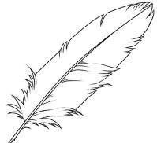
2 Newtons
5 Newtons

- A satellite in deep space is on a mission to Neptune. It fires its engines to change its velocity toward Neptune at a speed of 200 kilometers per hour. Suddenly, the engines stop working. After a few minutes, what is the velocity of the satellite?
- 100 kilometers per hour, towards Neptune
- 200 kilometers per hour, towards Earth
- 100 kilometers per hour, towards Earth
- 200 kilometers per hour, towards Neptune

The answer is D. The velocity of the satellite is the same as before, since (almost) no unbalanced forces are acting upon the satellite in outer space. (That is, no air resistance and almost no gravitational forces exist to act to change the trajectory of the satellite.)

