Post-Activity Comprehension Quiz Answer Key
- A negative trace takes power from the power supply to the negative side of the LED.

positive side negative side power supply

- True or False: Only one of the (+) sides of the battery holder needs to be connected to the positive side of the LED in order to supply it with power. The same is true for the (-) side.
Correct answer: Both of the (+) sides of the battery holder need to be connected to the positive side of the LED in order to supply it with power. The same is true for the (-) side.
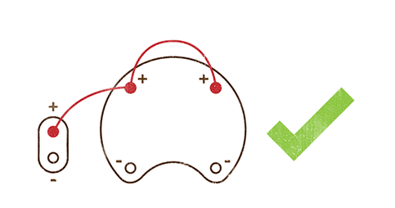

- Draw the correct way to create positive and negative tracers between the battery pack and the LED light. Indicate the approximate number of stitches to realistically use at each connection.
