Case File Sheet with Suspect Cards

Our case takes place in a remote research facility. This research lab comprises six Principal Investigators (PIs) with three engineers who work under the PIs. On DAY 296, Dr. Noolan Courage, one the PIs went to talk to Dr. Mystery Clearwater about one of the research projects. Dr. Courage knocked on Dr. Clearwater’s bedroom, and no answer came from within. He opened the door, only to find Dr. Clearwater’s lifeless body on the floor. Dr. Courage ran out of the bedroom and alerted the other 4 PIs, including Dr. Kristeena Crowfurd, Dr. Leena Specktackle, Dr. Ripple Mistales, and Dr. Sheerluck Molmes. Dr. Molmes got very excited upon arriving and he shared that it was because he is into true crime and also because he didn't like the guy. Dr. Molmes began working the place like a crime scene. He instructed all the PIs to put on the proper PPE and to walk around the room to see what could have caused the death of Dr. Clearwater. After a couple of minutes, Dr. Specktackle found a glass of what seemed to be water near the body. Could this mean that Dr. Clearwater was poisoned? The contents of the glass were put in a closed lid container to be analyzed later.
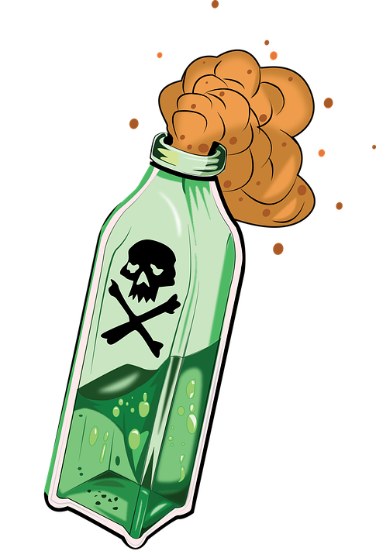
During breakfast, Dr. Mistales brought up an interesting fact. What if the whole water supply is compromised with whatever it is that killed Dr. Clearwater. The scientists started looking at each other. Lately everybody seemed to be on edge and seemed to be suffering from cabin fever. Could it be that there is a killer among them? Dr. Molmes instructed everybody to not drink the water until it could be properly examined. Luckily, the lab has a couple of boxes of soda pop that we can drink, but eventually water will be needed.
Dr. Molmes has called upon all the research engineers that work under each PI to help in the case. He wants each team to take a sample of the water supply and create a protocol in order to analyze the contents of the water. Let’s see who can solve the mystery of the contaminated water. Could it be an accident, or could this be the nasty job of a killer among our researchers? Dr. Molmes also started investigating the relationship of Dr. Clearwater with all the other PIs, and he has discovered some disturbing facts.
Dr. Kristeena Crowfurd:
Specializes in bacteria research, especially. She was very upset with Dr. Clearwater because one of his papers had been published before hers.
Dr. Leena Specktackle:
Specializes in microorganisms larger than bacteria. She had a couple of rough encounters with Dr. Clearwater because he kept stealing candy from her personal candy stash.
Dr. Ripple Mistales:
Specializes in chemicals- especially Phosphates. Dr. Clearwater and Dr. Mistales went to the same University and apparently Dr. Clearwater had dated Dr. Mistales’ sister and had broken her heart.
Dr. Sheerluck Molmes:
Specializes in chemicals- especially Nitrates. He is very open about not liking Dr. Clearwater. He shared that there’s something about how Dr. Clearwater chews his food.
Dr. Noolan Courage:
Specializes in aquatic plants. He doesn't seem to have a motive, but he has always felt intimidated by Dr. Clearwater, and also by every person in the research team, including the research engineers.

