How to Make a Buckyball
Read through this instruction sheet before you begin.

Materials (per group)
- scissors
- 24 pipe cleaners (chenille stems for arts and crafts); 16 of one color, 8 of another color
  - pipe cleaners for arts and crafts are usually ~30.5 cm (12 inches) long
  - 16 pipe cleaners will be cut in half, making 32 pieces total. Of those pieces, 20 will be made into hexagons and 12 will be made into pentagons
  - 8 pipe cleaners will be cut into 3.8 cm (1.5 inches) pieces, giving you 64 total
  - Note: make sure to have extra pipe cleaners of each color on hand
- Scotch tape (in case some pipe cleaners do not hold together)

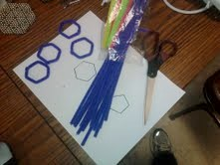
Step 1: Designate one color for the bonds of the buckyball (we chose purple here).
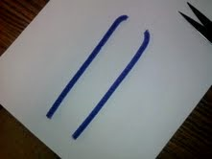
Cut each pipe cleaner in half.
Step 2
Make 20 hexagons and 12 pentagons.
Take a pipe cleaner and bend it around one of the shapes below. Be sure to overlap the ends a small amount.
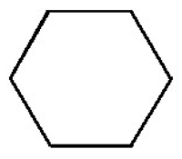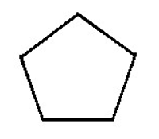
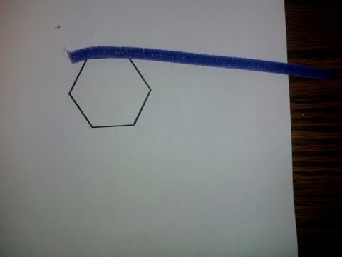
Twist the ends together so that they hook and lock.
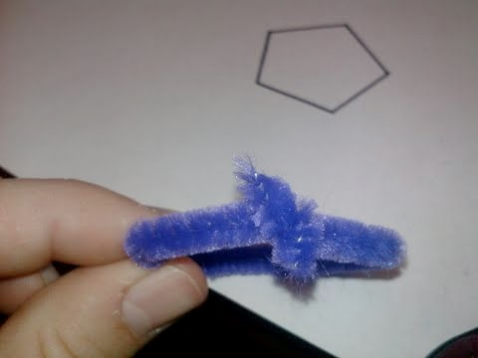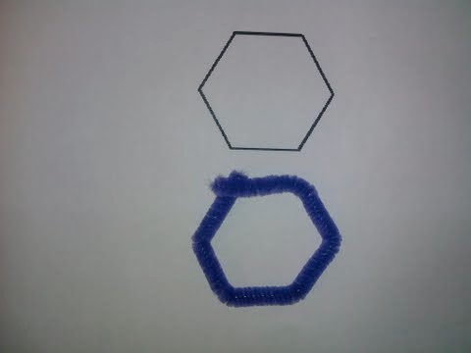

Step 3
Cut 60 connector pieces using a different color pipe cleaner (we chose neon green here.)
These will represent the “carbon atoms” Each piece should be 3.8 cm (1.5 inches) long.
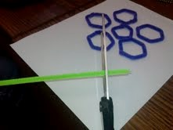
Step 4
Arrange five hexagons around one pentagon as in the image below.
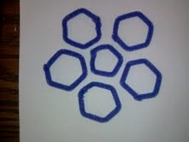
Take one green connector piece and attach the pentagon to two hexagons.
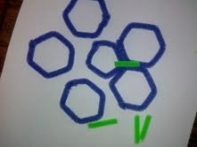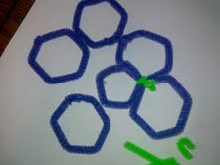
Each connector piece will connect three shapes (1 pentagon and 2 hexagons).
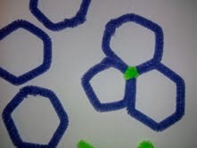
Use another connector piece to connect the next hexagon.
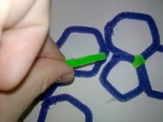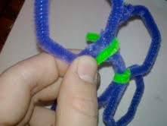
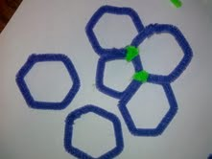

Continue connecting the other hexagons to the pentagon…

…till you get a shape that looks like this. Take care in making sure you maintain the shapes of the pentagon and the hexagon!

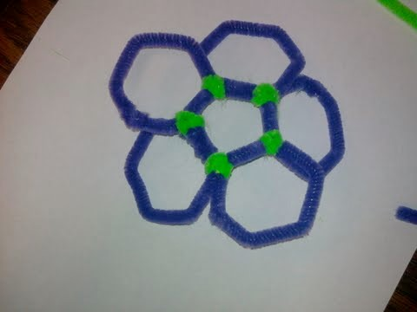
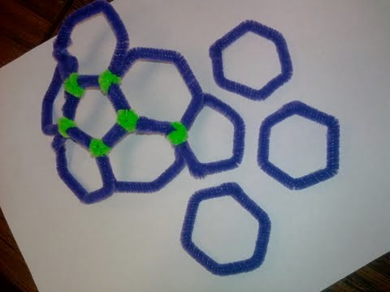
Continue to build the buckyball by adding another pentagon like so. Add a hexagon to each side of the pentagon.
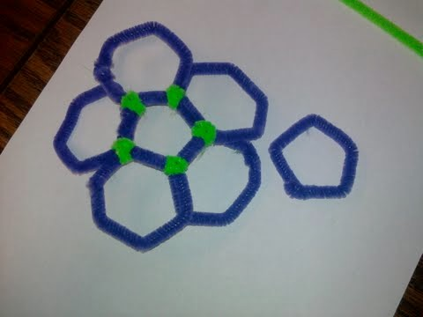

Add another pentagon to the top of the structure. Remember, each green “carbon atom” connects one pentagon and two hexagons.

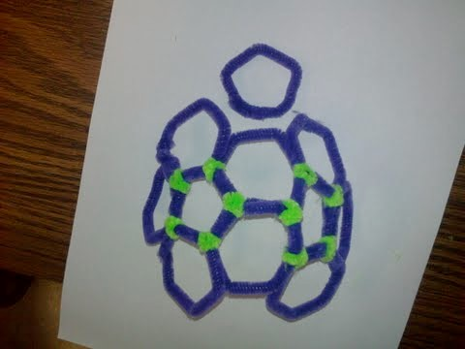
Add another pentagon to the top of the structure.

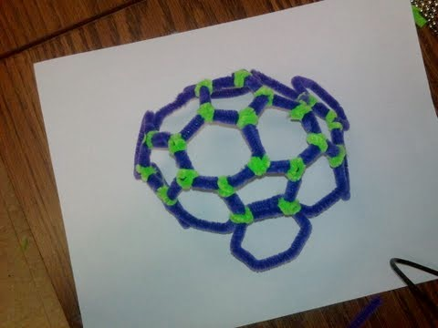
Now your buckyball should really start to take shape! Continue adding hexagons and pentagons, and keep in mind that no two pentagons will ever touch. Each pentagon is surrounded by five hexagons, and each hexagon is surrounded by alternating hexagons and pentagons, three of each.
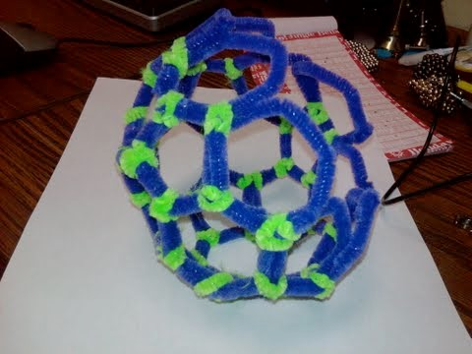

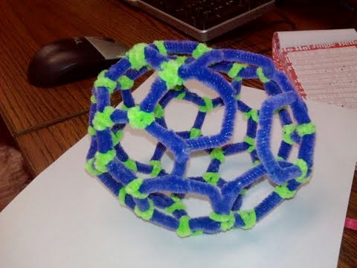

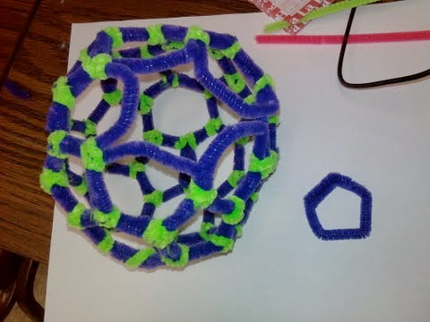
Only one pentagon left!
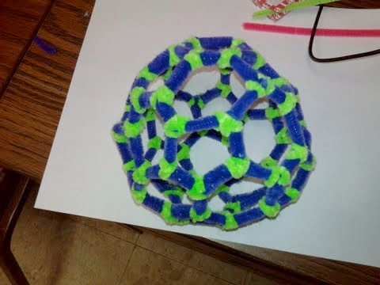
Your buckyball is complete!

For comparison, you can see the patterns of hexagons and pentagons in the buckyball are exactly the same as a soccer ball.
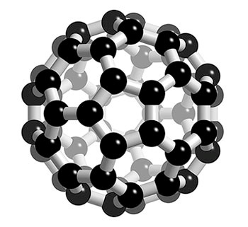
Good luck building your buckyball!

Worksheet and images adapted from Rebecca Quardokus, former graduate fellow at University of Notre Dame, current Assistant Professor in Chemistry, University of Connecticut.

