How to Create a Galvanic Cell Student Handout

Introduction

What is a galvanic cell and how does it work? A galvanic (or voltaic) cell is a type of electrochemical cell that utilizes chemical reactions to produce electrical energy.

Specifically, these chemical reactions can be further classified as oxidation-reduction reactions. An oxidation-reduction reaction, or redox for short, is a type of reaction whereby electrons are transferred via a series of steps which can be referred to as half-reactions. During the oxidation half-reaction an element will undergo a process resulting in an overall loss of electrons. The reduction half-reaction will result in an element that undergoes an overall gain of electrons. This process of electron transfer is more discernible in some redox reactions in comparison to others. The unique properties of a galvanic cell will separate these half-reactions from one another, thus allowing an electrical current to flow through conductive material. This electrical current can then be made available for the production of electrical energy.

To successfully create a galvanic cell, the most essential components should include two metal ion solutions of a given concentration and a salt bridge that connects these two solutions to one another. These metal ion solutions could include sulfates, nitrates, etc.

Materials
Each group will need:

- several pieces of electrical wiring with alligator clips
- duct tape
- 2 500 ml beakers
- graduated cylinder
- pipettes (plastic or glass)
- dialysis tubing to create a salt bridge
- sodium chloride solution
- cotton balls
- copper sulfate solution
- copper nitrate solution
- zinc sulfate (250 mL)
- zinc nitrate (250 mL)
- one voltmeter
- filter paper
- strip of copper metal
- strip of zinc metal

Lab Safety Precautions

- Safety goggles should be worn due to the need to work with redox reactions and exothermic processes
- Waste containers should be provided for byproducts of chemical reactions (metal ion waste solutions)
- Students will be working with small amounts of electrical current

Procedure
- Pour 250 ml of copper sulfate and 250 ml of zinc sulfate solution into two separate 500 ml beakers.

- Place a strip of copper metal into the copper sulfate solution and a strip of zinc metal into the zinc sulfate solution. This will begin the oxidation-reduction reaction process.

- Create a salt bridge between the two solutions by soaking the piece of filter paper with the sodium chloride solution using a pipette. After soaking the filter paper with sodium chloride, position the saturated filter paper so that each end of filter paper is in contact with the two separate solutions. See the figure below for an example.

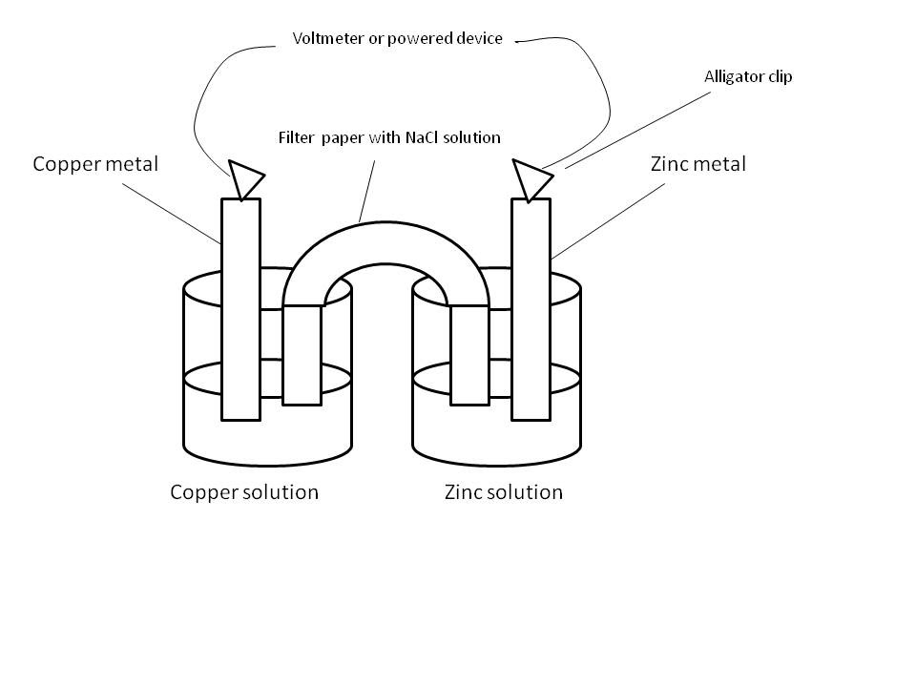

- Allow the reaction a few minutes to begin. After a few minutes, use the voltmeter to test the voltage of the cell by placing an electrode on each end of the two metal strips.

- Once confirmation is received that the cell is producing a potential difference, create a circuit based upon your schematic using your wiring, alligator clips, and your given device.

- Attempt to power your device using your galvanic cell. If your device will not power on you may need to add an additional cell to your circuit to generate more voltage.

- Once the activity is completed clean up your work area and dispose of waste materials following the given lab safety protocols for your station.

