Keychains and Keyrings Hardware Answer Key

Custom and unique keychains and keyrings are currently an extension of our lives by showcasing decorative trinkets, identifying important keys and containing useful objects. Keychain and keyrings often contain useful accessories that include tools, emergency devices, and gadgets for locating lost keys. Some people have key fobs on their keychains and keyrings. A key fob is an electronic small, programmable hardware device attachment that replaces a key or to initiate the opening of another device a such as a car or garage door. There are many different types of rings and shackles that are often patented for use to hold keys.
For this activity and worksheet, answer the following questions:
- What is the suggested maximum number of keys on a keychain or keyring? Why?
Most car experts believe that nine keys or less will not cause damage. While some will say that weight ignitions are able to withstand up to three pounds of weight while the car is at rest.

- Name four categories of materials are used to fabricate parts for a keychain or keyring?
Metal (copper, brass, nickel, alloys)
Leather (natural, faux)
Organic fibers (rope, string, macramé)
Fabric (cotton, upholstery)
Resin (natural, synthetic, plastic)

- Name 10 useful tools or objects that are attached to a keychain or keyring? Many possible answers. USB Flashlight Product locator Wrist ring
Bottle opener Compass Whistle Portable charger Carabiner Flash drive Pepper spray Swiss army knife Cosmetic holder (e.g. lipstick or hairbrush) Change purse

- Name and draw 5 types of holders for the keys that are commonly assembled to a keychain or keyring. What is one advantage to the style of the key holder? More types exist.
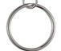
Examples include:
circular ring latch clip
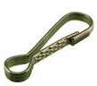
latch clip

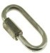
carabiner clip (aka quick link)

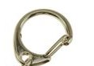
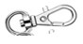

eye snap shackle

swivel snap hook

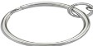
split ring

- What is the purpose of using a jump ring in the design of a keychain/keyring? Identify some shapes associated with jump rings.
Triangular or circular (more shapes possible); holds chain & objects with screw eyes to assembled object.
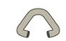
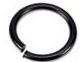

- What tool is needed to assemble an open jump ring to the keychain?
Needle nose or fine tip pliers (other names exist for tool)

- Why is an eye screw (sometimes called eyehook) used for in the assembly of a keychain?
A screw with a loop on one end and threads on the other end

- Define and explain the importance of the shank diameter of the eye screw.
Measure the distance from the outer thread on one side to the outer thread on the other side; determines capacity to carry weight

- What are some different styles of eye screws? Eye_______, eye_________ or eye________
Eye hooks, Eye pins or Eye bolts

- Name and sketch 4 styles of chains often on assembled keychains/keyrings. (Note: Some have jump rings attached.)
Beaded chain w/ connector 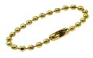Snake chain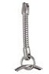Curb chain 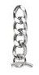Linkchain