Alternative fuel: Propane Answer Key
Instructions: Read this webpage https://afdc.energy.gov/vehicles/propane_emissions.html and then answer the questions below.

Propane Vehicle Emissions:
Summarize how propane compares to gasoline and diesel fuel?
Propane has less carbon in it than gasoline and diesel fuel.

Life Cycle Emissions:
What is a life cycle analysis?
A life cycle analysis assesses the environmental impacts of a product from its production and transportation to its final use.

Use the GREET excel database to complete the chart below:
- Open this link: https://greet.es.anl.gov/greet_1_series
- Click the link underneath “GREET 1 Series (Fuel-Cycle Model) or this link GREET_2020rev1.zip
- Open the GREET folder
- Select “GREET1-2020”
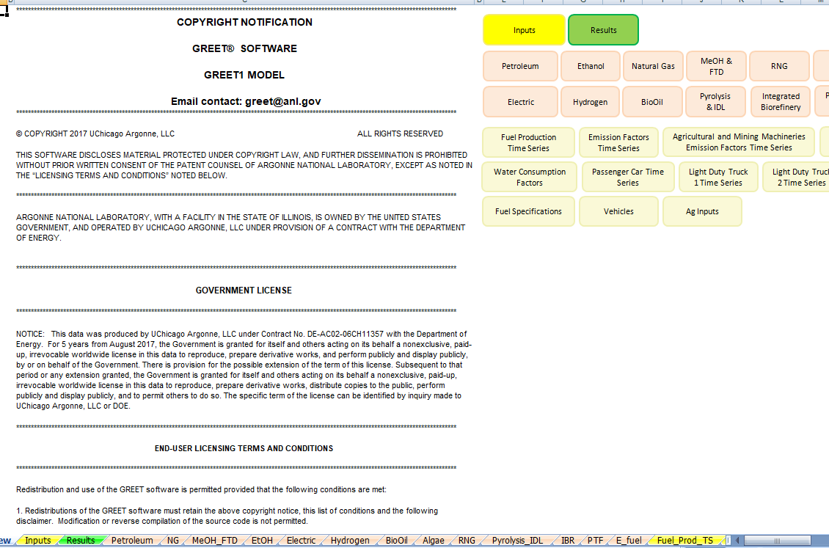

- To use the GREET database, you have to click on the tab at the bottom of the screen. Propane is liquified petroleum gas, so to get data about propane, click the tab at the bottom labeled “petroleum”. The red arrow above is pointing to it.
- There is a lot of information on this database. Scroll all the way down to 5) Summary of Energy Consumption, Water Consumption, and Emissions. Record the data listed in table 5.1 for the fuel type LPG (liquified petroleum gas). You are looking at the values for methane (CH4), carbon dioxide (CO2), and nitrous oxide (N2O). There are other variables in this chart, but we will focus just on these three. There is a red box around them in the table below.
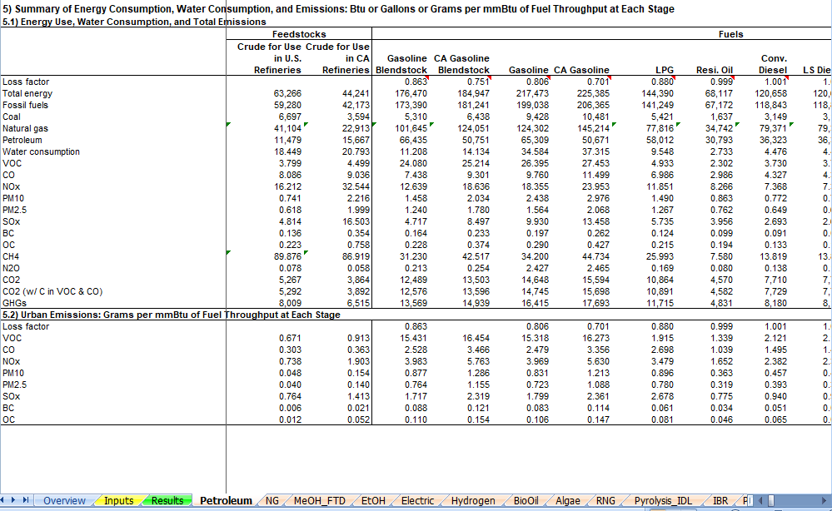

- If you would like to move through the data table to see the other data that is collected, use the arrow that has the red circle around it in the picture above.

Propane
Type of emission | Total amount of emission for LPG
CH₄ | 25.99
N₂O | .169
CO₂ | 10,864

The abbreviations in GREET are defined below:
VOC = volatile organic compounds
CO = carbon monoxide
NO_{X} = nitric oxide
PM10 = particulate matter with a diameter of 10 micrometers or less
PM2.5 = particulate matter with a diameter of 2.3 micrometers or less
SO_{X} = sulfur oxides
BC = black carbon (particulate matter/ soot & contributes to climate change)
OC = organic carbon (respiratory effects)
CH₄ = methane
N₂O = nitrous oxide
CO₂ = carbon dioxide

- In the table below, fill in the row for propane.
- When everyone is finished learning about the energy sources, share what you have learned with the group. Each individual should summarize the questions they answered and share the GREET emissions that were calculated. Notes should be taken in the table below so that the information can be shared with your poster group..
- Circle the energy source you will use to heat your building (remember that we are assuming that the technology for this will be in place) and complete the information below the table.
Answers will vary based in student presentations
Energy Source | Information about energy source | GREET values
Ethanol
Electric
Biodiesel
Natural Gas
Propane
Hydrogen

Type of fuel that will be recommended for use in heating your building structure:
The expectation is that they will choose hydrogen, but it does depend on students’ presentations.

Evidence and reasoning for this recommendation:
Evidence used would be the low greenhouse gas emissions.

- Return to the “Energy Source” document and continue to step 2.

