Alternative fuel: Hydrogen Answer Key
Instructions: Read this webpage (https://afdc.energy.gov/fuels/hydrogen_benefits.html) and then answer the questions below.

Hydrogen Benefits and Considerations:
Why is hydrogen a good choice for alternative fuel?
Hydrogen can be made with near-zero greenhouse gas emissions.

Energy security:
How does hydrogen increase our country’s energy security?
Hydrogen can be produced in the U.S.

Public Health and Environment:
What are the environmental and health benefits of using hydrogen as an energy source?
Vehicles powered by hydrogen do not produce any harmful substances, only water and warm air.

Fuel Storage:
What makes storing hydrogen a challenge?
Hydrogen’s energy content by volume is low so high pressure and low temperatures are required to store it.

Use the GREET excel database to complete the chart below:
- Open this link: https://greet.es.anl.gov/greet_1_series
- Click the link underneath “GREET 1 Series (Fuel-Cycle Model) or this link GREET_2020rev1.zip
- Open the GREET folder
- Select “GREET1-2020”
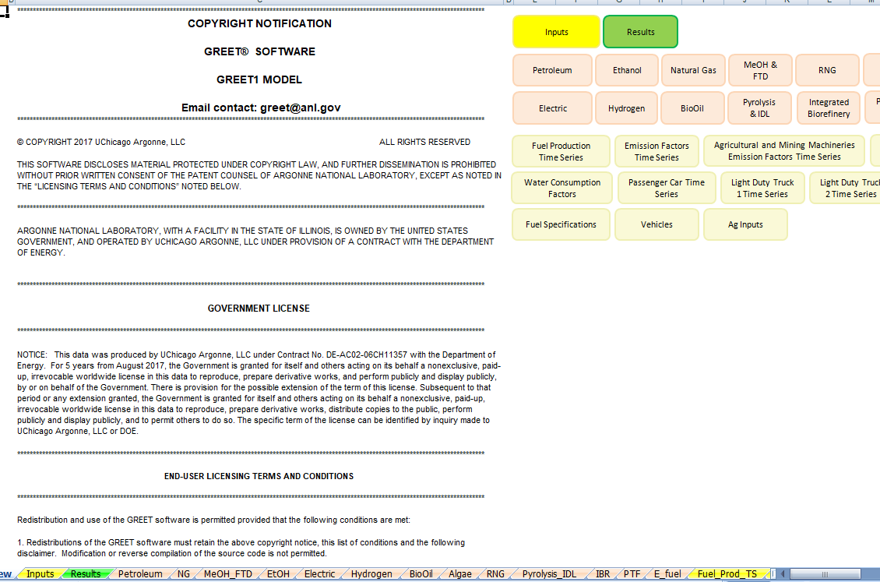

- To use the GREET database, you have to click on the “Hydrogen” tab at the bottom of the screen. The red arrow above is pointing to it.
- There is a lot of information on this database. Scroll all the way down to 4) Summary of Energy Consumption, Water Consumption, and Emissions. The data you are looking for is listed in table 4.1. This table tells you the energy consumption, water consumption, and total emissions for what are the units? Each gallon of ethanol? (it says Btu or Gallons or Grams per mmBtu of fuel)
- Because we are interested in reducing carbon emissions and climate change, you will be looking at the values for methane (CH4), carbon dioxide (CO2), and nitrous oxide (N2O). There are other variables in this chart, but we will focus just on these three. There is a red box around them in the table below.
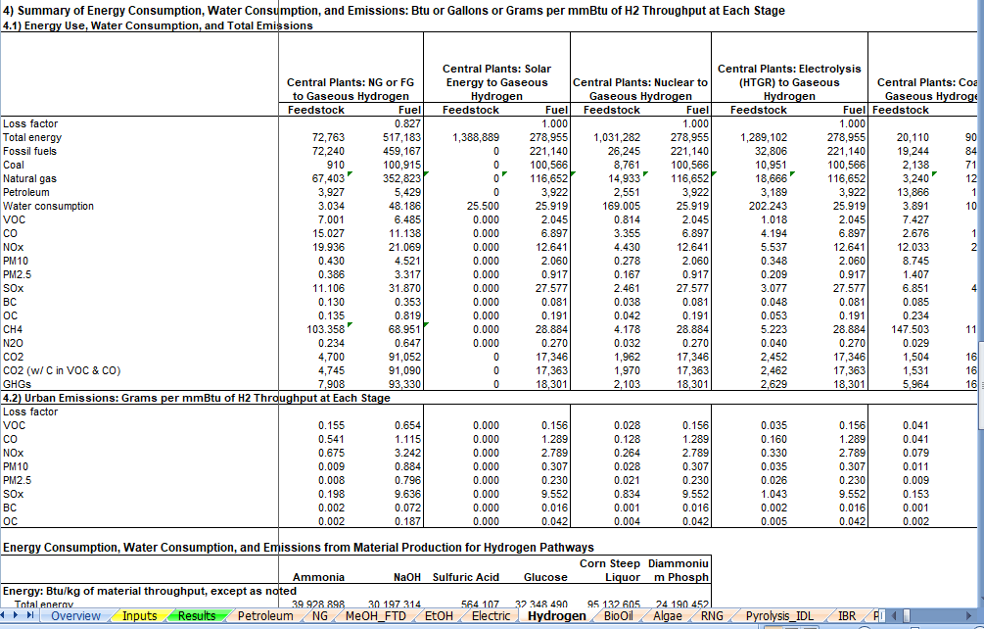

- There are many different ways to make hydrogen. Look at the first 4 columns in the data table (for Fuel, not Feedstock) and find the type of hydrogen formation that you think is best in regards to the amount of CO2, N2O, CH4 in the emissions. Record the type of hydrogen formation in the first row and the emissions data in the rows below. If you would like to move through the data table and investigate other ways of making hydrogen, use the arrow that has the red circle around it in the picture above.

Central Plants: Solar to Gaseous Hydrogen
Nuclear to Gaseous Hydrogen
Electrolysis to Gaseous Hydrogen
Type of emission | Total amount of emission for LPG
CH₄ | 28.9
N₂O | .3
CO₂ | 17,346

The abbreviations in GREET are defined below. We are focusing on the highlighted gases:
VOC = volatile organic compounds
CO = carbon monoxide
NO_{X} = nitric oxide
PM10 = particulate matter with a diameter of 10 micrometers or less
PM2.5 = particulate matter with a diameter of 2.3 micrometers or less
SO_{X} = sulfur oxides
BC = black carbon (particulate matter/ soot & contributes to climate change)
OC = organic carbon (respiratory effects)
CH₄ = methane
N₂O = nitrous oxide
CO₂ = carbon dioxide

- Fill in the row below for hydrogen.
- When everyone is finished learning about the energy sources, share what you have learned with the group. Each individual should summarize the questions they answered and share the GREET emissions that were calculated. Notes should be taken in the table below so that the information can be shared with your poster group.
- Circle the energy source you will use to heat your building (remember that we are assuming that the technology for this will be in place) and complete the information below the table.
Answers will vary based in student presentations
Energy Source | Information about energy source | GREET values
Ethanol
Electric
Biodiesel
Natural Gas
Propane
Hydrogen

Type of fuel that will be recommended for use in heating your building structure:
The expectation is that they will choose hydrogen, but it does depend on students’ presentations.

Evidence and reasoning for this recommendation:
Evidence used would be the low greenhouse gas emissions.

- Return to the “Energy Source” document and continue to step 2.

