Alternative fuel: Ethanol – Answer Key

Instructions: Read this webpage (https://afdc.energy.gov/vehicles/flexible_fuel_emissions.html) and then answer the questions below.
Ethanol Vehicle Emissions:
How is ethanol used? By itself or mixed with other substances?
It is blended with gasoline.

Life Cycle Emissions:
What is a life cycle analysis?
Life cycle analysis is used to assess the environmental impacts of all stages of a product's life, including raw material extraction, processing, manufacturing, distribution, use, and disposal or recycling. When comparing fuels, a life cycle analysis may focus on particular portions of a fuel's life cycle, such as from extraction-to-use, also referred to as well-to-wheels, to determine the merits or problems associated with each fuel.

What are the greenhouse gas (GHG) emissions?
Carbon dioxide (CO2)

How can the carbon dioxide emission be offset?
Carbon dioxide (CO2) released when ethanol is used in vehicles is offset by the CO2 captured when crops used to make the ethanol are grown. A 2020 analysis by Argonne National Laboratory(PDF) found that using corn-based ethanol in place of gasoline reduces life cycle GHG emissions on average by 40%.

How does the emission with ethanol compare to the emission with gasoline?
A 2012 study by Argonne National Laboratory found that when fuel life cycles are considered, average emissions reductions of cellulosic ethanol compared to conventional gasoline range from 88% to 108% depending on feedstocks used.

Evaporative and Tailpipe Emissions:
What are the emissions of primary concern?
E85 decreases the emissions of CO2, as well as the emissions of many harmful toxics, such as benzene—a known carcinogen. However, it increases acetaldehyde emissions, which the National Institutes of Health describe as "reasonably anticipated to be a human carcinogen" and is moderately reactive for ground level ozone formation.

Use the GREET excel database to complete the chart below:
- Open this link: https://greet.es.anl.gov/greet_1_series
- Click the link underneath “GREET 1 Series (Fuel-Cycle Model) or this link GREET_2020rev1.zip
- Open the GREET folder
- Select “GREET1-2020”
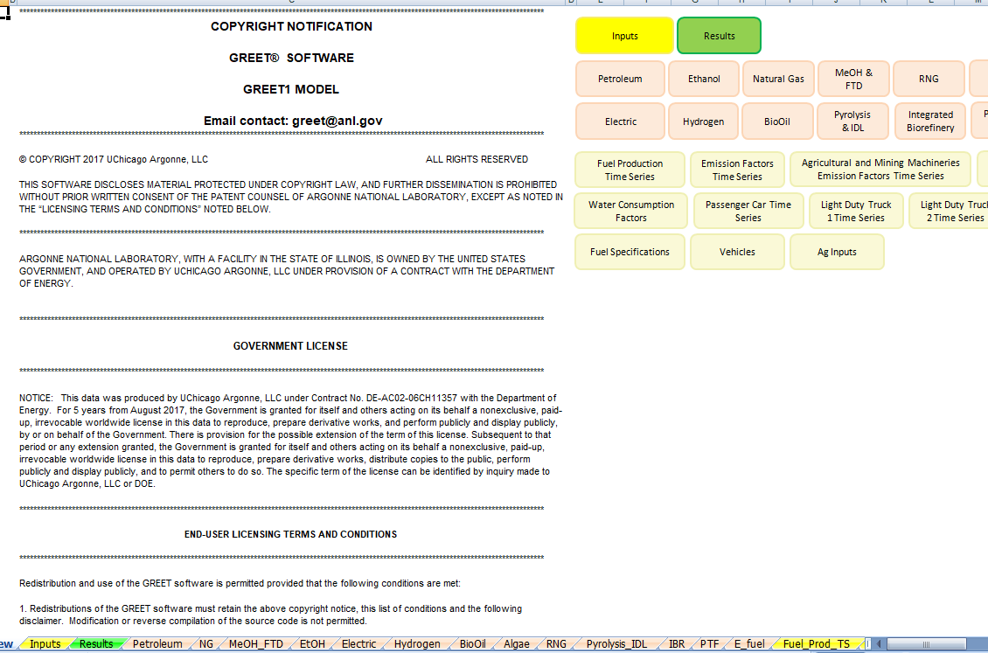

- To use the GREET database, you have to click on the tab at the bottom of the screen. Ethanol is abbreviated EtOH, so click the “EtOH” tab. The red arrow above is pointing to it.
- There is a lot of information on this database. Scroll all the way down to 4) Summary of Energy Consumption, Water Consumption, and Emissions. The data you are looking for is listed in table 4.1. This table tells you the energy consumption, water consumption, and total emissions for the use of ethanol fuel.
- Because we are interested in reducing carbon emissions and climate change, you will be looking at the values for methane (CH4), carbon dioxide (CO2), and nitrous oxide (N2O). There are other variables in this chart, but we will focus just on these three. There is a red box around them in the table below.
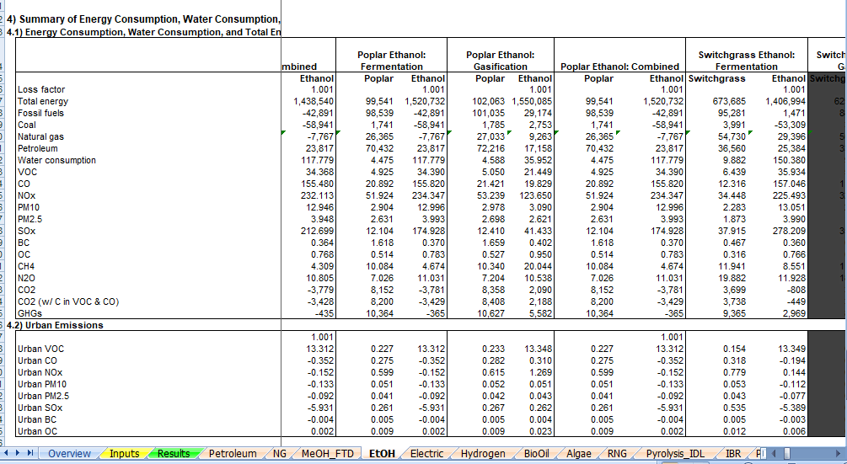

- There are many different plants that are used to make ethanol. Look through the data table and find the type of ethanol that you think is best in regards to the amount of CO2, N2O, CH4 in the emissions. To move through the data table, use the arrow that has the red circle around it in the picture above. Record the data in the table below. This is what you will share when the group comes back together. (there are extra lines in the data table, you can use them if it is helpful to record information while trying to determine which version of ethanol you want to use - circle the one that you will share)

Gas emission | Ethanol type
CH₄
N₂O
CO₂

The abbreviations in GREET are defined below:
VOC = volatile organic compounds
CO = carbon monoxide
NO_{X} = nitric oxide
PM10 = particulate matter with a diameter of 10 micrometers or less
PM2.5 = particulate matter with a diameter of 2.3 micrometers or less
SO_{X} = sulfur oxides
BC = black carbon (particulate matter/ soot & contributes to climate change)
OC = organic carbon (respiratory effects)
CH₄ = methane
N₂O = nitrous oxide
CO₂ = carbon dioxide

- Fill in the row below for ethanol.
- When everyone is finished learning about the energy sources, share what you have learned with the group. Each individual should summarize the questions they answered and share the GREET emissions that were calculated. Notes should be taken in the table below so that the information can be shared with your poster group.
- Highlight the energy source you will use to heat your building (remember that we are assuming that the technology for this will be in place) and complete the information below the table.

Energy Source | Information about energy source | GREET values
Ethanol
Electric
Biodiesel
Natural Gas
Propane
Hydrogen

Type of fuel that will be recommended for use in heating your building structure:

Evidence and reasoning for this recommendation:

- Return to the “Energy Source” document and continue to step 2.

