Alternative fuel: Electricity Answer Key
Instructions: Read this webpage https://afdc.energy.gov/vehicles/electric_emissions.html and then answer the questions below.

Emissions from Hybrid and Plug-In Electric Vehicles:
Besides the emission from the car’s tailpipe, what else needs to be considered?
Emissions associated with the production of electricity also need to be considered.

Electricity Sources and Emissions:
Summarize the data presented in the Annual Emissions per Vehicle graph:
All electric cars release fewer emissions. Most of the electricity is produced using natural gas and nuclear power.

Direct and Well-to-Wheel Emissions:
What are direct emissions?
Direct emissions are emissions that come from a vehicle's tailpipe and through evaporation from the vehicle's fuel system during the fueling process.

How are direct emissions different for different types of electric vehicles?
EV (all-electric vehicles):
All-electric vehicles produce zero direct emissions.

PHEV (Plug-In Hybrid Electric Vehicle) in all electric mode:
PHEV’s produce zero tailpipe emissions when they are in all-electric mode, but can produce evaporative emissions.

PHEV, when using ICE (internal combustion engine):
PHEV’s produce tailpipe emissions when they are use their ICE, but the direct emissions are usually lower than a conventional vehicle.

What are Well-to-wheel emissions?
Well-to-Wheel emissions include all the emissions related to fuel production, processing, distribution and use.

Why are well-to-wheel emissions important to consider with electric vehicles?
Most electric power plants produce emissions, there are also extra emissions during extraction, processing and distribution of the primary energy sources that are used for electricity production.

Use the GREET excel database to complete the chart below:
- Open this link: https://greet.es.anl.gov/greet_1_series
- Click the link underneath “GREET 1 Series (Fuel-Cycle Model) or this link GREET_2020rev1.zip
- Open the GREET folder
- Select “GREET1-2020”

- To use the GREET database, you have to click on the tab at the bottom of the screen. Click the “Electric” tab. The red arrow above is pointing to it.
- There is a lot of information on this database. Scroll all the way down to 12) Fuel-Cycle Energy Use, Water Consumption, and Emissions. Scroll down to the second half of the table. The data you are recording is the Energy Consumption, Water Consumption, and Total Emissions for what are the units? Each gallon of ethanol? (it says Btu or Gallons or Grams per mmBtu of electricity available)
- Because we are interested in reducing carbon emissions and climate change, record the values for methane (CH4), carbon dioxide (CO2), and nitrous oxide (N2O). There are other variables in this chart, but we will focus just on these three. There is a red box around them in the table below.
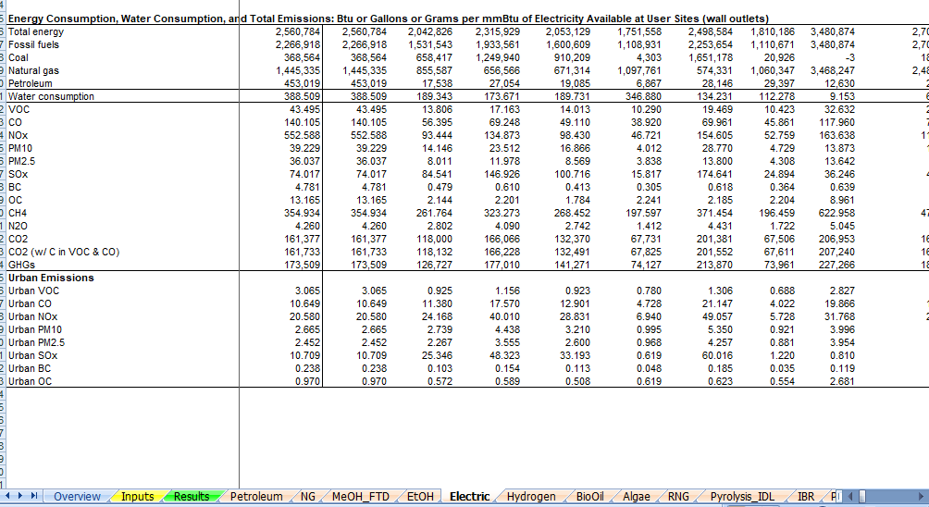

- Look through the data table and find the emissions for Illinois. To move through the data table, use the arrow that has the red circle around it in the picture above. Record the data in the table below. This is what you will share when the group comes back together.

Gas emission | State of IL
CH₄ | 211.58
N₂O | 2.56
CO₂ | 117,003

The abbreviations in GREET are defined below:
VOC = volatile organic compounds
CO = carbon monoxide
NO_{X} = nitric oxide
PM10 = particulate matter with a diameter of 10 micrometers or less
PM2.5 = particulate matter with a diameter of 2.3 micrometers or less
SO_{X} = sulfur oxides
BC = black carbon (particulate matter/ soot & contributes to climate change)
OC = organic carbon (respiratory effects)
CH₄ = methane
N₂O = nitrous oxide
CO₂ = carbon dioxide

- Fill in the row below for electric energy.
- When everyone is finished learning about the energy sources, share what you have learned with the group. Each individual should summarize the questions they answered and share the GREET emissions that were calculated. Notes should be taken in the table below so that the information can be shared with your poster group.
- Circle the energy source you will use to heat your building (remember that we are assuming that the technology for this will be in place) and complete the information below the table.
Answers will vary based in student presentations
Energy Source | Information about energy source | GREET values
Ethanol
Electric
Biodiesel
Natural Gas
Propane
Hydrogen

Type of fuel that will be recommended for use in heating your building structure:
The expectation is that they will choose hydrogen, but it does depend on students presentations

Evidence and reasoning for this recommendation:
Evidence used would be the low greenhouse gas emissions.

- Return to the “Energy Source” document and continue to step 2.

