Alternative fuel: Biodiesel Answer Key
Instructions: Read this webpage (https://afdc.energy.gov/fuels/biodiesel_benefits.html) and then answer the questions below.

Biodiesel Benefits and Considerations:
What is biodiesel?
Biodiesel is produced in the U.S. It is a clean-burning and renewable fuel.

Energy Security and Balance:
Where is biodiesel produced?
Biodiesel is produced in the U.S.

Air Quality:
Why does using biodiesel reduce the amount of carbon dioxide in the atmosphere?
Carbon dioxide released by biodiesel combustion is offset by the amount of carbon dioxide taken in by the plants that are used to make the biodiesel.

Safety:
Summarize the information that is provided about the safety of biodiesel.
When biodiesel is not mixed with anything else, spills cause less damage to the environment than petroleum diesel. Biodiesel is safe to handle, store and transport.

Use the GREET excel database to complete the chart below:
- Open this link: https://greet.es.anl.gov/greet_1_series
- Click the link underneath “GREET 1 Series (Fuel-Cycle Model) or this link GREET_2020rev1.zip
- Open the GREET folder
- Select “GREET1-2020”
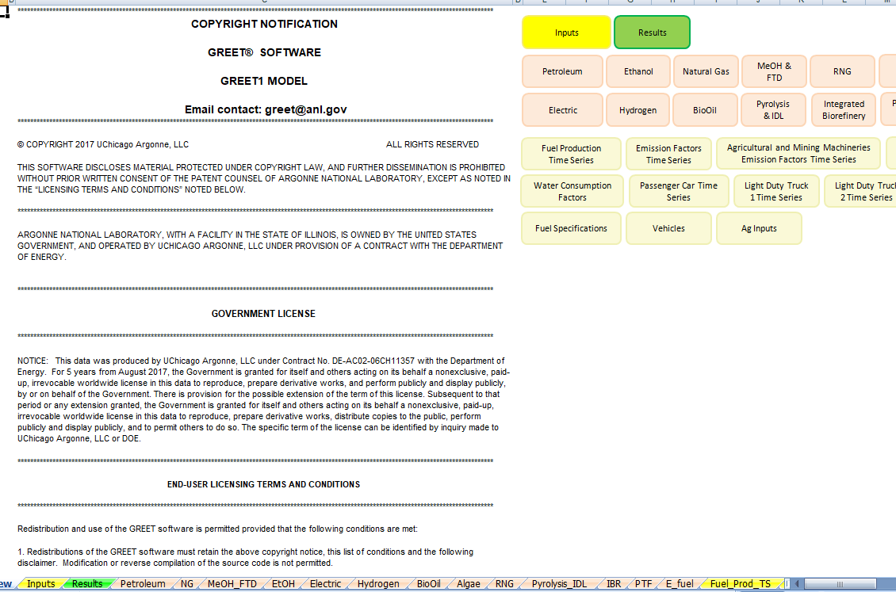

- To use the GREET database, you have to click on the tab at the bottom of the screen. Biodiesel is called “BioOil”, so click the “BioOil” tab. The red arrow above is pointing to it.
- There is a lot of information on this database. Scroll all the way down to #4) Summary of Energy Consumption, Water Consumption, and Emissions.
- Because we are interested in reducing carbon emissions and climate change, you will be looking at the values for methane (CH4), carbon dioxide (CO2), and nitrous oxide (N2O). There are other variables in this chart, but we will focus just on these three. There is a red box around them in the table below.
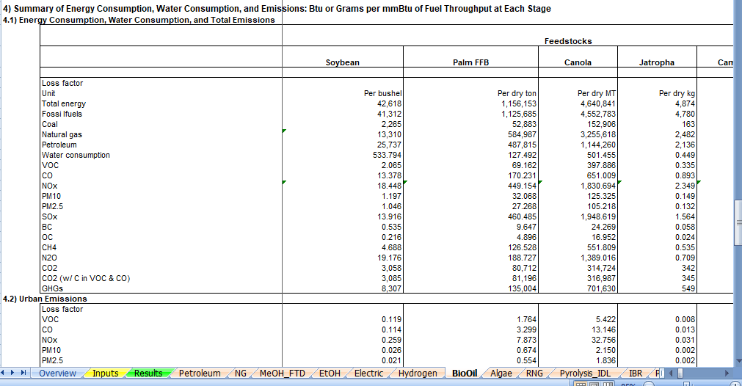

- There are many different oils that are used to make biodiesel. Look through the data table and find the type of oil that you think is best in regards to the amount of CO2, N2O, CH4 in the emissions. To move through the data table, use the arrow that has the red circle around it in the picture above. Record the data in the table below. This is what you will share when the group comes back together. (there are extra lines in the data table, you can use them if it is helpful to record information while trying to determine which version of oil you want to use - circle the one that you will share) what are the units? Each gallon of ethanol? (it says Btu or Grams per mmBtu of fuel)

Gas emission | Type of Oil-based Biodiesel (Fuel)
 | Soybean oil-based Biodiesel | Palm oil-based Biodiesel | Corn oil-based Biodiesel | Camelina oil-based Biodiesel | Tallow-based Biodiesel | Jatropha oil-based Biodiesel
CH₄ | 21.4 | 127.4 | 14.6 | 17.96 | 35.6 | 55.7
N₂O | .17 | .16 | .09 | .13 | .37 | 4.9
CO₂ | 21,708 | 12,073 | 8,207 | 10,122 | 19,942 | 10,369

The abbreviations in GREET are defined below:
VOC = volatile organic compounds
CO = carbon monoxide
NO_{X} = nitric oxide
PM10 = particulate matter with a diameter of 10 micrometers or less
PM2.5 = particulate matter with a diameter of 2.3 micrometers or less
SO_{X} = sulfur oxides
BC = black carbon (particulate matter/ soot & contributes to climate change)
OC = organic carbon (respiratory effects)
CH₄ = methane
N₂O = nitrous oxide
CO₂ = carbon dioxide

- Fill in the row below for biodiesel.
- When everyone is finished learning about the energy sources, share what you have learned with the group. Each individual should summarize the questions they answered and share the GREET emissions that were calculated. Notes should be taken in the table below so that the information can be shared with your poster group.
- Circle the energy source you will use to heat your building (remember that we are assuming that the technology for this will be in place) and complete the information below the table.

Answers will vary based in student presentations
Energy Source | Information about energy source | GREET values
Ethanol
Electric
Biodiesel
Natural Gas
Propane
Hydrogen

Type of fuel that will be recommended for use in heating your building structure:
The expectation is that they will choose hydrogen, but it does depend on students’ presentations.

Evidence and reasoning for this recommendation:
. Evidence used would be the low greenhouse gas emissions.

- Return to the “Energy Source” document and continue to step 2.

