Wind Turbines Post-Quiz Answer Key
A. Circle the best choice:
- energy: quantitative qualitative

- water: renewable nonrenewable
energy source energy source

- fossil fuel: renewable nonrenewable
energy source energy source

- gasoline: renewable nonrenewable
energy source energy source

- wind: renewable nonrenewable
energy source energy source

- natural gas: renewable nonrenewable
energy source energy source

- heat: energy form energy source

- sun: energy form energy source

- light: energy form energy source

- gravity: energy form energy source

B. Use the following words to label the six basic components that comprise a wind turbine:
tower
shaft
electric generator
rotor
gearbox
rotor blade

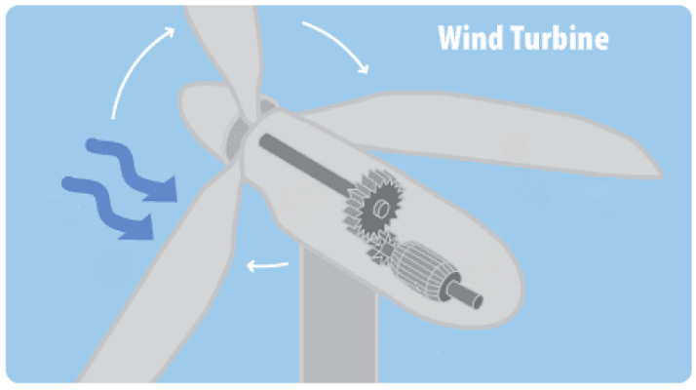

1
Wind
Rotor
Rotor Blade

Shaft
Gearbox
Tower
Electric Generator
3
5
2
6
4

C. Write a short description of each:
- Rotor and rotor blade:
A rotor is the heart of a wind turbine. It is the rotating central piece to a functioning wind turbine. Large propeller-like blades known as rotor blades extend from the rotor to capture the dynamic motion of the wind and its kinetic energy. The blowing wind applies a force against the rotor blades and causes the rotor to rotate (hence the name rotor). With this process, the wind’s kinetic energy is converted to mechanical rotational energy to spin the rotor blades.
- Shaft:
The rotor is connected to a rod known as shaft. The shaft is an apparatus that directly connects the rotor to an electrical generator. The shaft’s purpose is to transfer the rotational mechanical energy generated by the rotating rotor directly to the input of the electrical generator.
- Gearbox:
Most wind turbines contain a gearbox connected to the shaft, which turns the slow rotation of the rotor blades and shaft into faster rotations that are more suitable to drive an electrical generator.
- Electric generator:
The rotating shaft directs the rotation of a rotating electrical generator. The rotating generator is placed between two magnets to induce electricity to flow through a conductor through a process known as electromagnetic induction. With this process, rotational mechanical energy is converted into electrical energy, which can be stored and transmitted as electricity to an electric utility company.

