Activity Worksheet Example Answers
Challenge Question: How can we estimate the height of an object?
We can estimate the height of an object by observing objects around it that have a known height and estimating the difference. As an alternative, we can estimate the height of an object by using what we know about triangles.
Observations
Application: The height of the ceiling
Initial height guess | 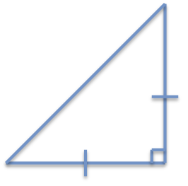  8 ft
Distance to wall | 7 ft
Predicted height | 7 ft
Measured height | 7.5 ft

Explanation and notes:

My initial estimate was not quite right, probably due to my angle not being quite 45 degrees.
Synthesis: On top of an object
Initial distance guess | 4 ft
Height of observer on object | 4.5 ft
Predicted distance to object | 4.5 ft
Measured distance to object | 4.5 ft

Explanation and notes:

The predicted distance matches the measured distance, since I correctly formed the 45-45-90 triangle.
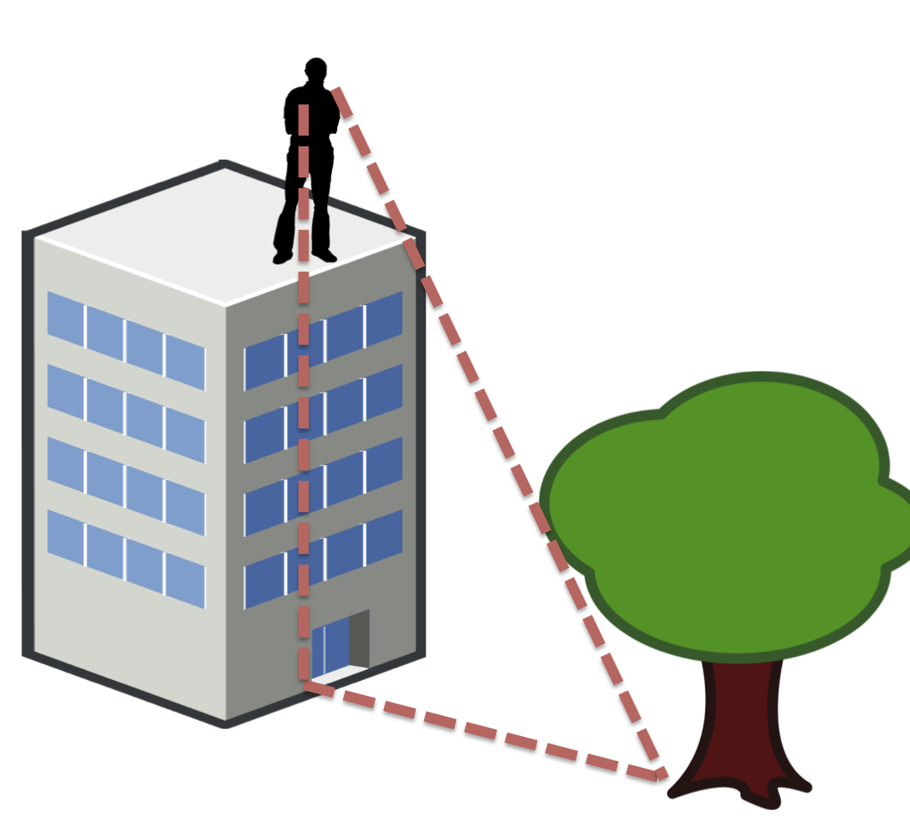
Reflection: Based on the information you have learned in this activity, how can you use triangles to estimate the height of objects?
A right-angled 45-degree triangle can be used to estimate the height of an object. This can be done by imagining a triangle being formed, using the (along the ground) distance from the object and the height of the object as the two sides of the triangle, with the hypotenuse in the air connecting them. If we can calculate or guess the distance on the ground, then the actual height of the object will be the same.

