Measuring Distance with Sound Waves Activity –
Ultrasound Sensor Homework

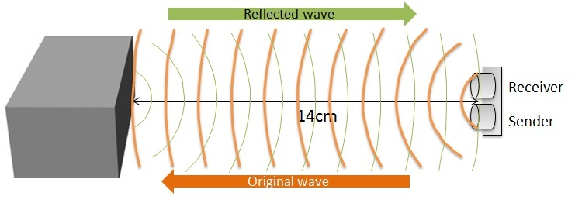

How Does an Ultrasound Sensor Work?

In the dry air at 20°C (68°F), the speed of sound is 343.2 meters per second. The sound wave is emitted by the sensor and travels to the object, bounces off and travels back to the sensor. The time that it takes for a sound wave to come back to the sensor is recorded and given to the user. If the round-trip travel time of the sound wave is $3*{10}^{-3}$ seconds, what is the distance between the sensor and the object?

Please show your work.

